Using tension-based soil moisture monitoring tools to schedule irrigation
Tension measuring devices provide information about water availability in the soil. Soil tension can be used by irrigators to better plan when to irrigate in order to optimise plant performance and water productivity.

Scheduling irrigation with tension
Tension is a measure of suction or negative pressure. It measures how tightly the water is held in the soil. It is generally measured in kilopascals (kPa) and recorded as values of minus or negative kPa, however the minus sign is not always present.
Water is held in the soil by the attractive forces between water molecules and the soil. When soil water is extracted by plants, the most readily available water is removed first. This water is held loosely in large pore spaces. As water extraction continues tightly held moisture remains, and the plant requires increasingly more energy to extract the remaining water. This results in a more negative tension.
Measuring soil tension provides irrigation managers with an estimate of the most appropriate time to irrigate. Unlike other soil moisture monitoring methods (such as capacitance or neutron probe), it does not readily provide information on how much to apply. To determine an estimate of the appropriate irrigation volume, soil texture and rootzone depth assessments need to be made. Soil water content data (RAW values) is available for different soil textures at a range of soil tensions.
Optimum plant growth occurs when soil moisture is maintained within a pre-set range of tension. At field capacity (generally 8-10 kPa), plants can easily extract water from the soil. Field capacity is the maximum amount of water soil can hold against gravity without producing drainage.
The refill/irrigation trigger point for perennial horticulture is generally 40 to 60 kPa. Therefore, the range of tension for unrestricted growth of most perennial horticultural crops is 8 to 60 kPa. These figures may vary depending on crop, soil type and irrigation system. In extremely sandy soils much lower tension figures are used to trigger irrigations.
During certain growth stages, irrigation managers may like to apply a certain level of moisture stress. In this situation, tension measuring devices are extremely useful as a guide to monitor the level of stress being applied as appropriate stress levels (in kPa) for most crops is well recognised.
The most common soil moisture monitoring tools which measure tension are the tensiometer and the gypsum block.

What are tensiometers?
Standard tensiometers generally consist of an airtight, water filled tube with a porous ceramic tip at the bottom and a manually read vacuum gauge at the top. The tensiometer is partly buried in the soil to a suitable depth and, when used properly, can help determine when water should be applied to maintain optimum crop growth (Figure 1).
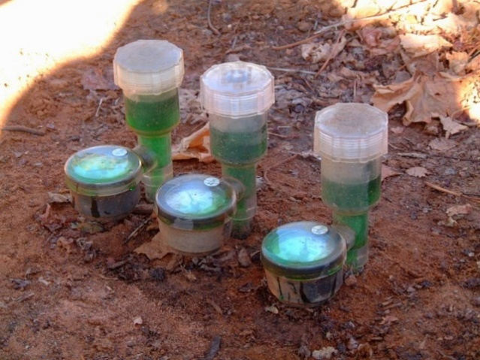
Figure 1. A standard set of tensiometers installed at 30, 60 and 90 cm depth (Image: Jeremy Giddings)
Other variations to tensiometers exist including the use of a portable vacuum meter with a re-sealable rubber bung at the top of the tensiometer into which a needle from the portable meter is inserted (Figure 2). This option may be economically favourable if a large number of sensors are to be read by a single meter.
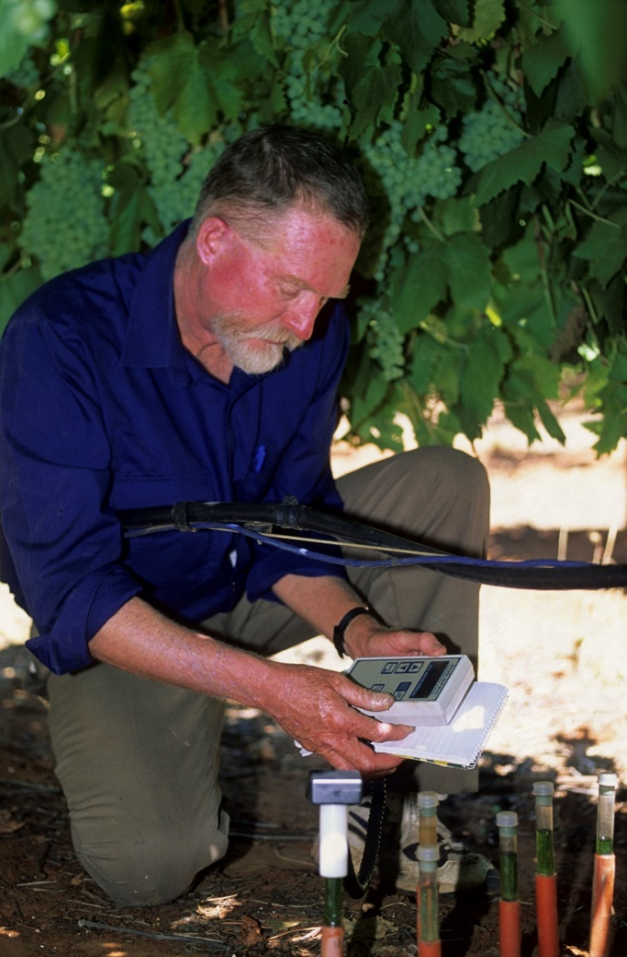
Figure 2. Portable needle type tensiometers (Image: NSW DPI)
Tensiometer gauges normally display tension in kilopascals (from 0 to 100 kPa) and operate accurately up to approximately 75 kPa.

How do they work?
Water moves freely in and out of the ceramic tip when in close contact with the soil. As the soil dries out, water is drawn out through the tip, creating a partial vacuum inside the tensiometer which is read on the vacuum gauge.
When the soil is wetted by sufficient irrigation or rainfall, water flows back into the tensiometer, the vacuum decreases and the gauge reading is lowered.
Tensiometers do not operate well when the soil becomes extremely dry. This is because excessive air is sucked in through the tip breaking the vacuum seal between the soil and the gauge. In this situation gypsum blocks are a more suitable device for measuring tension.

Preparing for installation
Proper preparation and installation are essential for the tensiometer to perform correctly.
Prior to installation, fill the tensiometer with clean water and allow to drain through overnight with the cap off. This saturates the tip and confirms that it is porous to water movement. Do not handle the tip if possible.
To test the tensiometer is functioning correctly, refill the tensiometer, install the cap and leave it free standing in the sun for a couple of hours. The reading on the gauge should rise as water evaporates from the ceramic tip. Then place the tensiometer into a bucket of water. The reading on the gauge should drop within half an hour.
When ready to install, it is preferable to remove as much air from the topped up tensiometer as possible. Vacuum pumps are available to do this. When using a vacuum pump, ensure the tip is submerged in a bucket of water, which ensures the tip is saturated. The tensiometer is now ready for installation.
Dig a 25 mm (or greater) diameter hole that is 100 mm shorter than the length of the tensiometer being installed. Most tensiometer tips are approximately 19 mm in diameter. Therefore, make a 19 mm diameter hole for the remaining 100 mm to ensure tight contact is created between undisturbed soil and the ceramic tip. Augers are available in this size. Hammering an appropriately sized metal rod or wooden dowel, such as a broom handle, is also an option.
Push the tensiometer firmly into the hole. Fill the hole with loose soil and pack it down. Heap the soil up around the tensiometer to avoid the re-filled hole acting as a preferred pathway for water. Covering tensiometers (with a bucket or container) helps prevent frost, physical damage and reduces algal growth.
Follow manufacturers installation guidelines to obtain optimum performance from the tensiometer.

Maintenance and troubleshooting
Tensiometers require regular maintenance including refilling the tensiometer tube and releasing any air. The condition of seals should also be checked periodically. Perished stoppers will cause problems.
A common issue with tensiometers is the gauge reading remaining on zero. This can be caused by:
- Continuously saturated conditions,
- No or low water levels in the tensiometer,
- Air leakage through the ceramic tip (loose threaded seal) or around joints and seals.
Measurements which appear untrue can arise from:
- Poor soil contact with the ceramic tip,
- The tensiometer being installed outside the wetted zone or crop rootzone,
- A faulty gauge which needs replacing.
If the tensiometer is slow to respond to irrigation:
- The tip may be sealed,
- The gauge is damaged,
- Water level in the tensiometer is low.
Many of these issues can be resolved through routine maintenance activities and ensuring the tensiometer has been installed correctly. Tensiometer measurements can be confirmed by ground truthing using an auger or shovel.

Commercial products
Most tensiometers are manually read devices, with a simple pressure gauge attached. However automatically logging tensiometers are becoming more popular.
Continuously logging devices will have either local storage, requiring the user to collect and download the information in person, or will automatically send data to the cloud where it can be accessed via a data portal.
Some examples of tensiometers are:
- Irrometer tensiometers
- Jetfill Tensiometer
- TEROs-32
- Soil Spec

What are gypsum blocks?
Gypsum blocks are devices—comprising of or containing a disc of gypsum—which measure soil water tension (also in kPa) using electrical resistance. There are two types of gypsum block:
- Malvic Gypsum Block,
- Granular Matrix Sensor (GMS) or Watermark.
The traditional malvic gypsum block consists of two electrodes embedded in a cylindrical block of gypsum (Figure 3, left). They measure soil water tension in the range from 30 to 1,500 kPa. Therefore, their ability to measure soil moisture close to field capacity is limited. They are very useful for conditions in the drier range (>70 kPa).
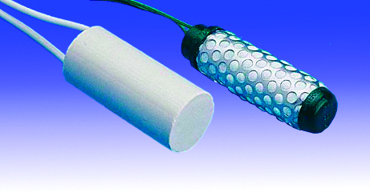
Figure 3. Traditional malvic gypsum block (left) and a Watermark granular matrix sensor (right) (Image: Dominic Skinner, MEA).
Granular matrix sensors also consist of two electrodes which instead are embedded in a uniform sand fill, or matrix. The matrix is encased by a synthetic membrane and held in place by a stainless-steel casing. The sensor also contains a small gypsum block embedded in the sand (Figure 3, right).
The GMS types have a sensitivity range from 0 to 300 kPa. The porous sandy material is designed to have a faster response to wetting and drying cycles than traditional gypsum blocks, although the response is still not instantaneous.

How do they work?
Water moves in and out of the pores in the blocks in equilibrium with the soil. As the soil dries out water is extracted from the gypsum block and the resistance reading between the electrodes increases. When the soil is wetted, water is drawn back into the block and the resistance decreases. A handheld meter or datalogging system measures the electrical resistance between the two electrodes in the sensor.
The resistance measurement (ohms) is converted to units of kilopascals (kPa).

Preparing for installation
All gypsum blocks should be soaked and tested before installation, following installation guidelines. Soak the sensors for several hours in irrigation water to remove any air from the matrix or block. Sensors must be installed wet. For GMS, if found to read more than 5 kPa when saturated, they should be replaced.
To install, use an auger to create a hole approximately the same size as the sensor and to the desired depth. Insert the sensor and backfill the access hole, tamping down the soil to eliminate air pockets.
Like tensiometers, gypsum blocks must have firm contact with the surrounding soil. In some cases, a slurry (soil, silica flour or kaolinite and water mix) may be needed to create better contact between the soil and sensor. It may be appropriate to use a sand/bentonite mix to avoid preferential water flow. This could also be prevented by auguring the access hole at a 45-degree angle to the horizontal resulting in undisturbed soil above the sensor.

Maintenance and troubleshooting
Compared to tensiometers, gypsum blocks are relatively maintenance free. Ensuring the gypsum block is working correctly prior to installation (as described above) should address most issues.
GMS and malvic gypsum blocks do not perform as well in coarse sands, where the large pore spaces don’t allow for good transfer of water between the matrix or gypsum. It may be more appropriate to select a different sensor type for these soils.
There are also occasions where gypsum blocks do not perform well in very dry soils. This occurs when the soil dries out and the contact between the soil and sensor changes.
Excessively saline soils can also create errors in readings (>3,125 EC).

Commercial products
Like tensiometers, gypsum blocks can be purchased as manually read or continuously logging devices. A unique option is the G-Dot, which provides an easy to read display option comprising seven yellow flip dots to indicate soil tension. Examples of gypsum block products include:
- G-block,
- Watermark GMS sensor:
  - Green Brain dataloggers,
  - Irrometer dataloggers,
  - GDot.

Placement of devices
It is essential to understand the location of the root system to accurately position the sensors. Rooting depth will vary depending on the soil, crop type and management practices. A soil pit might be needed to determine this. Do not assume standard installation depths are appropriate for every situation.
At least one sensor should be located in the active rootzone of the crop. One or two additional sensors should be placed throughout soil profile, including one at the bottom of the rootzone to monitor subsoil moisture and drainage.
Ideally each crop and soil type combination should have a set of sensors. Within each of these combinations the sensors should be located in order to receive the average application from a sprinkler or drip system. This same sensor arrangement should be repeated across all patches if possible.
For manually read sensors consider locations that are easily accessed.
Mark devices clearly to avoid damage from traffic, workers and cultivation. Any wires should be secured or buried to avoid interference from wildlife.

Comparison to other soil moisture monitoring tools
There are many types of soil moisture monitoring devices. Each of these provide users with soil moisture information which vary in detail, complexity, price, and data collection method. It is important to weigh up the advantages and disadvantages of each, considering what information is needed from the sensor to effectively manage irrigation.
Generally, the advantages of using tension to measure soil moisture are;
- No calibration necessary,
- Sensor data is easy to interpret and is immediately useful,
- Maximum tension levels are recognised for a range of crops, including stress levels,
- Tension measurements are independent of soil type,
- Sensors can be very useful for growers with multiple soil types and plant varieties,
- Can be more affordable than other devices,
- Manual-read devices have no ongoing costs associated with data storage and access.
Disadvantages
- Less readily able to determine how much to irrigate (volume),
- Ceramic sensors can dissolve over time,
- Good soil contact is critical,
- Can be slow to respond to changes in soil moisture,
- Gypsum blocks perform poorly in sandy soil,
- Tensiometers require regular maintenance.

Case Study
Francis Garreffa’ s family owns and manages 150 hectares of table grapes in Merbein Victoria and Euston NSW, irrigating with both drip and under-vine sprinklers.
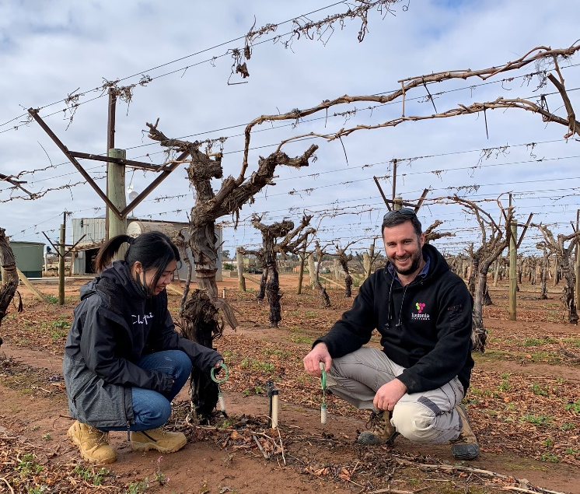
A combination of granular matrix sensors and tensiometers are a key component of irrigation management on Francis’ properties.
Table grapes are particularly sensitive to water stress in most stages of development and it is essential to maintain adequate soil moisture in the rootzone. However, at certain growth stages a slight water deficit is also applied. Francis has found that measuring tension gives a more powerful signal of the relative stress levels experienced by the vines across his properties. Other soil moisture monitoring tools require site specific calibration and then further understanding of the relationship between stress and soil water content.
Sensors are located in 25 sites across all properties, with a mix of manually read tensiometers and continuously logged gypsum blocks which are remotely downloaded. Rootzones are relatively shallow and sensors at each site are installed at two depths in the vine row, generally 30 and 50 cm. The shallow sensor is maintained at moisture levels which prevent plant stress within the rootzone. The 50 cm sensor is situated below the rootzone to monitor drainage and prevent over-irrigation.
Francis believes there are advantages and disadvantages to these systems,
- Remote access from a wireless network provides frequent updates on soil moisture in an easy-to-read App,
- The App also makes it easy to monitor the performance of the sensors. As long as readings return to 5 kPa after each irrigation, the sensors are still working properly,
- Gypsum blocks have had a good lifetime and have been installed for 5 years without need for replacement,
- Manual read tensiometers encourage more time in the orchard.
Challenges:
- To remote download successfully the in-field network needs line-of-sight visibility, and this is disrupted at certain times in the season,
- Tensiometers can only hold a high reading for so long before there are issues with air leakage and / or soil contact. This is not an issue with gypsum blocks (at the moisture levels being operate at), so having a combination of devices is beneficial,
- Tensiometers require ongoing maintenance and refilling which makes them more labour intensive.
Francis suggested, “It’s not too much of a hassle to manually collect data and it provides us with more opportunity to monitor what’s happening in the vineyard.
Make sure you keep up with maintenance on the tensiometers, often when we get zero readings, we need to release air from the vacuum and refill.
Monitoring plant stress is a key part of how we manage irrigation, and tension has always been a good way for us to monitor stress. We are always looking to improve and introducing dendrometers to monitor plant stress is a part of our plan for the future.”

further information
Jeremy Giddings, Agriculture Victoria. jeremy.giddings@agriculture.vic.gov.au

Acknowledgements
Dominic Skinner, MEA.
Francis Garreffa, Eustonia Vineyards.
Jeff Mitchell, Mitchell Agronomy.
Natalie Mason, formerly Agriculture Victoria
The mention of trade names or commercial products is solely for the information of the reader and does not constitute an endorsement or recommendation for use by the authors or Agriculture Victoria.
Accessibility
If you would like to receive this publication in an accessible format, please telephone (department, branch, contact) on (insert phone number or email).
This document is also available in (insert HTML and/or PDF and/or Word) format at www.victoriangovernmentdepartment.vic.gov.au

