Managing citrus orchards with less water
March 2018 Primefact 427 Fourth edition
Steven Falivene, Citrus Development Officer, NSW DPI Dareton
Jeremy Giddings, Manager Irrigation – Mallee, Agriculture Victoria Irymple
Mark Skewes, Research Scientist, South Australian Research and Development Institute

Introduction
To manage citrus orchards with less water requires an understanding of your orchard's water requirements and the impacts of water stress. There are a variety of options to consider when managing an orchard with reduced water availability. For example, water requirements will be influenced by tree size and age, so reducing mature tree canopies might be an option. Another strategy is to sacrifice less profitable blocks with minimal water and allocate water to more profitable blocks, rather than watering the whole orchard with a sub-optimal water regime. Implementing irrigation scheduling and drip irrigation practices could also help. When considering these options, careful planning, including the use of a water budget should be used to guide decision making. Every farm will be different in the selection and degree of water saving options. This Primefact addresses options for managing your citrus orchard with a reduced water allocation as well as describing the experiences of citrus growers from NSW and Victoria who faced limited water availability in 2003 and 2007.

Citrus water requirements
Mature sprinkler-irrigated citrus trees grown in Sunraysia and the Riverland require approximately 1,000–1,200 mm (10–12 ML/ha) of water annually. Yields will decline when less water is applied (Skewes, 2013a; Figure 1).
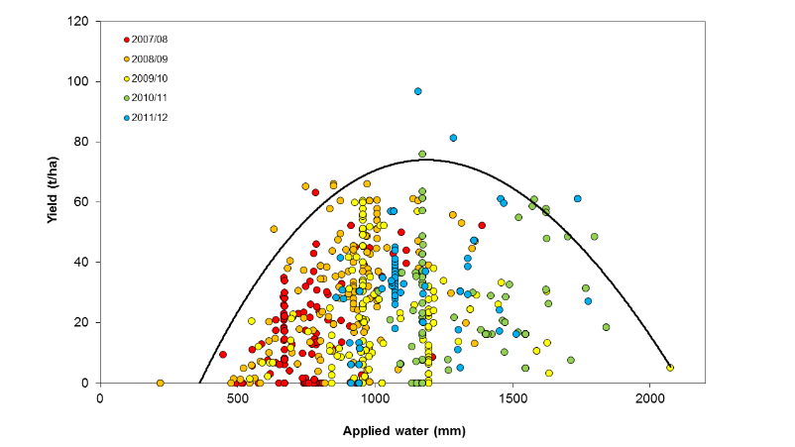
Figure 1. Citrus yield response to water in Riverland and Sunraysia.

Water and citrus growth
For unrestricted growth, citrus trees require water all year round. The peak demand for water is during the warmer months i.e. October to March, when 74% of the annual allocation is required (Figure 2). Water use declines during late autumn and winter with the onset of cooler temperatures and slower tree growth.
Water stress can affect citrus production at all development stages and stress can occur before any visual symptoms appear. Water availability will influence flowering, fruit set, fruit drop, fruit size, yield, internal fruit quality characteristics and canopy development. Water stress can also restrict vegetative growth and reduce canopy development, which is especially important in young trees and for next season’s flowering sites. Therefore, the options available for stressing citrus at particular growth stages to save water while remaining productive are limited.
Rootstocks vary in their tolerance to water stress and salinity levels. Recent research at Loxton, South Australia indicated that Cleopatra mandarin, Carrizo and Troyer citrange, and Swingle citrumelo have moderate to good drought tolerance. Poncirus trifoliata and Sweet orange have poor drought tolerance as they are relatively shallow rooted (NSW DPI mandarin manual). Recognising rootstock drought tolerance can influence which blocks could be prioritised if water rationing decisions need to be made.

Figure 2 depicts average water use by mature citrus trees based on long-term data collected at Dareton in south-western NSW. This information can be used as a guide to determine water needs and plan for the coming season. An Excel water budget spreadsheet is available from NSW DPI website (on the same page that this PDF document is located).
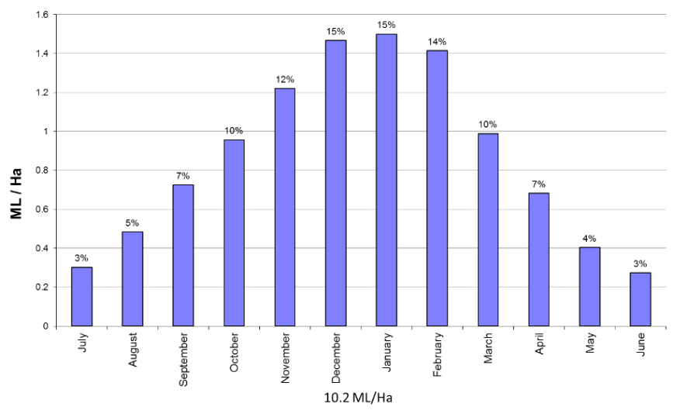
Figure 2. Long-term average water use and monthly percentage values of mature citrus trees with full ground cover, sprinkler irrigated at Dareton.

Citrus growth stages and water requirements
Table 1. Water requirements of citrus at various growth stages
Growth stage | % annual water requirement used | Effects of water stress at this stage
Flower bud induction and initiation (mid-May–July) | 10% | Can increase flowering. In fact, in some regions (e.g. Northern Territory) deliberate water stress is used to induce flowering in citrus. However, drought periods of more than 30 days are usually required to induce a significant number of flower buds
Flowering and fruit set (mid-September–October) | 13% | Can reduce fruit set, cause excessive fruitlet drop, reduce yield and suppress the spring flush
Stage 1: Fruit growth (cell division; November–December) | 26% | Cells are dividing and up to 60% of final fruit size is determined. Small fruit at the end of this period tends to be small at harvest. Water stress can cause excessive fruitlet drop and reduce fruit size. Fruitlet drop is usually more severe when water stress is coupled with high temperatures (>35 °C). Trees carrying mature fruit at this time, such as Valencias, seem to be able to buffer this effect to some extent, with fruit drop possibly more severe in navels. The summer leaf flush can also be suppressed, which might affect next season’s flowering sites.
Stage 2: Fruit growth (cell expansion; January–April) | 40% | The first few months of this stage (mid-December to February) is the critical time when fruit cells are expanding (cells can increase 1,000 times) and final fruit size is determined. Therefore, water stress in the early part of this stage should be kept to a minimum. An early sign of stress is that fruit stop growing, so it is important to regularly measure fruit size. From January onwards, measure fruit size weekly at the same time each day (7–9 am). If water is supplied at the first sign that fruit growth rate is decreasing, then final fruit size might not be reduced.  The best window for extending irrigation intervals is during late summer and autumn. Minor water stress during the latter part of this stage can be tolerated without a major effect on fruit size. However, prolonged water stress will reduce fruit size and the reduction is more pronounced when the crop load is heavy. Prolonged water stress can also influence internal fruit quality characteristics, increasing the acidity and total soluble solids (TSS) of fruit, while slightly decreasing percent juice. Short-term (i.e. 6–8 weeks) controlled water stress during late summer to early autumn (February to March) is used on some mandarin varieties to increase fruit brix and acid and to hasten fruit maturity. It is speculated it could provide similar effects on oranges. Mid-summer and autumn leaf flush will be suppressed, which can affect next season’s flowering sites.
Fruit maturity (May onwards) | 10% | Moderate water stress will have a minimal impact on fruit size but it can bring forward fruit maturity slightly, reduce the fruits’ shelf life and increase the incidence of stem end rind breakdown. The best strategy for reducing water use at this time is to slightly extend the interval between irrigation.

Impacts of water stress on growth
Reducing water application can increase soil salinity levels. Irrigation water salinity can also increase during drought. Irrigating with saline water will increase the severity of stress on trees. Soil salinity and moisture monitoring are therefore critical components of successfully managing orchards with less water (see next section), because it is easy to over stress or over water trees without a reference point or a way to measure a strategy’s impact. Contact your local horticulturist or agronomist for more information about irrigation and salinity management. The following information (Table 2) is a guide to the possible impacts of various levels of water reduction on the health and productivity of citrus trees.
Table 2. Impacts of water stress on growth
Reduction in water application | Effects
10-20% | Usually minimal impact on fruit size and yield
20-40% | Fruit size will decline and some crop reduction can occur
40-75% | Significant crop reduction, decline in fruit size and leaf flush will occur  Fruit might be too small for traditional fresh fruit marketing. If fruit are at a marketable size, the rind integrity might be poor resulting in postharvest breakdown, and poor internal quality can result in unacceptable eating quality  Trees might take a season or two to fully recover to optimum production. Recovery will depend upon the water reduction severity and how the current season’s leaf flush has been affected
> 75% | Total crop loss would be expected and the trees will be unthrifty with significant twig dieback and leaf drop  It could take a couple of seasons for the trees to fully recover.

Water saving practices

Immediate strategies
Water budgeting. Estimating the monthly water requirements for each block using average industry data (such as Figure 2) and your own historical irrigation records can be used to develop a drought management plan and prioritise the allocation of water to blocks. See page 8 for more information on developing a water budget.
Install irrigation scheduling devices. It is critical to use soil moisture monitoring devices to accurately check soil water levels and allow irrigation to be scheduled more precisely. If you do not currently have any devices, then tensiometers are relatively cheap, easy to install and use (see Primefact 1359 Tensiometer tips). More expensive and sophisticated scheduling tools will allow you to be more accurate and effective with your irrigation applications. However, it generally takes longer to learn how to use and understand the information generated from this equipment (see Primefact 1365 Using capacitance probes for irrigation scheduling).
Check, manage and maintain the irrigation system. Irrigation systems should be checked for any leaks or blockages. The accuracy of water meters should be checked by cross-referencing readouts with application rates and system specifications. If irrigation uniformity is poor, contact an irrigation consultant for advice on how improvements can be made (see Primefact 1364 Checking above canopy sprinkler performance). The effect an inefficient system has on an orchard will be exacerbated during times of drought. Correcting these issues might result in only modest water savings, but in a drought every drop counts.
Avoid leaching losses. Ensure water is not applied and lost below the root zone by carefully monitoring soil moisture levels and irrigation depth. Sampling for soil salinity is recommended to determine if a strategic leaching program is needed. Water available during drought conditions might have elevated salinity levels.
Mulch the wetted strip. Applying mulch over drip irrigation lines helps reduce soil evaporation. In mature orchards this might be of little benefit. However, it can be a useful option for young trees where a large percentage of the soil surface is exposed. Overseas information has shown that plastic mulches can be economically viable for young trees, but organic mulch (either natural leaf litter or imported mulch) might be a cheaper option. Ensure that the drip line is underneath the mulch. Mulches can act as a barrier to effective water penetration, and once wet can then quickly dry out. Accurate soil moisture monitoring is important in order to recognise this situation.
Reduce the wetted area. This is most applicable to young plantings. If irrigating with low level sprinklers, changing over to a sprinkler head, adaptor, or installing a sleeve over the head of the sprinkler creates a narrower throw, eliminating water application to the inter-row area where roots have not yet significantly colonised. Run times can be significantly shortened while still ensuring the majority of an under-developed root zone is watered. This might involve moving sprinkler heads closer to the butt of the tree.
For drip irrigated orchards, plugs can be installed between trees leaving only the emitters near the tree functioning.

Full cover weed control. Removing weeds and eliminating sods will reduce competition for water. Sods are best sprayed with herbicide and allowed to form a layer of mulch, protecting the soil and reducing evaporation. For drip irrigation systems it is best to slash the sod and throw the cuttings back over the wetted strip to form a mulch.
Irrigate at night. Under-tree sprinkler irrigating at night can provide water savings of 20–30% compared with daytime irrigation by reducing evaporation losses. However, the water savings with drip irrigation systems are variable depending on the amount of mulch, leaf litter and shade over the wetted soil surface.
Eliminate water run-off. Irrigation water should be kept in the orchard. If surface run-off is occurring, consider breaking up soil crusts to improve water penetration and soil aeration. The traditional methods of improving water penetration are applying gypsum and/or ripping (How to manage soil for citrus). Ripping in a low water scenario is not recommended due to the additional stress created through root damage, and the reduced ability of the tree to access any rainfall.
Reduce or cease windbreak irrigation. This can save water, but jeopardises the long-term benefits of windbreaks. Additionally, un-irrigated windbreaks can scavenge water from the adjacent crop, so deep ripping or trenching to trim windbreak roots might be required.
Re-use back-flush water. Contact an irrigation designer to ensure excessive back-flush volumes are not being generated to begin with. Some minor savings might be possible. The back-flush water that is created from drip irrigation filters can be re-used if run to a settling tank. Discuss this option with an irrigation designer. Media filters generally use 4.0–5.0% of the water pumped to back-flush, disc and screen filters 1.5–2.0%.
Reduce crop load. Reducing or eliminating the crop load can help to reduce water stress effects on fruit size. Trees carrying heavy crop loads will suffer more stress than trees with a lighter crop. However, under severe water stress fruitlet drop will occur naturally, reducing the crop load and the resulting tree stress. For trees under light to moderate water stress, monitor crop levels and fruit size and apply appropriate crop thinning strategies to decrease excessive crop loads in line with reductions in irrigation volume.
The choice of strategy depends on the water saving strategy chosen (i.e. trying to grow a crop or sacrificing crop) and the crop stage. Strategies include winter flower suppression sprays, hedging, chemical fruit thinning and hand thinning (see page 11-13 for additional information). The Fruit Size Management Guide Part 1 outlines when and how to implement these crop reduction strategies.
Reduce transpiration. Kaolin clay-based foliar spray products are claimed to reduce water losses through leaves. Demonstration trials have shown growth increases in young trees. However, using these products can increase scale insects incidence, particularly red scale. In trials on mature trees there was no significant effect on tree stress measurements or yield from using foliar sprays (Skewes, 2013b).
New products enter the market frequently and there is always the possibility that some might be beneficial. If using these products, consider leaving untreated areas in order to determine the effectiveness of whatever was applied.
Buy or trade water. Buying or leasing in water, if available, can be a viable option. Consider the long-term value of the trees and crops compared with the cost of water. If the cost of water is less than the value of produce lost by withholding that volume of water (including any ongoing recovery to production), then buying permanent (water entitlement) or temporary water (allocation) should be seriously considered. Relying on allocation water means greater exposure to price fluctuations. Although developed for winegrapes, spreadsheets such as that produced by Consolidated Co-operative Wineries (CCW) are available to quickly determine if buying water is a viable option. Rural counsellors might be able to help you use these tools.
Keep informed about water reductions. Maintain contact with the water supply authority for the latest information on water allocations, water flows and water levels in storage. Obtain information on next season’s likely water allocation scenarios to enable better long-term decision making. This information can be sourced from state (e.g. Victorian Water Register and Water in NSW) and local water authority websites. Look at long-term weather forecast information to help schedule irrigations.

Longer-term strategies
Install valves for each patch. Separate valves to blocks or patches that have different water requirements to allow a more accurate match of crop water needs with irrigation applications. Water use differs between varieties and tree age. If adopting canopy reduction on part of a block, the irrigation system should be modified to cater for the significant differences in water requirements which are created.
Install more sophisticated scheduling equipment. More sophisticated scheduling equipment (e.g. neutron probes, capacitance probes) will allow you to be much more accurate in your irrigation applications and in gauging rainfall effectiveness. Also, leaching losses can be completely avoided while still ensuring that irrigations are fully effective. This equipment is more expensive and requires some time to learn how to use and understand the information generated.
Convert to efficient irrigation systems. Drip irrigation is potentially the most efficient irrigation system with possible savings of 40–60% over furrow and overhead sprinkler systems and up to 30% on under-tree sprinkler systems. Figure 3 is an example from a Sunraysia grower showing the differences in monthly water application rates to navel oranges using drip irrigation and a low-level micro-sprinkler system. The same magnitude of savings cannot be guaranteed in all situations, but this demonstrates the savings that are possible.
A new drip irrigation system requires substantial investment and should be professionally designed. If there is a high probability that water restrictions will continue in the future, serious consideration of the long-term financial viability should be given to installing drip irrigation.
Drip irrigation has been very successful when installed in newly developed orchards. Converting a mature sprinkler or furrow irrigated orchard to drip irrigation has had mixed results. Some orchards have declined in productivity and growers have returned to sprinkler irrigation. The variable results are most likely due to management (i.e. good scheduling practices are critical) or existing orchard status (i.e. existing tree health, nematode presence, soil compaction, rootstock choice). Drip irrigation systems are preferably installed in winter immediately following harvest because the water supply needs to be shut down during conversion, and trees are less likely be become stressed in the cooler weather and without a crop load. Some growers have successfully converted to drip irrigation during summer. However, this carries a high risk if the new system is not quickly operational. A delay in irrigation over an extended period in summer can cause serious tree stress and crop loss. The trees will also need to be adequately irrigated and fertigated to hasten root development under the drip line. The time taken for roots to re-establish under the drip line can also cause tree stress.
It is important to be aware that converting to drip from a full cover irrigation system changes the distribution of water in the root zone. Roots take time to respond to this change in water pattern, and the tree will experience stress until the root system has adjusted. In a normal season, ample drip irrigation applications are recommended in the first year following conversion. Superimposing a water deficit on top of the conversion during drought conditions is likely to lead to significant stress. However, it is highly likely that water savings are still possible in an amply applied drip irrigation program in the first season compared with a typical full cover system (see Primefact 1456 Converting mature citrus from full cover to drip irrigation).
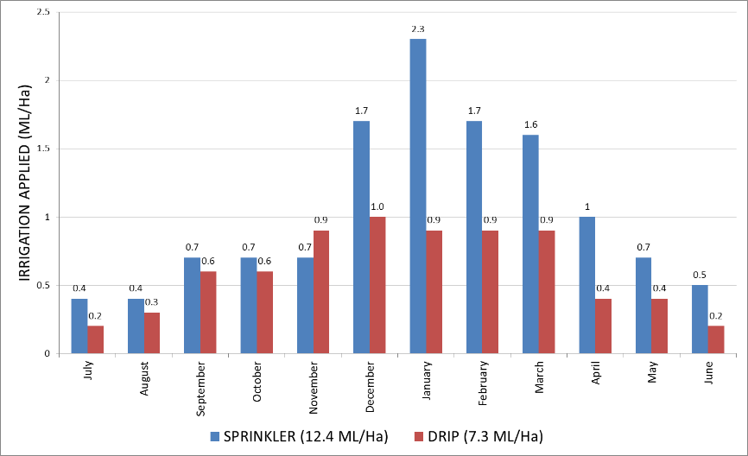
Another benefit from drip irrigation is that trees can withstand higher water salinity levels than when irrigated with sprinklers. Well monitored and managed drip irrigation is able to maintain a more stable and higher level of soil moisture, as well as avoiding foliage contact, thereby minimising salinity effects. Experience on the Darling River showed citrus on drip irrigation was able to tolerate water of 2,000 EC units.
Figure 3. Monthly irrigation applications to well monitored Late Lane navels using drip irrigation and low-level micro-sprinklers in Sunraysia during 2001–2002.

Selecting a strategy for managing citrus with less water
The following options can be used to develop a program that best suits your own situation. Small fruit normally provide poor returns and fruit with poor integrity are unmarketable. In times of predicted water shortages, often the most viable option is to maintain high value blocks in order to produce good sized fruit at the expense of less profitable blocks. Given that similar decisions may have recently been made during relatively recent drought events (eg 2007-09), this can be a difficult decision. Before severely water stressing, removing, skeletonising or hedging trees, discuss your plans with your packer/agent/processor, as these actions can have long-term implications. Consider the probability of an extended drought versus normal water allocations returning in the following season. The first step is to develop a water plan or budget for your farm.

Develop a water budget for your farm
A water budget is a plan of your orchard that identifies the present and proposed irrigation allocation for each block, and any additional management strategies. These decisions need to be based on a number of factors, including:
- profitability of the block
- current and long-term plans for the block/orchard
- tree age, variety, rootstock, crop load (on/off year) and growth stage
- packer, processor or agent priorities – current and future
- resources available
- current financial situation
- future water availability predictions.
The following steps can be used as a guide to developing your water budget:
1. Determine the typical monthly water allocation for each block based on historical water use.
2. Decide what water-saving strategies or management practices will be undertaken.
  - Maintain block and production, implement management practices (i.e. mulching, night watering) at 10–20% water saving.
  - Install drip irrigation, and possibly suffer an initial productivity loss at a 30% water saving.
  - Hedge trees lightly to trim back a heavy crop, produce a viable crop and save up to 30% water.
  - Hedge trees moderately to eliminate most of the current season’s crop and prepare for a crop next season, with water savings of up to 50%.
  - Hedge trees heavily or skeletonise to sacrifice the crop for the next 3–4 years, but save large amounts of water.
3. Adjust monthly irrigation allocations to suit your plan.
4. Put the plan into action.
5. Regularly monitor tree blocks and re-adjust as necessary.

Additional tree management strategies

Young tree management (0–6 years)
Significant water savings can be made on young trees if water is applied efficiently. Young trees have a smaller canopy and root zone than mature trees, and require less water in proportion to their reduced canopy size (Figure 4).
Basic water saving practices for young trees include:
- reducing leaching losses below the root zone
- building a small basin around newly planted trees to trap water (low level sprinklers)
- spreading mulches around the tree to reduce evaporation from the soil surface
- clips can be used for inline drippers to block off drippers between trees where the roots have not yet established
- installing additional submains and valves to separate young plantings from mature trees,
- installing sprinkler heads that have a small throw pattern
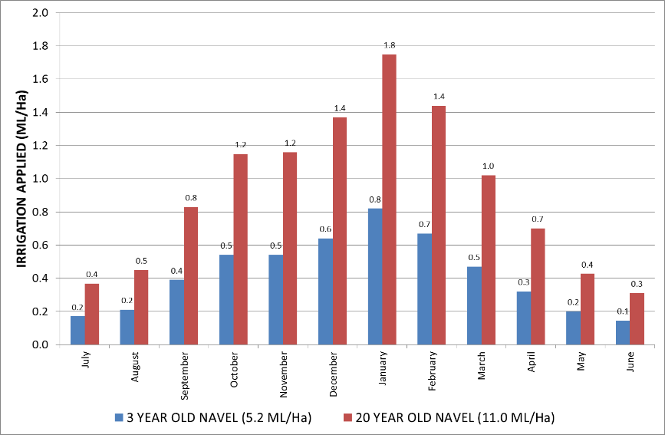
- installing soil moisture monitoring to accurately and confidently determine lower water demand from young trees.
Figure 4. Monthly water requirements of well monitored young and mature navel orange trees in Sunraysia during 2008–2009 (M Skewes, pers. comm.).

Mature tree management (>6 years)

Canopy reduction
Tree water use is directly related to canopy size, so reducing the canopy reduces water use. Figure 4 illustrates the impact of much smaller canopy size in young trees on monthly water requirements of navel orange trees.
The relationship between canopy size and water use occurs primarily through intercepting solar radiation (sunlight), so the shaded area under the tree at solar noon is a good indicator of relative water requirements. For example a 50% reduction in shaded canopy area will result in a 50% reduction of tree water use. However the effect of increased soil evaporation should also be considered when estimating water needs on a block basis. The amount of tree canopy removed for each block should be based on tree age, crop load, stage of growth, long-term block viability and how much water needs to be saved. Providing trees are given sufficient levels of water and nutrients, they should recover to form a vigorous canopy that produces good quality fruit (see Case Studies). The time taken for the tree to regrow and return to full production is related to the intensity of canopy reduction. In some circumstances, resources (labour and machinery) might not be available to undertake canopy reduction, so alternatively old or unproductive blocks could be abandoned in preparation for replanting when water supplies resume.
Under restricted water conditions, trees that have had their canopy reduced will recover more quickly than trees without any canopy reduction. Remember to adjust fertiliser applications to suit the tree canopy size and vegetative growth. A heavily pruned tree will require less fertiliser. Gradually increase the amount of fertiliser applied as the tree canopy re-grows. The best time to prune citrus is generally after harvest, but pruning can also be undertaken at other times throughout the year. Having a mix of heavily and lightly pruned blocks in the orchard allows some of the orchard (lightly pruned) to quickly return to full production when water allocations return to normal.

Hedging and skeletonising
Hedging is trimming the sides and tops of a tree (Figure 5). There are different degrees of hedging, from lightly trimming the tree to near skeletonising. The best time to hedge trees is in late winter/early spring to reduce the risk of sunburn to the newly exposed limbs. A light hedging will not significantly affect next season’s production. However, a medium or heavy hedging can result in trees being out of production for 1–2 seasons. One option is to hedge only one side of the tree to reduce any effect to yield.
Heavily hedging trees in late spring/summer might require exposed limbs to be painted with white wash to protect limbs from sunburn. Sunburn can occur within a day in hot temperatures (i.e. above 35 °C) and the risk increases significantly as temperatures rise further.
Heavily hedged trees might not require white washing if the hedging is conducted in late winter/early spring because the tree has adequate time for its bark to acclimatise to high light conditions, and an adequate cover of leaves will grow to shade limbs before hot conditions occur. The western side of the tree is more susceptible to sunburn because it is exposed to the afternoon sun.
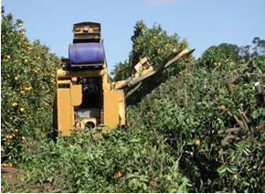
Figure 5. Mechanical hedging can be used to reduce the tree canopy.
Skeletonising is the most severe form of canopy reduction, involving removing nearly all of the tree branches and foliage. It is the most expensive form of pruning and is often done with a hedging machine followed up by manual chainsaw trimming. This type of pruning is normally used to rejuvenate old trees. The first five or so years of production after skeletonising is recognised as producing large, excellent quality fruit because it is grown on young, healthy, vigorous shoots. Trees that have been skeletonised will use a lot less water, but can take between two and four years to come back into full production. Skeletonised trees that are water restricted can take longer to return to full production because the water stress will reduce shoot regrowth.
The exposed limbs will need to be painted with white wash (1 part plastic paint:1 part water). Spray painting applies the white wash quickly and efficiently. As the trees grow, the regrowth needs to be managed to select the best positioned shoots to regrow the tree.
Heavy hedging and skeletonising must be carefully considered. If a block of trees are in need of hedging due to row access issues, or old trees need to be rejuvenated due to declining productivity, then this presents itself as an opportunity. However, if hedging is used purely as a water saving strategy this must be carefully considered as one part of a whole farm strategy, as it will significantly affect production levels for the next couple of years, even if allocations immediately return to normal.

Pruning for regrafting
Cutting back trees for regrafting will also reduce water use (Figure 6). This is one way of saving water and regenerating low value plantings at the same time. The exposed limbs will need to be painted with white wash (Figure 7). The ‘nurse’ limbs can be removed when the grafts are well established and actively growing.
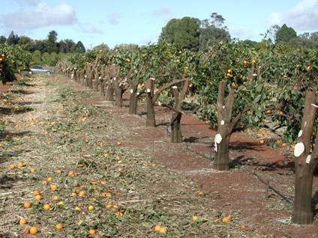
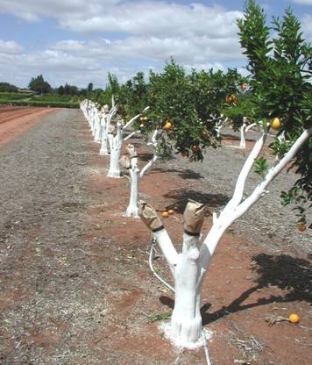
Figure 6. Trees pruned ready for white washing. Figure 7. Trees white washed ready for regrafting.

Reducing crop load

Flower manipulation
Flower suppression can be undertaken in predicted heavy crop years (‘on years’), using a registered gibberellic acid compound at the time of flower initiation in June–July. Refer to the product label, as well as the Fruit Size Management Guide Part 1 or your local horticultural advisor for directions on use and timing. The degree of thinning at the registered rate is about 20%, and varies depending on timing, rate, climatic conditions and tree health. Water stress can also induce a strong flowering in the following season, which might require thinning.

Pruning at flowering
Hand pruning can be undertaken before or during flowering, with an emphasis on removing weak and dead branches, crossover limbs and water shoots. Hedging can also be used during flowering to remove excess flowers, however, it is non-selective, so care should be taken on how much of the canopy is removed.

Chemical thinning
During early fruit growth (December; stage 1)
Chemical thinning using ethephon can be used when fruitlets are 10–15 mm in size on heavy crop loads. Chemical thinning has been shown to be cost effective in navel and Valencia oranges and Imperial and Murcott mandarins. However, the amount of fruit removed can vary depending on fruit load and application timing. Temperature and soil moisture levels are critical to success. Refer to the product label and the Fruit Size Management Guide Part 1 for more information. The degree of thinning at the registered rate is around 20% but varies depending on timing, rate, climatic conditions and tree health.
Reduced water during this stage will also lead to fruitlet drop, although in a much less controlled manner. Research at Loxton resulted in 65% reduction relative to an unstressed control (Skewes, 2013b). This will also result in a reduced crop load and could be considered instead of chemical thinning if total crop loss is desired rather than a controlled reduced crop load. This could be a more practical, effective and economical option than costly chemical application.

Hand or mechanical fruit thinning
During January–harvest
After the natural fruit drop has finished in December, a heavy crop load can be further reduced by hand thinning or light hedging. Hand thinning allows you to be selective and remove small, blemished or clustered fruit. Light hedging will remove fruit on the outside of the canopy, but is not selective and caution is required.

Other assistance
Contact your local horticulturist or irrigation agronomist for help in developing a water budget, or to discuss options for managing water shortages. The effects of drought place considerable pressure on you and your family. There are a range of professional counselling services available to provide advice on any issues you might have.
If you are experiencing financial difficulties, contact your local rural financial counsellor (www.rfcs.gov.au) and/or the Centrelink Drought Assistance Hotline: phone 132 316.

Sample water budget and plan
Table 3 is a sample water budget for a sprinkler-irrigated citrus orchard. The farm has 27 ha of orchard and an allocation of 350 ML. The orchard’s water allocation has been cut by 50% leaving 175 ML available.
Typical annual water use for each block and the amount needed for the remainder of the season (i.e. September to harvest) needs to be estimated from previous records. The proposed allocation for each block, as well as other management strategies to be implemented, must then be determined. In this example there is 11 ML remaining in surplus to allow for higher than expected water use (i.e. extended hot and/or dry periods).
Table 3. Sample of a water budget for a citrus orchard under 50% allocation. Note that this is an example and should be used as a guide only.
Variety and age | Area (ha) | Typical annual water use (ML) | Proposed water application (ML) | Management strategy
Washington 20 yr | 4 | 42 | 40 | Monitor soil moisture and eliminate deep drainage.
Ellendales 30 yr | 1 | 10.5 | 0 | Abandon, prepare for replanting.
Valencia 40 yr | 3.5 | 38 | 10 | Skeletonise and white wash.
Grapefruit 50 yr | 2 | 21 | 0 | Abandon, prepare for replanting.
Imperials 25 yr | 3.5 | 42 | 40 | Water saving practices. Monitor soil moisture and eliminate deep drainage.
Washington 40 yr | 8 | 88 | 40 | Heavily hedge eastern side of trees and white wash.
Lanes 20 yr | 3 | 30 | 28 | Monitor soil moisture and eliminate deep drainage.
Lanes 2 yr | 2 | 20 | 6 | Install manual valve to separate young Lanes from mature Lanes.
TOTAL | 27 | 291.5 | 164

NSW experience with drought and water reductions – Bourke district 2003 and 2007
Citrus growers using drip irrigation in the Bourke region of northwest New South Wales (NSW) experienced drought and severe water restrictions in 2003 and from 2006. This region normally experiences warmer climatic conditions than southern citrus growing districts, and generally uses higher levels of water. The long-term impact of combined water and salt stress on citrus trees is not documented in Australia.
Some specific examples of the experience and observations from Bourke include:
- Fifteen year old mandarin trees that had the eastern side of the tree removed were kept alive with 2.2 ML/ha applied from July 2002 to April 2003 (Figure 8). Any fruit remaining on the tree was unviable for marketing.
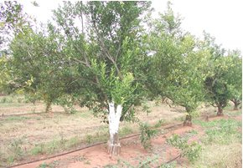
Figure 8. Fifteen-year-old Imperial mandarin trees showing regrowth on the eastern side of trees, which were previously heavily pruned.
- A reasonable crop of Leng navels was harvested from a block watered with 5.5 ML/ha (Figure 9).
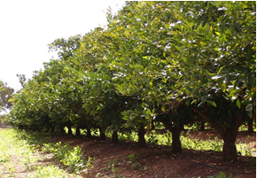
Figure 9. Leng navel trees maintained with 5.5 ML/ha of water.
- A block of seven-year-old navel orange trees received approximately 30% of normal application with 1,500–2,000 EC irrigation water during the summer of 2006–07. The trees were also moderately hedged to remove about 30% of the leaf canopy. As a consequence, trees and the adjacent Casuarina windbreak suffered heavy defoliation due to the combined effects of water and salt stress, some of these trees died (Figure 10). Significant fruit-drop occurred in late spring. However, a reasonable crop of good sized fruit remained but, due to the restricted water practices, the fruit was dry and unmarketable. The trees had a reasonable amount of foliage and health to maintain canopy function, but not to grow a viable crop.
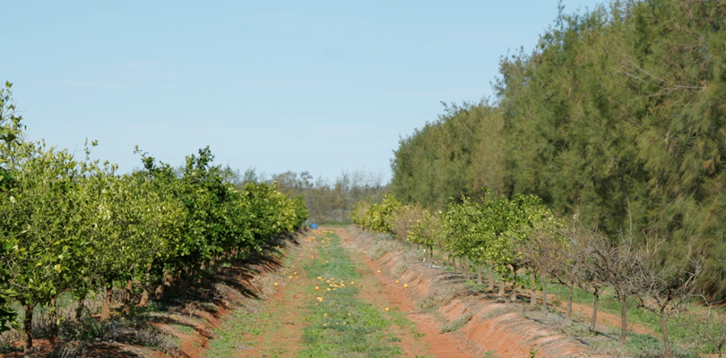
Figure 10. Young block of navels in June 2007 that recovered from 30% water application and salt stress in summer 2006–07.

Case studies

Col Nankivell, Mourquong NSW

Background
Col Nankivell grows 40 ha of citrus and avocados in Mourquong on the Murray River in NSW, 10 km from Mildura.
A 100% allocation was announced for NSW Murray high security entitlements at the start of the 2006–07 season. However, by November 2006, allocations had been suspended to approximately half following record low inflows. This had an enormous impact on NSW Murray irrigators who had developed and prepared their properties under the assumption that ample water would be made available in that season.
NSW Murray high security irrigators initially received zero allocation the following season (2007–08). Suspended water from the previous season was gradually returned to irrigators over the season. Critical water was also obtained for NSW high security licences in an attempt to keep permanent plantings alive but not necessarily produce a crop. This critical water represented approximately 50% of citrus water requirements. At the same time, water prices peaked at over $1,000/ML for the first half of the season (normally $100–$300) making water purchases on the open market uneconomic for many.

Four approaches
The approaches taken on this property involved hedging to various levels in order to reduce canopy size and therefore water requirements. The level of canopy reduction related to the perceived value of each variety at the time.
- A high value was placed on Washington navels. They were topped as usual (normally done every second year) down to 2.4 m, but the eastern side was cut back hard, almost to the point needed if top working, so that there were virtually no leaves on the eastern side. Water was wound back to about half. However, by Christmas enough water was available to water normally.
Recovery was surprisingly good. The first crop following hedging was of good quality and size, and a third to one half the yield of a typical crop. Heavy hedging created biennial bearing from one side to the other for a few years, but removed a lot of dead wood, which provided ongoing benefits.
- Less value was placed on Valencias and these were topped to 2.1 m. No side hedging occurred. In some ways this worked better as the fruiting structure for the following year was not destroyed. These cropped acceptably in the first year following topping and fruit size improved. Lanky regrowth was hard to handle and needed to be regularly pruned. Gradually the trees grew back to 2.4 m.
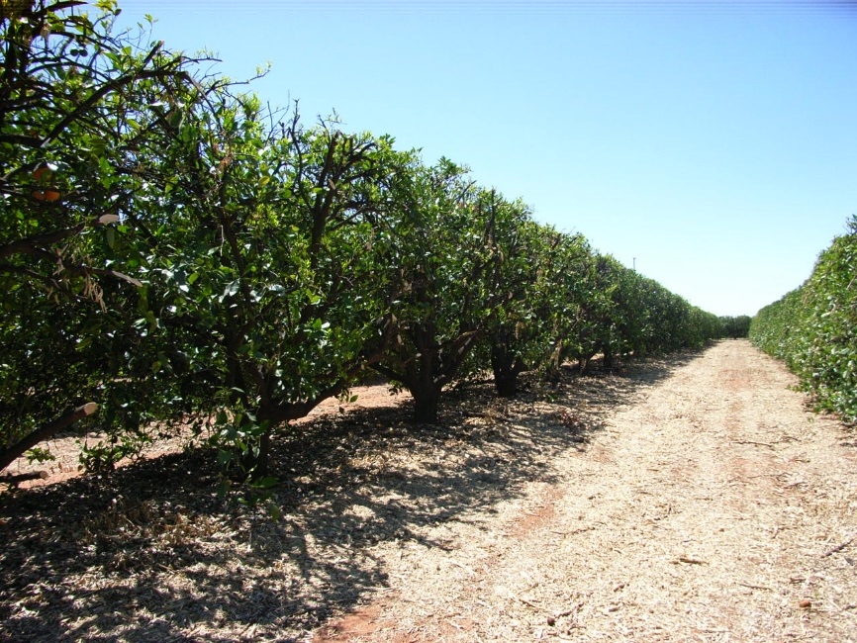
Figure 11. Heavily hedged Valencias at Mourquong showing regrowth in 2007.
- A neighbouring property was purchased that had been previously drought affected in the preceding two years. The trees were totally defoliated. Watering resumed in July and by spring the trees had satisfactory re-growth, so were hedged hard in September and October, followed by heavy chainsaw pruning. This rejuvenated the trees and the grower was extremely surprised at how well they re-grew (Leng navels on Citrange).
- The previous owner of the purchased property had also done some stumping (Figure 12). The stumps were not painted as well as they could have been and sunburn was a problem. Water had been turned off completely and, as a consequence, reshooting was impaired. Clearly some irrigation would have been beneficial. This resulted in trees regrowing with many sucker limbs that needed intensive pruning, and therefore took longer to re-grow. Trees have come back but need a lot of pruning attention.

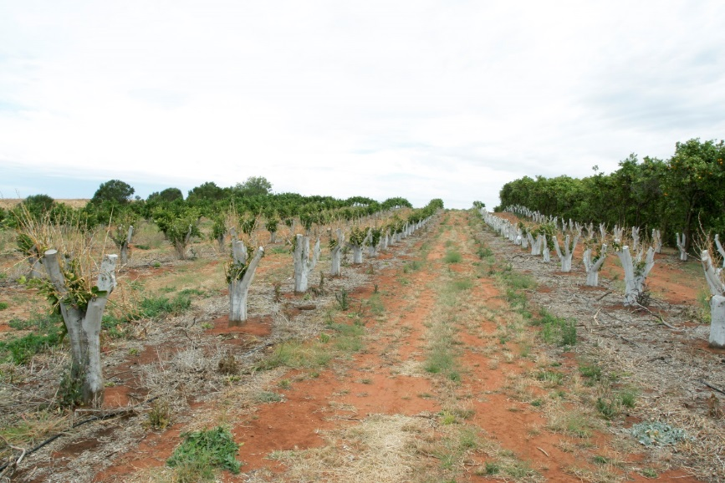
Figure 12. Stumped citrus at Mourquong in 2007.

Observations and comments by Colin Nankivell
- Create a hierarchy of crop value, i.e. Imperials, Washington navel, red grapefruit, late navel, Valencia and then grapefruit
- Work at preserving the highest value crops
- If needed, you can then be harsh (with cutting) on the lower value crops. We cut Valencias harder than others. If the predictions suggest only half the water will be available, we would hedge hard on crops like Valencias and grapefruit and apply severe water cuts, and treat valuable crops more generously
- Do not underestimate how well trees can come back.
- Follow up hedging with pruning as clustered growth occurred. I would hedge to 2.1 m again, but only if the forecast and predictions suggested a really dry year. Many other growers did nothing, used up their emergency water but then by Christmas things returned to normal and trees looked okay. Meanwhile we used up significant resources reducing the canopy.’
- Water more at critical stages early in the season to keep options open in case the water situation improves. I would then apply water a little more in December–January and then be more restricted in autumn.
- I would not rush any decisions.
- I would hedge and box again to create water savings as we found long-term benefits to the trees by doing this.’
- Consider removal of unthrifty patches of trees.

Robert and Ken Mansell, Nangiloc Vic

Background
Robert and Ken Mansell grow 130 ha of citrus and avocadoes in Colignan on the Murray River in Victoria, 40 km from Mildura.
Unlike NSW irrigators, Victorian irrigators experienced an unaffected seasonal allocation for 2006–07 (95% allocation received). Then in the following season (2007–08) the market price of water reached more than $1,000 /ML in the first half of the season, as irrigators responded to a seasonal outlook of very low allocation being made to entitlements. While some held carryover from the previous season, it was seen as insufficient to maintain crops.
The market price of water reduced significantly later in the season as other states increased allocation. Demand for water reduced as large horticultural operators had already purchased sufficient water to preserve their crops. Hence, buying pressure dropped away from the market.
The initial allocation at the start of the 2007–08 season was 0%, and 23% by 15 November. Increases throughout the season resulted in a total allocation of 43% by the end of the season. In the following season (2008–09), a total allocation of 35% was eventually received, with 100% returning from 2009–10 onwards.

Four approaches
- Washington navel trees (Figure 13) were skeletonised and had no water applied. The success of this was dependent on rootstock. Some trees on Sweet orange were lost. We could have skeletonised too hard. Some extra limbs could have been retained. The western side of the trees became a little burnt as paint was not applied quickly enough following cutting.
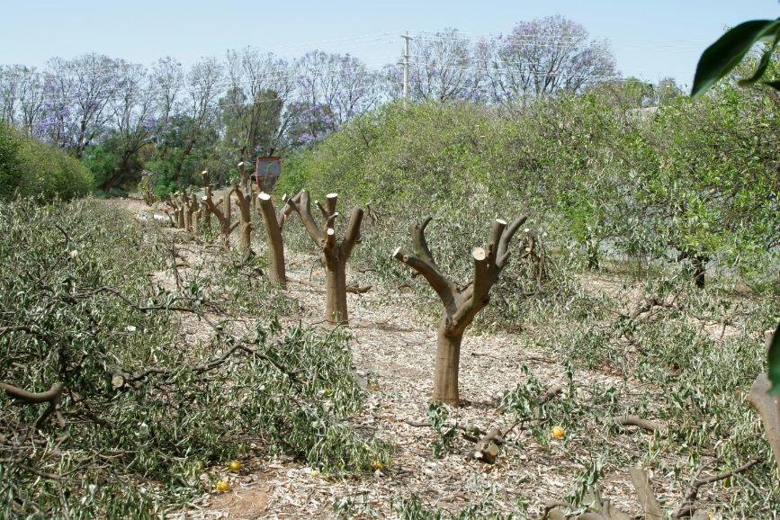
Figure 13. Skeletonised trees at Nangiloc in 2008.
- Valencia trees were boxed to 2.4 m high and 1.8 m wide. Prunings were mulched immediately. These trees are now more manageable which is a long-term benefit. They were previously large and constantly water stressed, but are now smaller and their water requirements are able to be met every 8–9 days.
- Previously top-worked grapefruit had the water turned off and left like this for three years. When water became available they were pretty sick and were top-worked again and reverted to Valencias, which produced a crop in two years.
- A patch of lemons and Late Lane navels were turned off and left unpruned. They were provided 5% of their water requirements by irrigating for approximately four hours using overhead sprinklers immediately following any rain during the season. This resulted in 3–4 irrigations only. Lemons were weakened by the drought and suffered Elephant Weevil damage, which is an ongoing problem along with limb breakage.

Observations and comments by Robert and Ken Mansell
- Some rootstocks are better than others at handling stress.
- After a couple of years must follow up with pruning, one side each year. Two years later you have a revitalised tree.
- Prepare to paint early after cutting.

Further information
Kriedemann, P.E., Barrs, H.D., 1981. Citrus Orchards, in: Kozlowski, T.T. (Ed.), Water deficits and plant growth. Academic Press Inc, New York, pp. 325–417
Primefact 1359 Tensiometer tips
Primefact 1365 Using capacitance probes for irrigation scheduling
Primefact 1364 Checking above canopy sprinkler performance
Primefact 1456 Converting mature citrus from full cover to drip irrigation
Skewes, M.A., 2013a. Citrus Drought Information Package, Factsheet. PIRSA, Adelaide, p. 8.
Skewes, M.A., 2013b. HAL Project Number CT08014 – Citrus drought survival and recovery trial – Final report. South Australian Research and Development Institute, p. 59.
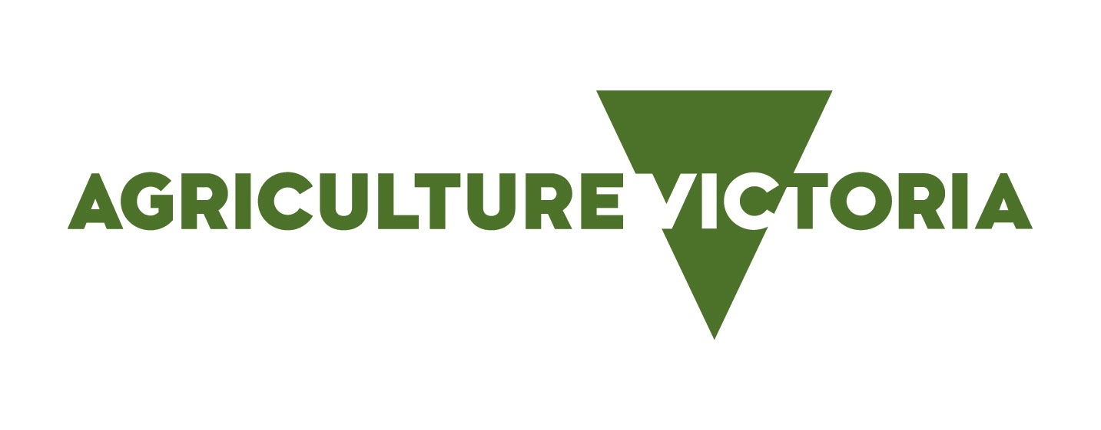
Acknowledgments
Col Nankivell, citrus grower, Mourquong NSW
Ken and Robert Mansell, citrus growers, Nangiloc Vic
Back of Bourke Farms, citrus growers, Bourke NSW

Sandra Hardy, formerly NSW DPI
Graeme Sanderson, Research Horticulturalist, NSW DPI Dareton

CM9 - INT18/111750
© State of New South Wales through the Department of Industry, 2018. You may copy, distribute and otherwise freely deal with this publication for any purpose, provided that you attribute the NSW Department of Primary Industries as the owner.
Disclaimer: The information contained in this publication is based on knowledge and understanding at the time of writing (August 2018). However, because of advances in knowledge, users are reminded of the need to ensure that information upon which they rely is up to date and to check currency of the information with the appropriate officer of the Department of Primary Industries or the user’s independent adviser.

