

2025 Animal Use Return
Submission Guideline

Contents

Submission of annual animal use return documents 2
Components of an annual return 2
Preparing and submitting the return 3
Queries and obtaining forms 3
Guidance for completing the Animal Use Spreadsheet 4
Reporting animal use 4
Inclusions and exclusions in reporting 4
Animal developmental stage 4
Specified animals 4
Animals assigned to a project 4
Animals reported in a previous year 5
Animal use outside of Victoria 5
Collaborative projects 5
Animal breeding colonies 5
Data entry 5
Grouping of animals for data entry 6
Category descriptions and examples 6
Appendix 1 - Examples of completed Animal Use Spreadsheet 15
Example 1: Other scientific procedures projects 15
Example 2: Animal use in breeding projects with offspring assigned to research projects involving scientific procedures 16
Appendix 2 - Examples of animal use requiring reporting 18

Submission of annual animal use return documents
The annual animal use return must be submitted on or before 31 March 2026 for all scientific procedures premises licences (SPPL), scientific procedures fieldwork licences (SPFL), and specified animals breeding licences (SABL). This applies to all licences held for any period during 2025, regardless of whether animals were used or not.
Failing to submit this return by the deadline is an offence under Regulation 145(1) of the Prevention of Cruelty to Animals Regulations 2019 (POCTA Regulations). Penalties may apply for failing to submit an annual return by the due date or providing false or misleading information.
Please read this guideline before submission of annual returns.
The licence holder is responsible for the accuracy of information. Animal Welfare Victoria (AWV) is not obliged to undertake an accuracy check prior to accepting the submission as final.
The information provided in this document is provided for guidance in completing the return. AWV does not intend this to be a substitute for an understanding of all applicable legislative requirements.

Components of an annual return
The licence holder is responsible for submitting a complete and accurate animal use return, which may consist of up to three parts.

Statement and Declaration (previously referred to as Part B) — a summary of animal use under the licence and declaration by the licence holder
- The Statement and Declaration is a word document that must be submitted for every licence held at any time during 2025 even if there was no animal use under the licence in 2025.
- There are changes to this document for 2025. Please read this guideline and review the required information before commencing this part.
Animal Use Spreadsheet (previously referred to as Part A) — an excel spreadsheet; details of animals assigned to or used in projects, including animals within breeding colonies
- Page 5 onwards provides instruction on completing the Animal Use Spreadsheet.
- Complete only if animals were used under the licence in 2025, including animals kept in a breeding colony.
- Where there are multiple Animal Ethics Committees (AECs) nominated under one licence, a separate Animal Use Spreadsheet may be completed for each AEC nominated, in this case add an abbreviation of the AEC name to the file name of the Animal Use Spreadsheet submission, e.g., SPPL12345 Z1ResearchLab_Animal Use_AEC XYZ.
Death as an Endpoint project form (previously referred to as Part C) — is a word document, that reports on death as an endpoint scientific procedures
- A death as an endpoint scientific procedure is where the death is a deliberate measure in the procedure and where there will be no intervention to kill the animal humanely before death.
- These procedures are approved by the Minister for Agriculture.
- The Death as an Endpoint project form must be submitted if there was an approved death as an endpoint scientific project under the licence during 2025, even if no procedures were conducted.
- Note: A separate form is required for each project involving death as an endpoint.

Preparing and submitting the return
- Read this guideline to familiarise yourself with reporting requirements for 2025. The licence holder is responsible for ensuring information provided is correct.
- Complete only the relevant parts of the submission.
- Check the information for accuracy, ensuring all information provided in the Statement and Declaration is consistent with details as they appear on the licence.
- Check the Statement and Declaration and Death as an Endpoint form (if applicable) have been signed.
  - The Statement and Declaration must be signed by person/s with authority to sign on behalf of the licence holder.
  - The Death as an Endpoint form (where applicable) must be signed by the Project’s principal investigator.
- Name each part of the submission with the licence name and number, see above for naming conventions if multiple AECs are nominated on the licence, e.g., SPPL12345 Z1ResearchLab_Declaration
- Email the Statement and Declaration and if applicable, the Animal Use Spreadsheet and Death as an Endpoint form within one email to: sp.licensing@agriculture.vic.gov.au using the subject line naming convention: Licence number – Licence Name – 2025 Animal Use Returns.

Note: The licence nominee/s must be copied into the submission email if sent by another person.

Queries and obtaining forms
Queries regarding the animal use return should be directed to:
Scientific and Pest Animals Licensing
Animal Welfare Victoria
sp.licensing@agriculture.vic.gov.au
These guidelines and 2025 Animal Use forms may be obtained from the forms page at www.agriculture.vic.gov.au/ART

Guidance for completing the Animal Use Spreadsheet

Reporting animal use

Inclusions and exclusions in reporting
All animals used during 2025 under a licence issued under the Prevention of Cruelty to Animals Act 1986 (POCTA Act) must be reported using the Animal Use Spreadsheet.
Report only animals alive at the time of allocation to a project. Use of carcasses or tissue in a project acquired after an animal’s death is not to be reported.

AEC approved projects that did not have any animals assigned or used during 2025 should not be reported in the Animal Use Spreadsheet but must be reported in the Statement and Declaration.

Only activities covered under Part 3 of the POCTA Act are to be reported. Do not report animal use that did not involve scientific procedures or breeding of animals primarily for use in scientific procedures (see Appendix 2). Information on exempt activities.

Animal developmental stage
For the purpose of Part 3 of the POCTA Act, the following stages of development apply:
- reptiles, birds, and mammals are considered animals at or after the half-way point of gestation or incubation;
- fishes and amphibians are considered animals when they are capable of self-feeding (e.g., for zebrafish this is 7 days); and
- decapod crustaceans and cephalopods are considered animals when adult.
All animals used under the licence at or beyond the specified developmental stage must be reported.
If counting neonates risks a negative impact to animal welfare, it is acceptable to delay active monitoring until the earliest appropriate time point. For example, for mice, week one may be appropriate. This arrangement must be justified and approved by the AEC. All animals identified at the AEC approved monitoring timepoint, living and dead, must be counted and recorded under the relevant AEC approval and reported within the annual animal use return.

Specified animals
As defined in section 25 of the POCTA Act specified animals are a guinea pig; rat, mouse or rabbit other than a rat, mouse or rabbit bred in the wild; and non-human primates.
There are prescribed requirements for reporting specified animals. Where specified animals have been used or bred under the licence ensure the correct option is selected. For reporting in the animal use spreadsheet, all options relating to specified animals have been marked with an asterisk (*).

Animals assigned to a project
All animals assigned to or used under a project for any period in 2025 must be reported in that project.
This may result in an animal being reported more than once if it is assigned to more than one project. This ‘reuse’ of animals in scientific procedures requires specific AEC approval. There are two exceptions to the requirement for reporting animals used in or assigned to more than one project under both projects:
- Where animals were assigned and identified as not suitable, did not undergo any scientific procedures and were immediately returned to the source. Do not report these animals under the project to which they were assigned.
- Animals in breeding colonies. This is to prevent ‘double reporting’. See also relevant sections of this guide: Animal breeding colonies, column C and Appendix 1 - Examples of completed Animal Use Spreadsheet.

Animals reported in a previous year
An animal must be reported each year that it is used within a project, regardless of any reporting in previous years.

Animal use outside of Victoria
Only animals used in Victoria or Victorian waters are to be reported.

Collaborative projects
To prevent duplication of reporting, report only for the licence under which the AEC approved the animal use.

Animal breeding colonies
Specified animals and other species kept in breeding colonies for the primary purpose of use in scientific procedures under the licence must be reported under the relevant AEC breeding approval, excluding progeny assigned to another project. These animals are reported under the project and licence that uses them (see Animal Use Spreadsheet and Appendix 1 - Examples of completed Animal Use Spreadsheet).
The number of animals to be reported for a breeding colony is the sum of:
- animals present at the start of the year; and
- animals acquired; and
- animals born, including neonates humanely killed or found dead
minus live animals assigned to AEC-approved projects.
Note that animals assigned and returned unused must be reported under the relevant breeding project.

Data entry
An Excel worksheet, titled Animal Use Spreadsheet, is provided to complete the animal use part of the return. Where response input is limited, there are drop-down selections that must be used.
Work from left to right in each row of the spreadsheet, as the responses provided in each column determine which options will show in columns to the right. If you need to alter your response for an earlier field, redo the whole row.
Pasting of entries is not permitted. Spreadsheets with incorrect entries or missing prescribed information will not be accepted.

Grouping of animals for data entry
Animals used in scientific procedures are to be reported in groups. A separate line is to be used to describe each group within an approved project.
Breeding colony animals are to be reported in groups by:
- Animal type;
- Animal source;
- Whether the animals are non-genetically modified or are involved in breeding established genetically modified (GM) lines; and
- Fate

All other animals used are to be reported in groups by:
- Animal type;
- Animal source;
- Impact of the procedures on animals within a project. (For example, within a project there may be more than one group of animals that undergo different procedures, and / or animals that have been assigned to the project but are yet to undergo procedures. Report each group based on impact of the procedure(s) as a separate row); and
- Fate

Category descriptions and examples
The following is a description of the entries for each column in the Animal Use Spreadsheet. Note: columns A-J and N-O are mandatory.
Refer to Appendix 1 - Examples of completed Animal Use Spreadsheet.

Year
Enter the reporting period year in four-figure format (2025) by using the drop-down box.

Licence number
Enter the five-digit licence number. Omit the four-letter prefix. For example, for licence SPPL20134 only 20134 should be entered. Only one licence is to be reported per spreadsheet.
Please note, many licence numbers changed in 2017. The previous number must not be used.

Type of use
There are four drop-down options relating to the primary type of animal use:
- Breeding – animals held for breeding or produced for use in scientific procedures.
- Creation of new lines of GM animals – creating and breeding novel animal lines of GM animals.
- Teaching – where animal use is not designed to acquire new knowledge but rather pass on established knowledge or training to others. This includes interactive classes in methods of animal husbandry, management, examination, and treatment. Examples include animals used by veterinary schools to teach examination procedures such as pregnancy diagnosis, and animals used to teach animal care to TAFE students.
- Other scientific procedures - where animal use does not fit the categories of either breeding or teaching, other scientific procedures should be selected.

The option selected for type of use will determine available options for spreadsheet fields to the right of Type of use.

AEC identification code
This is the reference code applied by the AEC to their approval of animal use.
Breeding colony projects must be approved by the AEC.

AEC approval date
The date the AEC approved the project must be written in the format: dd/mm/yyyy, e.g. 12/11/2024.
This is required for all groups, including specified and non-specified animal breeding colonies. Where two projects authorised activities in breeding colonies (due to expiry and approval of a new project) provide the date of approval of the most recent project.

Type of animal in group
Choose the category that most closely aligns to the animals used. In the spreadsheet, the specified animal types are listed first, followed by non-specified animal types, in alphabetical order. To assist with identifying suitable animal type, the available options have been grouped into the below categories. Specified animals are marked with an asterisk (*).

Specified animals
- *Baboons
- *Guinea pig (lab)
- *Macaques
- *Marmosets
- *Mouse (lab)
- *Primates other
- *Rabbit (lab)
- *Rat (lab)

Amphibia
- Amphibians

Aquatic
- Cephalopods
- Crustaceans
- Fish

Birds
- Bird exotic captive
- Bird exotic wild
- Bird native captive
- Bird native wild
- Bird other
- Embryonated avian eggs
- Poultry

Domestic mammal
- Cats (non-wild)
- Cattle (domestic)
- Deer (domestic)
- Dogs (non-wild)
- Goats (domestic)
- Horses (domestic)
- Pigs (domestic)
- Sheep (domestic)
- Other domestic mammals

Exotic feral mammal
- Cats (wild)
- Cattle (wild)
- Camels (wild)
- Dogs, foxes (wild)
- Exotic feral mammal other
- Goats (wild)
- Hares (wild)
- Horses (wild)
- Mice (wild)
- Pigs (wild)
- Rabbits (wild)
- Rats (wild)

Native mammal
- Dasyurids
- Koalas
- Macropods
- Monotremes
- Native mammal other
- Native Rats, Mice
- Possums, Gliders
- Seals, Sealions
- Whales, Dolphins
- Wombats

Zoo
- Exotic Zoo mammal

Other laboratory animals (non-specified)
- Ferret (lab)
- Laboratory mammal (non-specified)

Reptiles
- Lizards
- Snakes
- Reptile other
- Tortoises/turtle

Source of animals in the group
Select the option that most accurately describes the source of the animals within the group.

Specified animals
For *specified animals (guinea pig; non-wild bred mouse, rat and rabbit; non-human primate) a source marked with an asterisk must be selected from the following within the drop-down list in the spreadsheet:
- *Interstate institution authorised to distribute specified animals
- *Victoria – Specified Animals Breeding Licence
- *Imported from overseas
- *Own derivation (note, this refers to circumstances where animals have been bred by the licence holder)
- *Other

All other animals
For non-specified animals, a non-asterisk source must be selected from the following within the drop-down list in the spreadsheet:
- Own derivation (note, this refers to circumstances where animals have been bred by the licence holder)
- Commercial supplier
- Private donation
- Municipal pound
- Private companion animals
- Privately owned animals remaining on farm
- Animals used in their natural habitat
- Removed from Australian natural habitat
- Australian captive colony/zoo
- Other source

Project purpose or animal breeding colony group
Because this option applies to the project as a whole, it must be identical for all groups that are part of the same project. The options available to select are based on what has been selected in Type of use (column C) but all options are listed below for information.

Breeding
Select either *specified or non-specified animal breeding colony group as appropriate.

Creation of new lines of GM animals
Select the option that describes the primary purpose of the project for which a new line of GM animals is being produced.

Teaching
If teaching has been selected for Type of use (column C) the only available option for project purpose is educational objectives.

Other scientific procedures
Select the option that describes the primary purpose of the project as a whole.
- Understand human/animal biology
  - projects that aim to increase the basic understanding of the structure, function and behaviour of animals, including humans, and processes involved in physiology, biochemistry, and pathology.
- Maintenance/improvement of human/animal health/welfare
  - projects that aim to produce improvements in the health and welfare of animals, including humans.
  - Examples:
    - use of a sheep flock to donate blood to produce microbiological media
    - production of commercial anti-serum, antivenom.
- Improve animal management/production
  - projects that aim to produce improvements in domestic or captive animal management or production.
- Educational objectives
  - project purpose is not to acquire new knowledge but rather to pass on established knowledge or training to others. This includes interactive classes in methods of animal husbandry, management, examination, and treatment.
  - Examples:
    - animals used by veterinary schools to teach examination procedures such as pregnancy diagnosis
    - animals used to teach animal care to TAFE students.
- Environmental objectives:
  - projects that aim to increase the understanding of the animals’ environment, animals within a natural environment, or investigate management techniques for wild or feral populations.
  - Example:
    - studies to determine population levels and diversity that may involve techniques such as radio tracking.

Project benefit or animal breeding colony group
Because this option applies to the project as a whole, it must be identical for all groups that are part of the same project. The options available to select are based on what has been selected in Type of use (column C) but all options are listed below for information.

Breeding
Select either *specified or non-specified animal breeding colony as appropriate.

Teaching
Select either Education (demonstration) or Teaching (student use of animals).

Creation of new lines of GM animals or Other scientific procedures
Select the option that describes the primary benefit of the project as a whole.
Options available
Fundamental biology/physiology
Diseases – human
Diseases – animal
Diseases – zoonotic
Environmental monitoring/ecology
Domestic animal management/production
Wildlife management/conservation
Vertebrate pest management
Production of biological products
Development of techniques
Regulatory product testing

Impact of activities on project group or genetically modified (GM) status of animal breeding colony group
The options available to select are based on what has been selected in Type of use (column C) but all options are listed below for information.

Breeding
There are two available options each for specified animals, and non-specified animals.
- *Specified animal breeding colony group (non-GM): routinely bred specified animals with no genetic modification
- *Specified animal breeding colony group established GM line: specified animals that have undergone genetic modification (or are from lines of animals resulting from genetic modification)
- Non-specified animal breeding colony group: applies to non-specified animals held or produced primarily for use in scientific procedures
- Non-specified animal breeding colony group established GM line: animals that have undergone genetic modification (or are from lines of animals resulting from genetic modification)

Creation of new lines of GM animals, Teaching and Other scientific procedures
Select the option reflecting the activity with the highest impact on the welfare of the animals in the group for the reporting year. For animals that died or were euthanased prior to reaching the conclusion of the project, select the option representing the highest impact activity that the animal actually experienced.
- Observational study involving minor interference:
  - The normal activities of animals are minimally impacted on.
  - Examples:
    - laboratory animals in cages
    - feeding trial, such as digestible energy determination of feed in a balanced diet
    - behavioural or growth study with minor environmental manipulation
    - teaching of normal, non-invasive husbandry such as handling, grooming, etc.
- Animal unconscious without recovery
  - Animals are humanely rendered unconscious under controlled circumstances (i.e. not in a field situation) with as little pain or distress as possible. Capture methods are not required. Any pain is minor and brief and does not require analgesia. Procedures are carried out on the unconscious animal that is then humanely killed without regaining consciousness.
  - Examples:
    - animals (including fish) in a laboratory killed humanely for dissection, biochemical analysis, etc.
    - teaching surgical techniques on live, anaesthetised patients that are not allowed to recover following the procedure.

- Minor conscious intervention, no anaesthesia
  - Animals are subjected to minor procedures that do not normally require anaesthesia. Any pain is minor and analgesia is usually unnecessary, although some distress may occur as a result of trapping or handling.
  - Examples:
    - capture and release (with or without tagging - see page 3 for exempt activities) of animals (including fish) in the wild. Excludes electrofishing, refer to Minor Physiological Challenge below.
    - trapping and humane euthanasia for collection of specimens
    - ear notching for DNA sampling of a new line of GM animals
    - injections, blood sampling in conscious animals
    - minor dietary or environmental deprivation or manipulation, such as feeding nutrient-deficient diets for short periods
    - stomach tubing, shearing.
- Minor operative procedures with recovery
  - Animals are anaesthetised for a minor procedure. Animals recover, although may later be humanely killed. Depending on the procedure, pain may be minor or moderate and post-operative analgesia may be appropriate.
  - Examples:
    - biopsies or blood sampling under anaesthesia or sedation
    - cannulations under anaesthesia or sedation
    - sedation/anaesthesia for relocation, examination or injections/blood sampling
    - field capture using chemical restraint methods.
- Minor physiological challenge
  - Studies in which there is interference with the animals’ physiological or psychological processes. The challenge may cause mild or short-term pain/distress, or any pain/distress is quickly and effectively alleviated.
  - Examples:
    - electrofishing
    - minor infection, minor or moderate phenotypic modification, early oncogenesis
    - arthritis studies with pain alleviation
    - prolonged deficient diets, induction of metabolic disease
    - polyclonal antibody production
    - antiserum production.
- Surgery with recovery
  - Animals are anaesthetised for a major procedure such as abdominal or orthopaedic surgery following which the animal is allowed to recover. Post-operative pain should be managed with analgesia.
  - Examples
    - orthopaedic surgery
    - abdominal or thoracic surgery
    - transplant surgery
    - surgery under anaesthesia for implantation of telemetry devices.
- Moderate to major physiological challenge
  - Studies in which there is interference with the animals’ physiological or psychological processes. The challenge causes a moderate or longer lasting pain/distress that may not be alleviated due to the nature of the experimental question.
  - Examples
    - major infection, major phenotypic modification, oncogenesis without pain alleviation
    - arthritis studies with no pain alleviation, uncontrolled metabolic disease
    - isolation or environmental deprivation for extended periods.
- Death as an endpoint
  - Death as an endpoint procedures must be approved by the Minister for Agriculture
  - See definition on page 2 of this guideline. Do not use this classification to report animals humanely killed or that die prior to the planned completion of a project.
  - Where an animal is subjected to scientific procedures where death is the endpoint, this option must always be chosen even when other procedures have been undertaken prior to death.
  - Examples
    - efficacy of antivenom
    - development of pest control agents
    - studies of acutely fatal conditions.

Fate of animals in group - optional
Select from the list of options to best describe what happened to the animals as part of or following their use in the project.
- Still participating in project at 31 December
- Death as an endpoint
- Euthanased during project
- Euthanased at completion of project
- Reused in another project
- Kept in stock
- Returned to source
- Rehomed – explanation required
- Other – explanation required

Commentary relating to fate and rehoming, if required - optional
A response is required in this column if the fate of animals in group was rehomed or other. If rehomed, describe the method of rehoming (e.g. privately, or through a particular rehoming organisation). If other, describe the fate of the animals in the group.

Particular procedure applied – optional
Free text entry is permitted to briefly describe procedure undertaken on animals.

Number of animals in group in 2025
Include only animals that are used under the licence. This may be less than the total number of animals approved by the AEC for the project.
Enter the total number of animals in the group during 2025. Where a precise measure of the numbers is impractical, such as for very large groups of animals (e.g. fish schools) or for non-captive animals, an estimate is satisfactory.
For breeding groups, this is the sum of:
- animals at the start of the year;
- animals acquired; and
- animals born,
minus live animals assigned to other projects.

Number of deaths in the group in 2025
Enter the number of animals in the group that died during the reporting period. This includes animals that are humanely killed, death as an endpoint, or death by other causes (including unexpected event).
To calculate the number of deaths in a breeding colony, subtract the number of animals alive at the end of the year from the total number of animals reported for the colony.
Where the options “animal unconscious without recovery” or “death as an endpoint” are chosen for impact (column J), the number reported in columns N and O must be the same. If animals are alive at the end of the calendar year for the same project these must be described as a separate group in a new line.
The number of animal deaths within a group may never exceed that used or held. Therefore, the number in column O may never be more than that in column N.

Appendix 1 - Examples of completed Animal Use Spreadsheet
Several examples are provided to demonstrate how the animal use is to be reported. The inclusion of ‘group numbers’ are illustrative only and should not be included in the submitted worksheet.

Example 1: Other scientific procedures projects
In 2023, under licence SPPL20999, mice and rats (*specified animals) and fish were used in Projects 00061 and 00046.
Project 00061 was assigned rats and mice, with similar procedures on all the animals. As such, the project was broken down into 2 groups, one for the mice and one for the rats. However, 10 rats were assigned to but did not undergo procedures in 2023. A third line was used to describe these animals with zero in deaths (column O) as these rats were alive as at December 2023 (Group 3).
Project 00046 was assigned laboratory mice and fish, forming 2 initial groups, 19 fish were humanely killed and 5 recovered from minor operative procedures. To describe this variability the fish group was further split into 2, and ultimately the project was described in 3 groups (lines). Zero was entered under number of deaths (column O) for Group 2, to indicate that no animals died or were killed in this group.
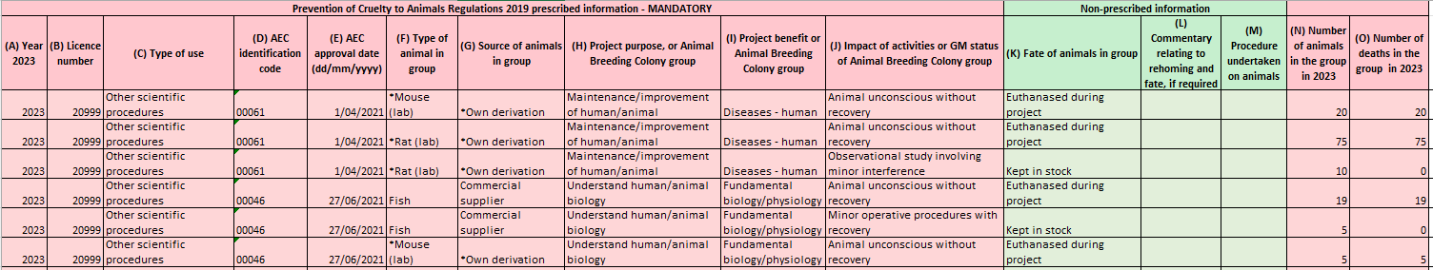
Example 1 Animal Use Spreadsheet

Example 2: Animal use in breeding projects with offspring assigned to research projects involving scientific procedures
This example demonstrates animal use and reporting of two breeding colonies; mice (*specified animal) and cats (non-specified animal) and subsequent allocation of animals for use in AEC approved projects (non-breeding).
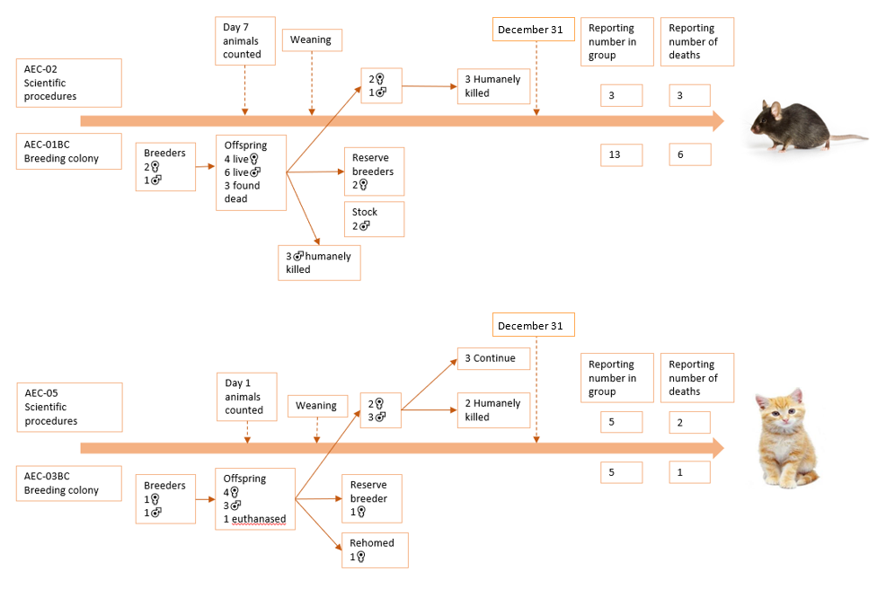
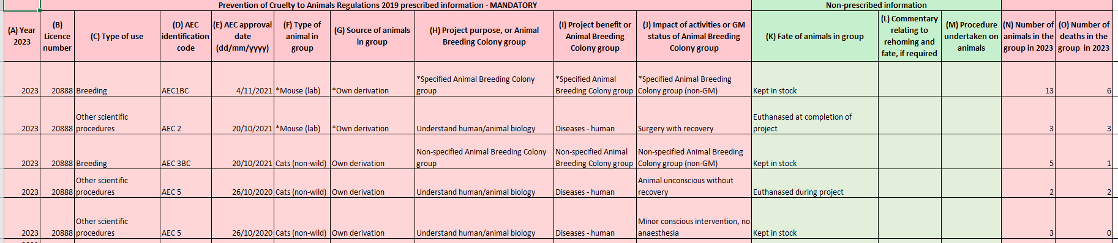

Example 2 - Animal Use Spreadsheet

Appendix 2 - Examples of animal use requiring reporting
The following examples are provided for guidance in reporting to AWV via the annual return. This list is not exhaustive.
Example | Which animals should be reported to AWV in the annual return?
A herd of breeding cattle is co-located on a farm that is also used to keep animals allocated to research projects involving scientific procedures. There are no activities undertaken on the breeding herd specifically related to the use of offspring in scientific procedures. Some offspring are assigned to projects at weaning while others are maintained within the herd for meat production. | Animals assigned to research projects
A flock of breeding sheep is co-located on a farm that is also used to keep animals allocated to research projects involving scientific procedures. Reproductive technology is used at various time points to provide pregnant sheep at a known point of foetal development to projects. Depending on demand, some pregnant sheep are assigned to projects while others are maintained within the breeding flock for production of meat. | Animals used for breeding  Animals assigned to research projects
A group of breeding pigs is located on a farm solely for supply of piglets for organ collection under an AEC-approved research project. | Animals in the breeding group (breeders and offspring)  Animals assigned to research projects
A group of breeding cats is kept for supply of cats and kittens for use under an AEC-approved research project. | Animals in the breeding group (breeders and offspring)  Animals assigned to research projects
A supplier produces fertile chicken eggs for supply to poultry farms to produce meat and for use in scientific procedures at day 11 of gestation (half gestation for a chicken is day 10.5). | Eggs assigned to projects for use in scientific procedures on or after day 10.5 of incubation
Multiple strains of genetically modified zebrafish are maintained in an aquatic facility to produce zebrafish larvae. Some of the female breeding zebrafish undergo ‘milking’ to collect eggs and some adult fish undergo tail fin biopsy for DNA testing. Some larvae are anaesthetised and immersed in various substances prior to humane killing at day four of embryological development, others at day nine. | Fish in the breeding group (breeders and offspring post day 7)  Fish assigned to research project and used in scientific procedures after day 7 of development
A pregnant mammal, kept for the primary purpose of supplying animals for use in scientific procedures, is killed at a time point past half-gestation. | Pregnant female and all foetuses identified at the time of death of the female.
A rabbit is kept for the primary purpose of supplying animals for use in scientific procedures. She delivers six offspring, four live and two dead. Prior to weaning, one of the offspring is humanely killed as it is not required, the remaining three are retained as stock. | Seven rabbits – that being the female and six offspring (those found dead, those killed prior to weaning and those retained as ‘stock’)

