

Taskforce on Rehoming Pets
Final report to the Victorian Government
December 2021
Official

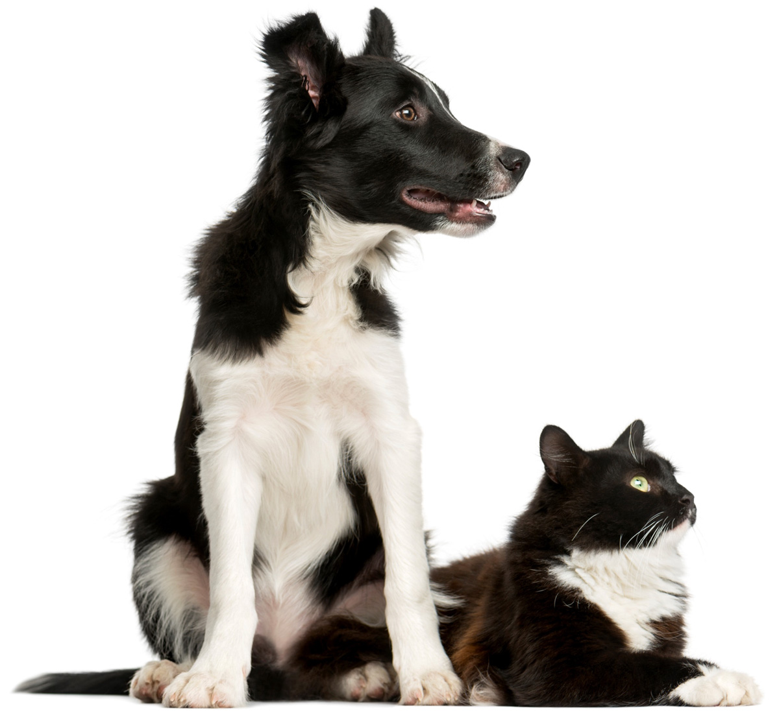

Contents
1. Glossary 5
2. Executive summary & recommendations 6
3. Background 10
4. Consultation activities 10
4.1. Community consultation survey 11
4.2. Site visits 11
4.3. Community engagement sessions 13
4.4. Written submissions 13
4.5. Meetings with sector and industry representatives 14
5. Findings and Recommendations 15
5.1. How to improve the welfare and survival rates of cats and dogs requiring rehoming while maintaining community safety 16
5.1.2. Findings 16
5.2. A regulatory framework for the rehoming of pets in Victoria 18
5.2.2. Findings 18
5.3. How to improve transparency in the movement of animals between shelters, pounds, CFCNs and rescue groups 21
5.3.2. Findings 21
5.4. How to improve information and advice for scientific organisations and AECs to support the successful rehoming of dogs and cats used in research and teaching 22
5.4.2. Findings 22
5.5. How to further develop and implement the successful rehoming of dogs and cats used in research and teaching 23
5.5.2. Findings 23
6. Out of scope topics raised 24
7. Appendices 26

Foreword
This Taskforce on Rehoming Pets was convened specifically to investigate and provide recommendations, in the form of a report to the Government, on how to improve pet welfare - in particular improving pet rehoming pathways and survival rates.
The Taskforce has considered what systems can be implemented for successful rehoming of cats and dogs with known medical circumstances or behavioural traits such as anxiety, how to improve the transparency in the movement of animals between shelters, pounds, community foster care networks and rescue groups and how to establish a regulatory framework for rescue groups to further professionalise the service. Importantly, the Taskforce also considered rehoming opportunities for animals used in medical research and teaching.
It has been a great honour to be the Chair of the Taskforce on Rehoming Pets, working alongside my parliamentary colleagues, Gary Maas MP and Maree Edwards MP. They were asked to become part of a Taskforce with people they had not previously worked with, and in a sector that they might not have had a deep understanding of. Their commitment, their natural inquiring nature, and their inbuilt desire to do good in the community has seen them ask all the right questions, and bring an important insight to the process. I must also make mention of the Government’s willingness to acknowledge that they need a strong partnership with the sector to understand the issues.
As an MP with a specific interest in animal welfare and protection, I am keenly aware of how important these issues are to the animal rescue and care community. This final report is something we should all be very proud of.
With the assistance of the Secretariat, we established an exceptionally high-functioning, collegial and effective Taskforce.
The consultation process was thorough, with all members impressed by the sheer amount of feedback and submissions received. The Taskforce was warmly welcomed on many site visits and roundtables, where we saw the passion and enthusiasm of this dedicated workforce - largely made up of volunteers. The survey responses were in the thousands, demonstrating the love Victorians have for our companion animals - and the support behind implementing processes and regulation to make their lives better.
The recommendations in this report are bold and, in some cases, landmark. This report gives Victoria the opportunity to be a leader in pet welfare, and to build a system that other states should aspire to follow.
I want to thank all participants from the sector and the broader community, whose input throughout the process has formed the findings and recommendations of this report. It is notable that this report contains not only recommendations that were directly related to our terms of reference, but with the Minister’s feedback, also covers a number of issues that were out of scope, but deemed essential to recognise and comment on.
I want to thank the Minister for Agriculture, Mary-Anne Thomas, for establishing the taskforce. It reinforces the genuine commitment the Andrews Government has to the betterment of the lives of animals.
This was also evidenced in the work of the previous Ministers, Jaclyn Symes and Jaala Pulford. The groundbreaking legislation on puppy farms has been “ground zero” for all domestic animal reform in Victoria and is now being echoed in other states.
On behalf of the Committee, I would like to extend my appreciation to the tireless efforts of the Secretariat, Joe Wheeler and Maddy Denham, whose extraordinary organisational skills have been central to our work.
My staff have my gratitude for their ongoing commitment to support the Taskforce and its work. My Chief of Staff Georgie Purcell, Adviser Dannielle Chandler and Electorate Officer Gary Hall have all been a rock of support and organisational experts in this work.
Finally, most importantly, I want to thank Dash the greyhound. A lovable greyhound who spurred the largest petition in Parliamentary history. The petition that inspired the Motion to establish the Taskforce and all that may flow from this work.

Andy Meddick MLC
Chair, Taskforce on Rehoming Pets

Glossary
The following are explanations or definitions of acronyms, words and terms used in this report.
Term | Definition
Animal Ethics Committee (AEC) | AECs provide for public participation in the regulation of animal research and are responsible for approving and monitoring research within accredited animal research establishments.
Animal Welfare Victoria (AWV) | AWV is the agency of the Victorian Government responsible for the administration of Victoria’s animal welfare legislation and certain aspects of domestic animal and animal welfare research, policy, education and compliance.
Australian Code for the Care and Use of Animals for Scientific Purposes (Australian Code) | The purpose of the Australian Code is to promote the ethical, humane and responsible care and use of animals in scientific purposes. It provides guidance for investigators, institutions, AECs and animal carers.
Code of Practice for the Management of Dogs and Cats in Shelters and Pounds (the Code) | The Code sets out mandatory minimum standards and practices for the operation of shelters and pounds in Victoria, including the care and management of animals in these establishments.
Community foster care network (CFCN) | A CFCN coordinates and may provide temporary care for dogs and cats from shelters, pounds or surrenders in private residential premises. Most CFCNs work with a network of foster carers to rehabilitate and rehome animals.
Pound | A pound is operated by council, or contractor on behalf of council. It is an establishment that impounds and cares for lost, injured, stray and unowned dogs and cats. While pounds play an important role in the rehabilitation and rehoming of pets; for the purposes of this report, these establishments are not captured under the definitions of ‘rehoming groups’ or ‘rehoming sector’.
Domestic Animals Act 1994 (DA Act) | The purpose of the DA Act is to promote animal welfare, responsible pet ownership and to protect the environment. The legislation provides for cat and dog identification and the overarching regulatory framework within which pet rehoming takes place.
Foster carer | A foster carer is a person who undertakes temporary care of an individual or special group of animals (up to a maximum of five) until they can be rehomed. Most foster care takes place in a person's home, which enables specific care and treatment.
Rehoming groups | For the purposes of this report, ‘rehoming groups’ is used as a collective term to capture all rehoming and rescue groups, CFCNs, and foster carers.
Rescue groups | A rescue group coordinates and may provide temporary care for dogs and cats from shelters, pounds or surrenders in private residential premises. Rescue groups may range in size from the small to the large and may operate as a single person or a multi-person organisation. A rescue group may provide its services to a range of species and breeds or to only a particular species or breed.
Rehoming sector | For the purposes of this report, ‘rehoming sector’ is used as the collective term for all the currently unregulated service providers in the sector (i.e. rehoming and rescue groups, CFCNs, foster carers and foster care groups).
Sector | For the purposes of this report, ‘sector’ is used as the collective term for all organisations and individuals (both regulated and unregulated) involved in the rehoming of pets (i.e. rescue groups, CFCNs, foster carers, shelters, pounds).
Shelters / registered shelters | An animal shelter is an establishment that takes in and cares for large numbers of lost, stray, abandoned or unowned dogs and cats for the purpose of their rehabilitation and rehoming.

Executive summary & recommendations
Pet rescue, rehoming and foster care groups (rehoming groups) provide valuable and essential animal care, rehabilitation and rehoming services in Victoria. They offer a key service in efforts to actively reduce the number of dogs and cats in Victoria’s shelter and pound system. Victoria’s rehoming sector also provides care to animals from other states and territories that come to Victoria for rehabilitation and rehoming.
To further improve rehoming outcomes and recognise the valuable services of rehoming groups, the Minister for Agriculture established the Taskforce for Rehoming Pets (the Taskforce). The Taskforce was established to investigate and recommend how the Victorian Government could better support rehoming pathways for pets in Victoria, including those used in research and teaching.
To inform its recommendations, the Taskforce undertook an extensive consultation process. This included a community consultation survey, site visits and meetings with organisations and representatives from Victoria’s rehoming sector, written submissions from animal welfare organisations, and sector-focused roundtables and community webinars. Desktop research complemented these consultation processes.
The consultation process provided the Taskforce with a clear understanding of the opportunities to improve rehoming activities in Victoria, as well as the many challenges faced by those involved in this work.
Opportunities
- Wide support for regulation of the pet rehoming sector by all stakeholders.
- Commitment from many rehoming groups to co-designing regulatory reforms (with Victorian Government) that will improve the sector’s operating environment and promote better animal welfare outcomes.
- Enthusiasm from all stakeholders to improve collaboration and information sharing to ensure the best outcomes for pets and people within the sector.
Challenges
- Prominent and contrasting positions on animal euthanasia within the pet rehoming sector.
- Demand for Victorian Government assistance to meet costs associated with rehabilitating and rehoming pets; competition for support resources can sometimes lead to sector conflict.
- Difficulty accessing specialised care services such as veterinary care, behavioural rehabilitation and long-term foster care.
- Demand for pet rehoming services limits the sector’s ability to collaborate and communicate effectively.
- Concern from rehoming groups about the potentially heavy compliance and enforcement activities that may be applied to them under a regulatory model.
The Taskforce recommendations build on the opportunities and address the challenges identified to improve conditions and outcomes for pets and people within the sector. The Taskforce’s 17 recommendations are presented below according to the sections of the Taskforce’s scope:
- Recommendations on how to improve the welfare and survival rates of cats and dogs requiring rehoming while maintaining community safety.
- Victorian Government to work in collaboration with the sector to determine needs relating to online platforms to deliver increased transparency, animal access and information sharing.
- Victorian Government to fund the development, implementation, and operation of a suitable online platform (or platforms) in line with rehoming sector needs.
- Government to review the Animal Welfare Fund grant application and funding process to ensure equitable access for all rescue and foster care providers, with a specific focus on microchipping and desexing grants.
- Victorian Government to review and consider options to improve animal behavioural testing.
- Victorian Government to consider and develop appropriate protections to minimise the use of euthanasia for animals with treatable or manageable health conditions.
- Victorian Government to fund ongoing, meaningful sector communication and collaboration processes to facilitate continued sector improvements and relationship building.
- Recommendations on a regulatory framework for the rehoming of pets in Victoria.
- Victorian Government to work with the sector to develop and implement a regulatory framework for the sector that considers and, where relevant, reviews existing regulatory instruments.
- Victorian Government to amend the DA Act to introduce a registration scheme for the sector, similar to other registration schemes for existing domestic animal care and management organisations.
- Victorian Government to develop and introduce minimum standards for the care and management of animals by the sector (i.e. animals in temporary care).
- Victorian Government to fund the development, implementation and sustainable operation of a regulatory framework for the sector and identify resources and/or agencies best placed to undertake necessary administrative and compliance functions, noting a self-regulatory model is not suitable for the sector at this time.
- Recommendations on how to improve transparency in the movement of animals between shelters, pounds, CFCNs and rescue groups.
- Victorian Government to require regulated rehoming groups (once a regulatory scheme is introduced) to collect and report animal fate data –aligning reporting requirements with the proposed amendments to shelter and pound reporting under the Code.
- Victorian Government to consider how to better encourage partnerships and information-sharing between shelters, council pounds, CFCNs and rescue groups.
- Recommendations on how to improve information and advice for scientific organisations and AECs to support the successful rehoming of dogs and cats used in research and teaching.
- Victorian Government to consider implementing a mandatory rehoming policy for suitable dogs and cats used in research and teaching
- Victorian Government to formally request for a review of the Australian Code, with a specific focus on retirement age for dogs and cats used in research and teaching.
- Victorian Government to consider a review of the current processes for data collection and reporting for animals used in research, to inform improvements to transparency, accuracy and timeliness.
- Recommendations on how to further develop and implement the successful rehoming of dogs and cats used in research and teaching.
- Victorian Government to consider specific grant programs to support the rehabilitation and rehoming of animals used in research and training.
- Victorian Government to consider funding programs to support the sector to upskill in rehabilitation and care for animals used in research and training.

Additionally, a range of issues emerged during consultation that sit outside the Taskforce’s scope. Acknowledging the relevance of many of these issues to sector operations and animal welfare, they have been captured in Section 6 of this report.

Background
On 30 March 2021, the Minister for Agriculture officially launched the Taskforce, comprising:
- Member for Western Victoria Andy Meddick (Chair)
- Member for Bendigo West Maree Edwards, and
- Member for Narre Warren South Gary Maas.
The Taskforce was supported in its operations, research and consultation activities by a secretariat and independent stakeholder engagement consultant, both engaged by the Department of Jobs, Precincts and Regions.
Following its launch, the Taskforce developed a guiding project and consultation plan to complement its scope and Terms of Reference. The plan set out matters relating to governance, objectives, operations, key activities and deliverables.
On 30 August 2021, the Taskforce provided its interim report to the Minister for Agriculture, outlining the Taskforce’s activities, key findings to date and next steps for further consultation and finalisation of recommendations.

Consultation activities
To inform its findings and recommendations, the Taskforce undertook extensive consultation activities throughout 2021 with rehoming groups, local councils, shelters, veterinarians, animal welfare peak bodies, state government authorities, and the Victorian community. These activities included:
- research of domestic and international best practice rehoming systems and regulatory models
- receiving written submissions from organisations and individuals involved in the animal welfare sector (March – October)
- a community consultation survey to gather information on pet rehoming experiences and opportunities for improvement (May – June)
- site visits to, and meetings with, key organisations and representatives from Victoria’s rehoming sector (June – July)
- meetings with sector and industry representatives (August – October)
- online roundtables with representatives from Victoria’s animal welfare and rehoming groups (September-October)
- community consultation webinars (September-October).
Each consultation activity is described in detail in sections 4.1 – 4.5 of this report.

Community consultation survey
The Taskforce conducted community consultation via a public, online survey between 27 May and 24 June 2021. The survey was widely distributed and promoted, inviting Victorians to provide information and insights on their pet rehoming experiences, and opportunities for improving Victoria’s pet rehoming systems and processes. On closing, the survey had been viewed 2297 times and completed by 1262 members of the Victorian community.
The below table sets out survey respondents according to their self-nominated stakeholder group.
Stakeholder type | Views | # survey responses | % survey responses | Seeking further engagement
Community foster care network (CFCN) or rescue group | 180 | 140 | 11 | 81
Registered shelter | 53 | 28 | 2 | 17
Foster carer | 364 | 250 | 20 | 85
Member of the public | 1360 | 656 | 52 | 207
Veterinarian | 55 | 37 | 3 | 15
Local council | 91 | 49 | 4 | 22
Other | 194 | 102 | 8 | 40
TOTAL | 2297 | 1262 | 100% | 467

Site visits
The Taskforce conducted five site visits to Victorian organisations involved in pet rehoming, shown in the table below. Due to restrictions associated with the COVID-19 pandemic, a number of planned site visits had to be moved to online or in-person meetings. These are captured in section 4.5.
Organisation name | Organisation type | Location | Taskforce member attendance | Date of visit
Royal Society for the Prevention of Cruelty to Animals (RSPCA) Victoria | Shelter | Burwood | Andy Meddick  Gary Maas | 25 June 2021
Maneki Neko Cat Rescue | Rescue group | Preston | Andy Meddick | 30 June 2021
Lost Dogs’ Home (LDH) | Shelter | Cranbourne | Andy Meddick  Gary Maas | 1 July 2021
Australian Animal Protection Society | Shelter | Dandenong South | Andy Meddick  Gary Maas | 28 July 2021
Bendigo Animal Relief Centre | Shelter | Bendigo | Andy Meddick  Maree Edwards | 30 July 2021

Community engagement sessions
The Taskforce planned and conducted five online, sector focused roundtables and two public webinars, with a total of 76 attendees.
Date | Engagement session type | Taskforce member attendance | Attendees
Wednesday 22 September, 6.00 - 8.00pm | Roundtable | Andy Meddick  Maree Edwards  Gary Maas | 10
Monday 27 September, 6.00 - 8.00 pm | Roundtable | Andy Meddick  Maree Edwards | 10
Tuesday 28 September, 12.00 - 2.00 pm | Roundtable | Andy Meddick  Maree Edwards  Gary Maas | 14
Thursday 30 September, 12.00 - 2.00 pm | Roundtable | Andy Meddick  Maree Edwards  Gary Maas | 7
Friday 1 October, 12.00 - 2.00 pm | Roundtable | Andy Meddick  Maree Edwards | 17
Monday 4 October, 7.00 - 8.00 pm | Public webinar | Andy Meddick  Maree Edwards  Gary Maas | 9
Friday 8 October, 1.00 - 2.00 pm | Public webinar | Andy Meddick  Maree Edwards | 9

Written submissions
The Taskforce received 25 written submissions in total, 24 individual and one joint. Individual submissions were received from:
- Animal Aid
- Animal Care Australia
- Australian and New Zealand Council for the Care of Animals in Research and Teaching
- Australian Animal Protection Society (AAPS)
- Australian Institute of Animal Management
- Australian Pet Welfare Foundation
- Beagle Freedom Australia
- Bendigo Animal Relief Centre (BARC)
- Cherished Pets
- Companion Animal Reform Australia
- Dog Rescue Association of Victoria
- Forever Friends Animal Rescue
- Geelong Animal Rescue
- Geelong Animal Welfare Society
- Humane Research Australia
- Lort Smith Animal Hospital
- Maneki Neko Cat Rescue
- Mars Petcare Australia
- Oscar's Law
- RSPCA Victoria
- Second Chance Animal Rescue
- LDH
- Victorian Dog Rescue and Resource Group
- Westside Community Desexing.
AAPS, BARC, LDH and RSPCA Victoria, in addition to their individual submissions, made a joint submission recommending change to the quarantine requirements in the Code of Practice for the Management of Dogs and Cats in Shelters and Pounds (the Code) to improve rehoming.

Meetings with sector and industry representatives
On behalf of the Taskforce, the Chair met with representatives from the following organisations:
- Central Animal Records
- PetRescue Ltd
- Second Chance Animal Rescue
- Victorian Dog Rescue Association of Victoria.
The Taskforce also met with executives from Animal Welfare Victoria to be briefed on current priorities (including high-level updates on key reforms underway) and to understand the current pet rehoming framework.

Findings and Recommendations
This section outlines the Taskforce’s findings and recommendations according to the five key components of its scope:
- How to improve the welfare and survival rates of cats and dogs requiring rehoming while maintaining community safety.
  - These recommendations will specifically address the merits of developing a database for pets requiring rehoming and/or a database of Victorian community foster care networks (CFCNs) and rescue groups.
  - These recommendations will consider the successful rehoming of cats and dogs with known medical conditions or behavioural traits (e.g. anxiety).
- A regulatory framework for the rehoming of pets in Victoria.
  - These recommendations will consider how existing regulatory frameworks, including those under the Domestic Animals Act 1994 (DA Act) and the Prevention of Cruelty to Animals Act 1986, would interact with a new regulatory framework for CFCNs and rescue groups.
- How to improve transparency in the movement of animals between shelters, pounds, CFCNs and rescue groups.
  - These recommendations will consider process, systems, and reporting methods.
  - These recommendations will consider the movement and rehoming of dogs and cats used in research and teaching.
- How to improve information and advice for scientific organisations and Animal Ethics Committees (AECs) to support the successful rehoming of dogs and cats used in research and teaching.
- How to further develop and implement the successful rehoming of dogs and cats used in research and teaching.

How to improve the welfare and survival rates of cats and dogs requiring rehoming while maintaining community safety

Recommendations
- Victorian Government to work in collaboration with the animal rescue and rehoming sector (the sector) to determine needs relating to online platforms to deliver increased transparency, recognition of rehoming organisations, animal access and information sharing.
- Victorian Government to fund the development and implementation of a suitable online platform (or platforms) in line with sector needs.
- Victorian Government to review the grant application and funding process to ensure equitable access for all rescue and foster care providers, with a specific focus on microchipping and desexing grants.
- Victorian Government to review and consider options to improve animal behavioural testing.
- Victorian Government to develop appropriate protections to minimise the use of euthanasia for animals with treatable or manageable health conditions.
- Victorian Government to enable ongoing sector communication and collaboration processes to facilitate meaningful interactions both within the sector and with government, to achieve continued sector improvements and relationship building.

Findings

Online platform(s) or database(s)
There is strong support among stakeholders for new or improved online platforms, such as databases and web-based portals. Stakeholders report that a consistent online platform could help reduce the volume and complexity of websites and other tools (e.g. social media) currently being used to perform a range of functions, including:
- coordinate lost/found pets
- advertise animals for rehoming
- increase visibility, profile and adopter awareness of rescue groups or CFCNs
- request foster carers or resources
- track and share information about animal history, medical care and movements
- share information between individuals and organisations in the sector
- access guidelines or standards, education and information about Victorian Government programs or funding.
A large number of sector stakeholders already use public-facing systems for advertising and information sharing (e.g. PetRescue, SavourLife, Facebook), and internal software packages (e.g. ShelterMate, ShelterBuddy or Microsoft products) to track and manage animal health, adoptions and movements.
This leads to an infrequently expressed but legitimate concern from stakeholders that introducing new systems, platforms or websites will duplicate systems and practices already in use, as well as increase the administrative burden on rehoming groups.
Matching the demand for new information sharing methods with existing tools and practices is necessary.

Support for the rehoming sector
Consultation found that the main barriers to rehoming animals are costs and access to long-term foster care. Over 90% of consulted CFCNs, rescue groups and registered shelters identified financial assistance as their primary need.
Survey data showed it costs, on average, at least $500 to rehome a dog, between $200 and $500 to rehome a cat, and up to $200 to rehome ‘other’ animals (i.e. rabbits, guinea pigs, rats, etc.).
Nearly all consulted rehoming groups reported a need for regular and affordable access to specialised care services, such as veterinary care and behavioural rehabilitation, as well as long-term, reliable foster carers. Additionally, most animals cared for by rehoming groups require microchipping and desexing before being rehomed. Given the significant demand for microchipping and desexing services, grants to support these activities are likely to provide valuable outcomes for the sector and, in turn, animal welfare.
Recruitment and retention of suitable, experienced foster carers is already a significant issue for the rehoming sector. An additional consideration therefore is the potential need for the Victorian Government to provide increased support for foster carers (e.g. grants, standardised training, access to emotional and practical supports).
Access to financial support through the Victorian Government’s Animal Welfare Fund (AWF) Grants Program, particularly the Individual Pet Rehoming grants, has been well received. However, revisions or additions to the AWF Grants Program should be considered to account for the relative disadvantage smaller or new groups face when accessing donations or government funding.

Animal temperament assessments
Many sector stakeholders are concerned about animals they perceive are being euthanised for ‘behavioural issues’. Primarily this concern arises from animals displaying anxiety or other behavioural traits when being held in unfamiliar and stressful shelter or pound facilities. There was consensus among rehoming groups that anxiety should not be a reason for euthanising an animal, but a reason to access foster or specialised care.
There was also concern among stakeholders that current animal temperament testing standards are outdated. Many stakeholders thought it would be more appropriate for some animals to be temperament-assessed in a home environment, for example when in foster care.

Treatable or manageable health conditions
There are diverse views across the sector about determining which health and behavioural conditions are treatable or manageable and when euthanasia is acceptable. Many rehoming groups are deeply committed to helping all animals, with some providing long-term palliative or terminal care when an animal is too unwell or is unsuitable to be adopted. Rehoming sector stakeholders are concerned about how cats with feline immunodeficiency virus are currently managed by other service providers in the sector. There is also strong community sentiment that euthanasia is very rarely an acceptable outcome.
Consideration and development of more contemporary standards for euthanasia, temperament testing and health and adoptability assessments for use across the sector is likely to contribute to improving the welfare and survival rates of cats and dogs, while maintaining consideration of community safety. There are international models for this (such as the Asilomar Accords), that are known and regarded among sector stakeholders as proven approaches to improving animal welfare outcomes. Changes to assessment requirements and practices would need to be appropriately reflected in regulatory instruments, such as the Code.

Supporting communication and collaboration
While there are commendable efforts from all sector stakeholders to collaborate to improve animal welfare outcomes, a lack of trust remains between rescue groups, foster carers, shelters, pounds and councils. Consultation indicated a desire from the sector for the Victorian Government to help to improve collaboration, communication and trust across sector stakeholder groups.
The positive reception to (and feedback from) the Taskforce’s sector-focused consultation roundtables shows the value of providing networking opportunities for information sharing, collaboration and joint problem solving. Some consultation participants highlighted the potential for such forums to improve collegiality and emotional support across the sector.

A regulatory framework for the rehoming of pets in Victoria

Recommendations
- Victorian Government to work with the sector to develop and implement a regulatory framework for the sector that considers and, where relevant, reviews existing regulatory instruments.
- Victorian Government to amend the DA Act to introduce a registration scheme for the sector, similar to other registration schemes for existing domestic animal care and management organisations.
- Victorian Government to develop and introduce minimum standards for the care and management of animals by the sector (i.e. animals in temporary care).
- Victorian Government to sustainably fund a regulatory framework for the sector and identify resources and/or agencies best placed to undertake necessary administrative and compliance functions, noting a self-regulatory model would not be suitable for the sector at this time.

Findings

Appetite for regulation of the rehoming sector
There is strong cross-sector support for the regulation of pet rehoming, including among rehoming groups themselves.
Most stakeholders encouraged the introduction of regulation, suggesting that it would improve consistency in operations and animal care, enhance rescue group and foster carer recognition and perceived legitimacy. Stakeholders suggested that a regulatory framework for pet rehoming would also increase opportunities for collaboration and cooperation with the already regulated components of Victoria’s pet rehoming pathways/systems (such as councils, shelters and pounds).
Support for regulation was based on the widespread acceptance of the need to establish minimum standards for animal welfare. Regulation was also viewed as a necessary step for the Victorian Government to hold rehoming groups accountable for animal welfare, create a mechanism to manage complaints and ensure community safety through suitable foster care and rehoming arrangements.
Concerns about the impact of regulation centred on the potential for it to divert valuable and limited resources from animal care to administration and compliance response efforts, in a largely volunteer led, resource poor and stressed sector.

Designing and implementing a regulatory framework
Feedback consistently advised that any regulatory model needs to be co-designed with the rehoming sector. This will ensure the regulatory model is informed by an understanding of the breadth and scale of rehoming activity in Victoria, and the expertise of people and organisations involved in rehoming operations.
Development of a regulatory framework will require careful consideration of the appropriate compliance and enforcement agency. Relationships between rehoming groups and councils are varied, with some characterised by low levels of trust and communication. Members of the rehoming sector expressed concerns about the potential for variable compliance and enforcement activities if local councils became the primary regulators of CFCNs and rescue groups.
There were many suggestions on the types of instruments needed to regulate the rehoming sector. Most commonly suggested tools were a mandatory code of practice; minimum standards for animal care and operational management; an accreditation, registration or licensing scheme; and education materials. Recognising rehoming groups through licensing or registration was viewed as a way for groups to demonstrate their professionalism and competency to the sector, as well as to the adopting and donating public.
While it is acknowledged that a co-design approach to developing a regulatory model will meet stakeholder expectations, rehoming groups have differing views on how a regulatory model should operate, and what animal care and management standards should be included. Any final regulatory model will need to balance these expectations with animal welfare outcomes to ensure it is fit-for-purpose, robust and enforceable.
Some stakeholders expressed concern about people with animal cruelty or welfare convictions participating in pet rehoming and recommended that any registration or licencing scheme exclude those who are unfit to care for animals.
A key factor to ensure success and buy-in for any regulatory model will be allowing sufficient lead time prior to commencement, enabling impacted groups to prepare processes and procedures to achieve compliance. As suggested during consultation, this could involve a transition period, guidance and engagement with rehoming groups, and dedicated Victorian Government resourcing to support implementation (e.g. financial assistance, education campaigns).

Increase opportunities for training, guidance and information-sharing through regulation
A theme throughout consultation was the desire for education and training opportunities within the sector, as well as a need for guidance materials to inform and educate on best practice animal care and management, including:
- medical care
- behavioural assessment
- rehabilitation
- foster caring
- adopter assessments or screening
- strategies for foster carer and volunteer recruitment and retention
- rehoming group management.
Any training opportunities should be inclusive of all stakeholders (i.e. rescue groups, CFCNs, shelters and councils) and also cover standards and expectations relevant to regulation (once the regulatory scheme is developed).
There is considerable expertise, experience and knowledge among rehoming group leaders, and many consultation participants voiced their willingness to share knowledge and resources. This could leverage current collegial and collaborative social media channels, or online platforms like Zoom, already being used for information-sharing and learning within the rehoming sector.

Possible barriers to regulation
While support for regulation was consistent, there are many potential barriers to implementing regulation.
Rehoming groups are concerned about the administrative and resource burden a new regulatory framework will place on them. There is also concern that any increase to regulatory requirements will reduce their capacity and resources to care for animals. A small cohort of rehoming groups see no benefit or need for regulation or suggested that their current regulation through Australian Charities and Not-for-Profit Commission and Consumer Affairs Victoria was sufficient.
A widespread view in the rehoming sector is that the existing regulatory framework is not fit for purpose (i.e. the Code, Domestic Animals Act 1994 (DA Act)). Feedback suggests existing legislative instruments need to be reviewed in concert with introducing any new regulatory framework, to improve welfare outcomes, operations and collaboration.
The diverse and informal nature of rehoming groups may also present a barrier to regulation. Some organisations are better prepared and have the necessary resources to take on the administration that regulation will require. Other organisations are entirely volunteer led, with minimal capacity to absorb additional administrative duties. Burnout, high volunteer turnover and the stressful and time-consuming nature of rehoming activities all contribute to their anxiety about the impact of regulation; all important factors to consider when developing a proposed regulatory model.

Complementary review of existing regulatory instruments to improve rehoming
A recurring suggestion for improving dog and cat welfare and survival rates was a review of existing regulatory instruments that apply to rehoming activities.
For example, a consensus opinion from four of the sector’s largest service providers is that the current 8-day mandatory quarantine period set out in the Code should be shortened. They contend shortening the quarantine period will lessen the possibility of disease transmission between animals, reduce animal stress and anxiety, and improve rehoming outcomes.
Consideration of how regulatory frameworks (such as the Code) could better enable release of animals for rehoming and align with current best practice would be welcomed by many stakeholders in the sector. There are ambiguities and conflicting interpretations of the Code, creating varied and inconsistent operations and hampering collaboration.
Additionally, the application of existing DA Act schemes to support foster carers and facilitate animal movement is inconsistent. While the Voluntary Foster Carer Registration Scheme is intended to support foster carers (and by extension rehoming groups) with costs, it appears to have very limited uptake by foster carers, due in part to many councils not yet implementing the scheme. Section 84Y agreements are the key tool for facilitating movement of dogs and cats from council facilities to rehoming groups, by establishing formal relationships and pathways. Use of such agreements varies between councils and organisations, with certain stakeholders noting the complexity of administering multiple 84Y agreements across several municipalities.

How to improve transparency in the movement of animals between shelters, pounds, CFCNs and rescue groups

Recommendations
- Victorian Government to include collection and reporting of sector animal fate data when developing a regulatory framework, aligned with the proposed amendments to the reporting requirements under the Code.
- Victorian Government to consider how to better encourage partnerships and information-sharing between shelters, council pounds, CFCNs and rescue groups.

Findings

Strong desire for access to data on animal outcomes
While there is some precedent for data publication (e.g. RSPCA Victoria, LDH and the Local Government Performance Reporting Framework), there is significant demand for access to more detailed information about outcomes. Many sector stakeholders want to see the introduction of standardised, comprehensive, industry-wide reporting of raw data on animal management outcomes at regular intervals.
Stakeholders are interested in increased data access to help identify issues or systemic problems and increase accountability for animal management activities and outcomes.
Noting the Victorian Government has committed to introducing mandatory reporting of animal fate data from shelters and pounds, expanding data collection and reporting requirements to other types of service providers such as rescue groups, foster care groups or unregistered rehoming organisations may be a reasonable next step.

Release of animal history information
Being able to access or track an animal’s health history is useful to inform decisions about rehabilitation, medical care and rehoming activities. Transfer of information about an animal when it is transitioning between service providers or owners can help to facilitate a positive outcome for the animal.
Many stakeholders saw room for this to be improved and various solutions were suggested. Technology solutions such as use of online platforms and microchips for tracking an animal’s history were suggested approaches. Another was to mandate and standardise provision of information between organisations or caretakers (including surrendering owners and adopters). Any changes to information sharing must be considerate of relevant legislated privacy and data protection requirements.
Rehoming groups are also seeking more communication and transparency on animal management decisions in shelters and pounds. This is linked to their desire for more streamlined and formal avenues to release these animals into their care. Linked to this, many groups and individuals wish to receive information about particular animals that they have previously cared for or are aware of.

How to improve information and advice for scientific organisations and AECs to support the successful rehoming of dogs and cats used in research and teaching

Recommendations
- Victorian Government to consider implementing a mandatory rehoming policy for suitable dogs and cats used in research and teaching
- Victorian Government to formally request for a review of the Australian Code, with a specific focus on retirement age for dogs and cats used in research and teaching.
- Victorian Government to consider a review of the current processes for animals in research data collection and reporting, to inform improvements to transparency, accuracy and timeliness.

Findings

Revisions to existing best practice guidance to support rehoming
While the Australian Code sets out an ethical framework and governing principles for care and use of animals in teaching and research, it contains some gaps that stakeholders believe prevent rehoming. There is support for a mandatory right to rehoming for cats and dogs used in research, where death is not the planned end point and the animal is suitable for rehoming. Currently, the Australian Code only requires AECs to consider rehoming.
The Taskforce and sector stakeholders acknowledged efforts already underway to improve information and advice for AECs and research organisations in the absence of a mandatory right to release. One tool is Agriculture Victoria’s Guidelines on Establishing a Rehoming Program for Animals used in Research and Teaching, developed in collaboration with Beagle Freedom Australia in 2018. Developing more guidelines, operating procedures and sharing of best practice among those who undertake this work may also contribute to increasing successful rehoming.
Unlike standards set out in Victoria’s mandatory Code of Practice for Breeding and Rearing Businesses (the Breeding Code), the Australian Code does not specify a mandatory retirement age for cats and dogs used in research and teaching. Some sector stakeholders recommended bringing retirement practices for animals in research and teaching in line with the Breeding Code (i.e. 6 years for male dogs, or 5 litters for females dogs; 8 litters for female cats), to improve the likelihood of successfully rehoming these animals. Guidance on signs that indicate an animal is not coping with a project’s conditions could also assist in identifying animals that need to be retired before the mandatory retirement age to be rehomed.

Release of information
There is a perceived lack of detailed information available about the use and rehoming of animals in research and teaching in Victoria.
Providing timely access to more information about animal fate and the volume of animals in research may contribute to a better understanding of the demand for rehoming support, resource needs and opportunities to increase rehoming activity. Many stakeholders acknowledged the sensitivity of this information during consultations. However, increased transparency may mean rehoming of research animals becomes more consistent across research facilities.

How to further develop and implement the successful rehoming of dogs and cats used in research and teaching

Recommendations
- Victorian Government to consider specific grant programs to support the rehabilitation and rehoming of animals used in research and training.
- Victorian Government to consider funding programs to support the sector to upskill in rehabilitation and care for animals used in research and training.

Findings

Specialist skill set
Many of the cats and dogs involved in research and teaching are owned animals and do not require rehoming (e.g. owners have consented to their pet’s veterinary data contributing to research outcomes).
Those animals that do require rehoming have unique needs, with specialist expertise and significant resources required to ensure their successful rehoming. In Victoria, there currently appears to be only a small number of people and organisations with the specialist skills and knowledge required to rehome cats and dogs from research facilities.
The online platform or database recommended in Section 5.1.1 could provide AECs and scientific organisations with better access to rehoming pathways for animals at the end of a project, if organisations with the required skills and expertise can be identified. This could also encourage greater collaboration or partnerships between AECs, research and teaching organisations and rehoming groups, where the skills and knowledge of rehoming organisations are recognised and used.

Meeting increased demand for specialist rehoming
Seeking changes to the Australian Code such as those suggested in Section 5.4.1 may increase the number of animals that require support from specialist rehoming groups. This will place additional pressure on these groups and the rehoming sector more broadly.
Stakeholders strongly advocated that it would not be suitable for animals used in research to be rehomed by an organisation without the specialist skills and experience required. However, there is likely to be an opportunity to use existing rehoming sector expertise to up-skill other groups through tailored education and training for adequately experienced individuals and organisations already rehoming companion animals.
The recent introduction of the Victorian Government’s Individual Pet Rehoming grants to providing funding relief for individual animal costs has been a welcomed support for the sector. It might be suitable for a similar program targeted at animals used in research and teaching; however, consultation with the rehoming sector on how to meet specific resource needs is required.

Out of scope topics raised
The Taskforce was provided advice on a range of out-of-scope issues, set out in this section for the Victorian Government’s consideration. Many of these suggestions are intended to reduce the demand for rehoming services, rather than supporting and investing in the rehoming sector.
- There was strong support for new or strengthened proactive measures to prevent demand for rehoming services, such as:
- reducing breeding of community cats by funding low or no-cost desexing programs and promoting early-age desexing
- implementing strategies to prevent owners surrendering pets due to cost, health issues, behavioural issues and changes in circumstances or lifestyle
- improving pet reunification strategies such as uptake of microchipping and registration, information about finding lost pets and centralising advertising of lost pets
- strengthening and enforcing existing animal welfare legislation, particularly commercial breeding regulation
- implementing or supporting trap-neuter-release/rehome programs for cats.
- Review or reform of council practices was suggested as strategies for reducing demand for rehoming services, including:
- streamlining registration practices or reducing registration fees to influence responsible pet ownership behaviours
- reducing impoundment fees and changing impoundment practices to reduce pet reclaim barriers
- removing the need for excess animal permits for cats, to allow ownership of more animals per household.
- There is significant interest in changes to microchipping arrangements such as:
- inclusion of health history on a pet’s microchip (e.g. information about the pet’s temperament, medical/physical conditions etc)
- improving and centralising of microchipping processes/requirements to improve pet reunification and pet traceability.
- reducing the cost of microchipping.
- Access to sufficient veterinary care was a concern highlighted by many stakeholders, with concern about a veterinary shortage across the state, particularly for shelter vets. Related to this is a perceived lack of training in shelter medicine in Victoria.
- Regarding research, many stakeholders are interested in efforts to reduce the need for animals to be used in research.
- Other suggestions included:
- investing in more responsible pet ownership and pet purchasing education, to assist Victorians to have a more realistic understanding of pet ownership obligations and costs of varying pets and breeds, and suitable avenues to acquire pets
- improving options and support for companion animals in family violence situations (in line with the Victorian Government’s 2021-22 State Budget commitment and the work currently underway on this issue by the Department of Justice and Community Safety).

Appendices
Appendix A: Summary of key insights from phase one of the Taskforce’s consultation
PHASE 1 CONSULTATION INSIGHTS FROM COMMUNITY CONSULTATION SURVEY AND SITE VISITS
- 1262 people from rehoming groups, shelters, pounds and the community responded to the Taskforce's community consultation survey.
- Survey data suggests there are 15000 - 20000 dogs and cats being cared for by rehoming groups each year.
- The Taskforce visited five organisations providing animal rehoming services.

Supports and issues for the rehoming sector:
- The main barriers to rehoming animals are costs and access to long-term foster care. Over 90% of consulted rehoming groups and registered shelters identified financial assistance as their primary need.
- Most animals cared for by rehoming groups require microchipping and desexing before being rehomed.
- There is strong support for platforms such as databases and web-based portals to improve communication and information sharing within the pet rehoming sector. Of survey respondents:
  - 71% thought a database accessible to rehoming groups would improve the pet rehoming process.
  - 23% did not think a database accessible to rehoming groups would improve the pet rehoming process.
  - 8% were unsure if a database accessible to rehoming groups would improve the pet rehoming process.
  - 83% would use such a database; 17% would not use a database.
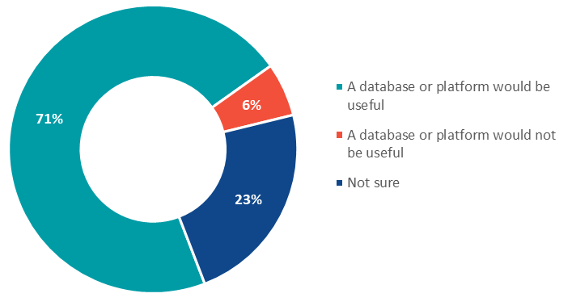

- Rehoming groups need access to knowledgeable and experienced personnel - foster carers, animal trainers, administrative volunteers.
- Support for foster carers may be needed so that more animals can be assessed and rehabilitated in a home environment.
- There is a disconnect in communication and working relationships between rehoming groups and shelters/pounds. Victorian Government assistance is desired to improve collaboration and communication across the sector.
- Shelters identified that larger dogs are harder to rehome. To improve rehoming rates, support for improved networks between shelters, rehoming groups and foster carers is required.
- There is a view that feline immunodeficiency virus (FIV) is not a reason to euthanise a cat and that greater support is required to ensure cats with FIV are rehomed.

Rehoming sector regulation:
- There is strong cross-sector support for the regulation of rehoming groups. Of survey respondents:
  - 67% supported regulation.
  - 29% were not sure about regulation.
  - 5% did not support regulation.
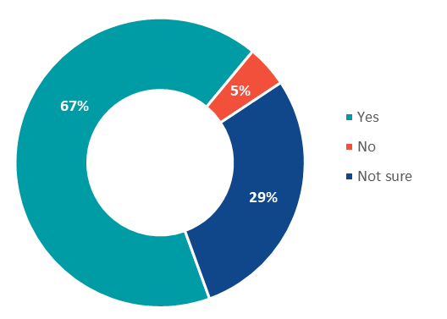

- Any regulatory model should be developed in consultation with the sector, informed by an understanding of the breadth and scale of rehoming activity in Victoria and the expertise and experience of the people and organisations involved in rehoming.
- Illustrative quotes from consultation participants:
  - “CFCN / Rescue to be regulated with minimum standards to be applied across the rescue sector.”
  - “A regulatory framework to help rescues become more professional / better communication between rescues.”

Characteristics of the Victorian rehoming sector:
- Victoria’s rehoming groups are rehoming and rehabilitating pets from across Australia.
- Rehoming groups range in size from small groups that rehome up to 20 animals each year to large groups that rehome more than 150 animals. Others rehome hundreds of animals of differing species.
- There are currently over 270 rehoming groups operating in Victoria.
- Rehoming groups source animals from a range of locations. Community or owner surrenders make up a significant part of rehoming group activity.
- Survey respondents advised where animals entering the rehoming sector come from, including:
- 33% from community / owner surrenders
- 26% from pounds
- 21% from shelters
- 11% from other sources
- 8% from breeders
- 2% from research organisations.
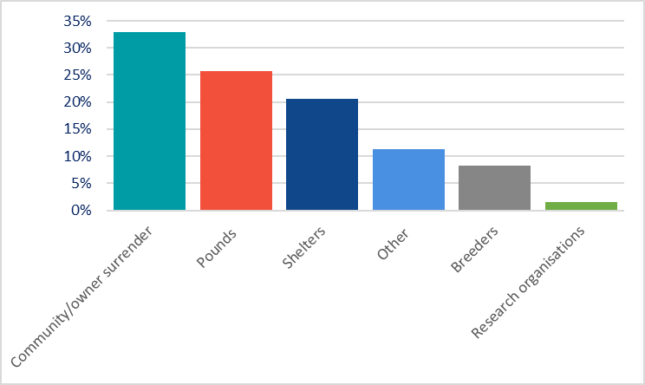

Survey data suggests there are prominent and contrasting positions on animal euthanasia within the pet rehoming sector:
- Most survey respondents from local council and veterinary cohorts suggested that animals with dangerous and/or untreatable behavioural conditions should not be rehomed. These respondents considered euthanasia a viable and necessary option for some animals, particularly when considering community safety and an animal’s quality of life.
- Most members of the public who responded to the survey believed ‘every animal could be rehomed’. While respondents from rehoming groups suggested that most animals could be rehomed with the right support, they acknowledged there are certain circumstances where an animal should not be rehomed (e.g. where a dog is declared dangerous or a pet has a terminal illness).
- Of survey respondents who thought an animal should always be rehomed:
  - 70% were members of the public
  - 22% were foster carers
  - 6% were rehoming groups
  - 1% were registered shelters
  - 1% were local councils
  - 0% were veterinarians.
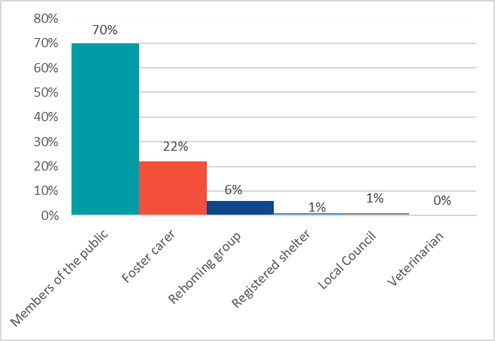
- Illustrative quotes from consultation participants:
  - “Euthanasia is a very important part of good animal welfare”
  - “Every life is worth saving. Every life is worth bettering. No life is meaningless & there is always the right someone for an animal.”
Animals used in research:
- Stakeholders have described the needs of dogs and cats used in research as unique, with expertise and significant resources required to ensure successful rehoming.
- In Victoria, there is a small number of people and organisations with the specialist skills, knowledge and experience required to rehome animals from research facilities.
- Survey data suggested the current system for accessing, rehabilitating and rehoming animals used in research is working and that animals suitable for rehoming are able to access rehoming pathways.
- There is a clear desire for an increase in educational information and advice to support successful rehoming outcomes for dogs and cats, including those used in research and teaching.

Appendix B: Summary of key insights from phase two of the Taskforce’s consultation
PHASE 2 CONSULTATION INSIGHTS FROM SECTOR ROUNDTABLES
- The Taskforce met with over 80 community members and representatives from the pet rehoming and animal welfare sector.
Supports that most assist with rehoming are:
- Use of social media, traditional media, adoption days or animal focused events (e.g. Cat Lover’s show) to increase organisation’s visibility.
- Partnerships with veterinary clinics and pet shops for reduced fees for veterinary care and supplies.
- Networks of people – working or volunteering within a rehoming group, contact with other rehoming groups or sector leaders for referrals or advice, access to specialist trainers, positive relationships with previous adopters.
- Financial support - donations from the community and government grants.
- Guidance or education materials for rehoming groups and adopters.
Supports likely to make the most difference on a day-to-day basis include:
- Access to funding, mostly to pay for veterinary care.
- Standardised staff and foster care training on animal care and adopter screening.
- Recruitment of reliable foster carers and volunteers, and capacity to provide practical and emotional support.
- Space to store supplies or hold animals.
- More information about animal history to inform rehabilitation, medical care and rehoming.
- Opportunities to network with other rehoming groups.
- Clearer role for rehoming groups in the animal welfare sector.
- Owner support post-adoption.
- Illustrative quotes from consultation participants:
  - “Govt financial assistance with veterinary costs to increase the number of animals we can afford to assist and ultimately rehome”
  - “Funding to reduce the costs of desexing of companion animals across the state to stop the flow., and more funding support for rescue agencies.”
Supports that are less available include:
- Money to provide veterinary care, rehabilitation and subsidise foster care costs.
- Collaboration and communication with other animal welfare/management organisations.
- On site storage, physical space.
- Knowledgeable and experienced personnel – foster carers, animal trainers, administrative volunteers.
- Ability to track and understand an animal’s history.
- Public capacity and willingness to properly care for pets, as well as understanding of rehoming groups’ purpose and objectives.
Supports likely to make the most difference on a longer-term basis include:
- Review and improvement of microchipping processes.
- Review and modernising of the Code of Practice for the Management of Dogs and Cats in Shelters and Pounds (the Code) to better promote and support rehoming.
- Consistent, accessible system to list rehoming groups and enable tracking of animals requiring rehoming.
- Networking for information-sharing, collaboration and collegiality.
- Specialised training and rehabilitation services - specialised services for institutionalised dogs/cats.
- Funding support for better long-term holding or isolation facilities.
- Responsible pet ownership education - members of the public having a realistic understanding of pet ownership obligations and costs.
- Public understanding of the animal welfare sector.
- Streamlined regulation within the animal welfare sector.
- Stopping the number of animals that require rehoming - preventing animals entering the system.
Benefits of regulation include:
- Consistency for all organisations.
- Minimum standards for animal welfare, running a rehoming group, adoption, owner-surrender.
- Formal recognition of rehoming groups.
- Mechanism for holding rehoming groups accountable for animal welfare, complaints, community safety and financial management.
- Increased opportunities to work with already regulated components of Victoria’s pet rehoming system.
- Increased education and training opportunities through guidance materials and networks to share expertise.
Possible enablers for regulation are:
- The opportunity to support and improve relationships between rehoming groups, pounds and shelters.
- Community support for regulation and standardisation of the rehoming sector.
- Sector buy-in to process.
- Identification of rehoming sector champions.
- Establishment of guidelines and standards, and accompanying templates.
- Precedents set by international models.
- Review of microchipping policies and practices to make improvements for animals in temporary care.
- Illustrative quotes from consultation participants:
  - “Everyone wants to help and achieve change. Most seem to be on the same page with what needs to change.”
  - “Don't just listen to advice from large players in the industry as smaller players have different ideas.”
Perceived barriers to regulation are:
- The disconnected relationships between rehoming groups and Councils.
- Rehoming group resistance to regulation because of administrative burden, or disagreement with operations or policies of other animal welfare or management providers.
- Requirement for review of regulatory mechanisms under the Domestic Animals Act 1994 (DA Act) to improve the operation and outcomes of Victoria's animal welfare sector (the Code, microchipping, foster care registration scheme, section 84Y agreements).
Potential issues for implementing regulation:
- General support for regulation exists, but there are differing methods and perspectives between organisations within the sector on how this regulation should be structured.
- There are rehoming sector calls for further consultation in developing a regulatory model.
- The provision of time for rehoming groups to comply with regulation needs to be considered as this could involve a transition period and resourcing to support implementation (financial assistance and education campaigns).
- Resistance to regulation is evident from some rehoming groups.
- The current regulatory frameworks in place and the components requiring change need to be considered.
- Illustrative quote from consultation participant:
  - “Differences in groups and people about what animal welfare actually is, including rehoming and euthanasia. This results in groups working against each other rather than together.”
Collaboration & communication processes that work well include:
- Social media used to advertise to potential adopters or foster carers and for communication between rehoming groups.
- Sharing information and resources between rehoming groups.
- Education being provided within the rehoming sector.
- RSPCA Victoria's dedicated rehoming resource has been a beneficial support.
How to improve communication & collaboration:
- Help Councils, shelters and rehoming groups to work together and build trust.
- Provide communication tools, including online platforms, networking opportunities, operating procedures.
- Provide inclusive education for rehoming groups, shelters and Councils on animal care, welfare, accreditation or regulation.
- Recognise rehoming groups through licensing or similar.
- Educate the public about the animal welfare sector to improve understanding of roles and responsibilities.
Barriers to communication & collaboration include:
- Disconnect between Councils and rehoming groups on best-practice operations and management of animals.
- Unwillingness to share with other rehoming groups.
- Competition for resources and animals as well as differing ideologies.
- Limited capacity of and high demand for rehoming groups.
- Lack of clear and consistent regulatory guidance.
Online systems to support rehoming include:
- Social media for advertising animals needing rehoming.
- Pet advertising websites to find adopters.
- Record management systems, some of which are too expensive for smaller rehoming groups.
- Video platforms for operational activities such as educational events.
- Online file sharing for operational activities (e.g. foster agreements, adoption contracts).
- Illustrative quote from consultation participant:
  - “State government should support an online system that rehoming groups can use.”
Benefits of increasing transparency:
- Publication of statistics on animal movements and rehoming means issues can be identified and support provided.
- Council and animal welfare organisation policies/frameworks for animal management are clear/accessible.
- There is increased accountability for activities and decisions.
- Improvements will be evident in animal and human welfare through more live animal outcomes and strategies to reduce burn-out and stress for those helping animals.
Opportunities to increase transparency include:
- Standardising and requiring sector-wide data reporting.
- Facilitating communication between stakeholders.
- Using existing or new online systems for information and/or resource sharing and/or tracking animal history.
- Standardising practices across animal welfare and management sectors, including formalised adoption processes for members of the public.
- Illustrative quote from consultation participant:
  - “Lack of transparency is a symptom of the competition and lack of collaboration across the sector.”
PHASE 2 CONSULTATION INSIGHTS FROM SUBMISSIONS
- The Taskforce received a total of 24 submissions
Suggestions about regulation:
- Set minimum animal care and management standards, through a code of practice or similar instrument.
- Consider of the need for a complaints mechanism to report any animals at risk or being poorly cared for.
- Develop a regulatory model in close consultation with the sector.
- Consider reviewing other regulatory mechanisms under the DA Act (such as the Code, the Foster Carer Registration Scheme) to identify improvements or changes necessary to support improvements in pet rehoming.
- Further consider and develop standards for temperament testing and euthanasia, including consideration of international models (such as the Asilomar Accords).
- Consider changing quarantine requirements in the Code to shorten length of stay for animals.
- Review or improve current legislated agreements between Councils and other animal welfare organisations for the rehabilitation and rehoming of animals (e.g. Section 84Y agreements).
- Provide education and training for rehoming groups on animal medical care, assessment, rehabilitation, best practice foster care, and rehoming group management
Suggestions for transparency:
- Introduce mandatory publication of animal fate statistics, with standardisation of categories for reporting.
- Require mandatory release of individual animal information to organisations that take on the care of an animal and to an animal's adopter.
Suggestions about supports:
- Review Council policies, to improve animal management practices and capacity to rehome impounded animals.
- Improve access to and quality of animal behaviourists or animal trainers.
- Fund care for neo-natal kittens
- Illustrative quote from submission:
  - “Fund a third party to do health and temperament testing to see if an animal is suitable for rehoming.”
Suggestions for online systems:
- Develop a single database or platform for use by rehoming groups for access to support and for adopters and foster carers.
- A single platform will potentially reduce the volume and complexity of services currently used to coordinate lost/found pets and advertise animals for rehoming.
- Consider the time and resource impost of using another online system in addition to those already used by rehoming groups
Suggestions for animals used in research:
- There is room to improve collaboration between research/teaching organisations regarding use of animals and in preparing animals for rehoming while being used in research/teaching, supported by a code of practice.
- A central database of rehoming groups could allow scientific organisations to better access alternative pathways for animals at the end of any projects by identifying rehoming groups with the required expertise to take on an animal.
- Provide resources to support the care of animals used in research or to upskill the sector.

