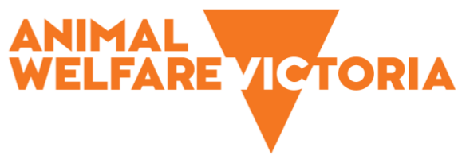
Victorian Government response to the final report and recommendations of the Taskforce on Rehoming Pets

May 2022
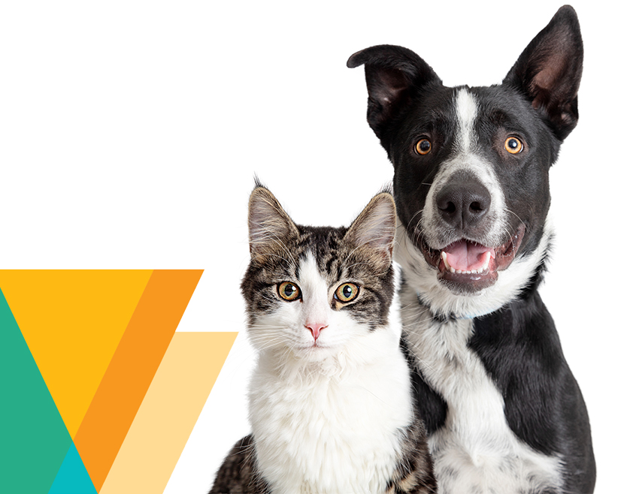

Message from the Minister for Agriculture
The Victorian Government acknowledges the valuable work done by Victoria’s pet rescue, rehoming and foster care groups (rehoming groups) to achieve successful animal welfare and rehoming outcomes. Government remains committed to supporting rehoming groups to deliver their services effectively and in the best interests of animal welfare.
In March 2021, I launched the Taskforce on Rehoming Pets (the Taskforce) to investigate and provide recommendations to Government on how to improve and best support rehoming pathways for pets in Victoria, including those animals used in research and teaching.
After extensive consultation with community, government, rehoming groups and Victoria’s broader animal welfare sector, the Taskforce provided its final report and recommendations to Government in December 2021.
The Victorian Government welcomes the Taskforce’s final report and commends its members, Member for Western Victoria Andy Meddick (Chair), Member for Bendigo West Maree Edwards and Member for Narre Warren South Gary Maas, as well as the supporting Secretariat, for the significant work undertaken to deliver an informed and comprehensive report.
Having considered the Taskforce's report and its 17 recommendations, I am pleased to provide the Government’s response and to outline the next steps for implementation.
I look forward to working in partnership with Victoria’s rehoming groups and animal welfare sector to build upon the Taskforce’s recommendations and improve welfare and rehoming outcomes for Victoria’s pets.

Mary-Anne Thomas
Minister for Agriculture

Overview
In March 2021, the Minister for Agriculture established the Taskforce on Rehoming Pets to investigate and provide recommendations to government on how to improve pet rehoming pathways in Victoria. In December 2021, the Taskforce provided its final report and recommendations to the Minister.
The Victorian Government broadly supports the Taskforce’s recommendations and is committed to working closely with key stakeholders, particularly rehoming groups, to develop and implement reforms that will improve welfare and rehoming outcomes for pets.
The Victorian Government’s response to each of the Taskforce’s recommendations is outlined below.

Response to recommendations

Taskforce recommendations on how to improve the welfare and survival rates of cats and dogs requiring rehoming while maintaining community safety:

Victorian Government to work in collaboration with the (rehoming) sector to determine needs relating to online platforms to deliver increased transparency, animal access and information sharing.

Victorian Government to fund the development, implementation, and operation of a suitable online platform (or platforms) in line with rehoming sector needs.
Government response: Support in principle
The Victorian Government recognises the importance of better communication and collaboration between rehoming and animal welfare sector stakeholders, including local and state government bodies, to improve information sharing, transparency and animal welfare outcomes. The Victorian Government also recognises the potential that online platforms provide for supporting and enhancing these efforts.
During consultation, the Taskforce identified several possible functions for online platform(s) or tools, which ranged from advertising and information sharing to recording and reporting animal movements. Consequently, Animal Welfare Victoria (AWV) will lead a targeted needs analysis process involving consultation with rehoming groups, shelters and pounds to identify the most suitable and practical options to meet the broad requirements of the sector.

Government to review the Animal Welfare Fund grant application and funding process to ensure equitable access for all rescue and foster care providers, with a specific focus on microchipping and desexing grants.
Government response: Support
AWV will undertake an evaluation of the Animal Welfare Fund (AWF) grant program to determine whether the application and funding process provides equitable access for all rescue and foster care providers, and to identify potential avenues to improve equity of access. The Victorian Government’s AWF provides assistance to eligible companion animal welfare service providers and includes a number of targeted programs, such as supporting costs for pet desexing and animal rehoming (including microchipping). Competitive grant applications are assessed on their merits by an independent panel, while applications for reimbursement under the Individual Pet Rehoming grant stream are approved on the basis of evidence of expenditure.

Victorian Government to review and consider options to improve animal behavioural testing.
Government response: Support
The Victorian Government supports this recommendation and notes the positive feedback the Taskforce received for its consultation roundtables. As such, AWV will coordinate structured workshops with sector representatives to explore options to improve animal behavioural testing. AWV will also seek advice from the Australian Institute of Animal Management, the Animal Welfare Advisory Committee, the Chief Veterinary Officer, the Veterinary Practitioners Registration Board of Victoria and the Australian Veterinary Association on the evidence base and emerging perspectives applicable to behavioural testing for animals in shelters and pounds.
The outcomes of these activities may necessitate amending the provisions for behavioural assessment and euthanasia in the Code of Practice for the Management of Dogs and Cats in Shelters and Pounds (the Code) and may inform the development of a regulatory framework as part of Recommendation 7.

Victorian Government to consider and develop appropriate protections to minimise the use of euthanasia for animals with treatable or manageable health conditions.
Government response: Support in principle
The Victorian Government notes the lack of comprehensive and contemporary data on the use of euthanasia in shelters and pounds.
The Government has committed to introduce mandatory animal fate data reporting requirements for shelters and pounds regulated by the Code. As part of these new reporting requirements for shelters and pounds, stakeholders and the public will have access to government published data on the fate of all animals cared for in Victoria’s shelter and pound system, including the use of, and reasons for, euthanasia.
AWV, in consultation with the veterinary and animal welfare sectors, will use this animal fate data set to inform what (if any) supports are needed.

Victorian Government to fund ongoing, meaningful sector communication and collaboration processes to facilitate continued sector improvements and relationship building.
Government response: Support
The Victorian Government recognises the importance of communication and collaboration between Councils and rehoming groups to ensure successful animal welfare and rehoming outcomes.
AWV will engage all rehoming groups, councils and shelters to understand their needs and preferences for sector communication and collaboration, and use the information gathered to plan and implement activities to support sector improvements and inter-sector relationships. AWV will develop a rehoming communications plan that will span 5 years, which is the expected duration of the activities planned for implementation in response to the Taskforce’s recommendations. Ongoing and meaningful communication and collaboration between AWV and the sector will be necessary to implement recommendations 1, 3, 4, 5, 7, 9, 13, 16 and 17.

Recommendations on a regulatory framework for the rehoming of pets in Victoria:

Victorian Government to work with the sector to develop and implement a regulatory framework for the sector that considers and, where relevant, reviews existing regulatory instruments.

Victorian Government to amend the DA Act to introduce a registration scheme for the sector, similar to other registration schemes for existing domestic animal care and management organisations.

Victorian Government to develop and introduce minimum standards for the care and management of animals by the sector (i.e. animals in temporary care).

Victorian Government to fund the development, implementation and sustainable operation of a regulatory framework for the sector and identify resources and/or agencies best placed to undertake necessary administrative and compliance functions, noting a self-regulatory model is not suitable for the sector at this time.
Government response: Support
The Victorian Government recognises the need for regulation of the pet rehoming sector and is encouraged by the strong cross-sector support for regulation. Government agrees that regulation will improve sector collaboration, enable government oversight, and ensure consistency of care and equity in rehoming opportunities. The Victorian Government also acknowledges the benefits a registration scheme and minimum care standards will afford rehoming groups, by accrediting their operation and standardising care requirements.
Government will actively engage and work with the pet rehoming and animal welfare sectors to determine the most appropriate regulatory model design, tools for implementation, and the resources and/or agencies best placed to administer regulatory compliance functions. Such a regulatory co-design approach will ensure the regulatory scheme is informed by the expertise and needs of the individuals and organisations involved in pet rehoming in Victoria.
The DA Act and its supporting regulatory instruments will be reviewed and amended as required, in parallel with the development of any rehoming sector regulatory scheme. This approach will maintain consistency across Victoria’s domestic animal regulatory framework.
In implementing these recommendations, it is anticipated government would undertake a three-phase approach:
- Phase one: research and consultation, including legislative impact assessment
- Phase two: regulatory scheme design, including review of relevant existing legislation, regulatory impact assessment and development of legislation, governance structures, policies, procedures, minimum care standards and, if relevant, training and accreditation/certification programs
- Phase three: formal establishment and implementation of regulatory scheme, including designation of regulatory authority, public and sector education and communications campaign and, if relevant, application and certification/accreditation (or registration) of rehoming groups.
To deliver on this recommendation, the Victorian Government commits to working closely with the pet rehoming sector. This significant reform will also require cooperation and collaboration from a wide range of individuals and organisations from across Victoria. The Government’s intent is to provide a regulatory framework for the rehoming of pets in Victoria that meets the needs of all stakeholders.

Recommendations on how to improve transparency in the movement of animals between shelters, pounds, CFCNs and rescue groups:

Victorian Government to require regulated rehoming groups (once a regulatory scheme is introduced) to collect and report animal fate data – aligning reporting requirements with the proposed amendments to shelter and pound reporting under the Code.
Government response: Support
The Government has committed to introduce mandatory animal fate data reporting requirements for shelters and pounds regulated by the Code. As part of these new reporting requirements, stakeholders and the public will have access to government published data on the fate of all animals cared for in Victoria’s shelter and pound system, including the use of, and reasons for, euthanasia.
The Victorian Government recognises the benefits of aligning animal fate data reporting requirements for all organisations and groups involved in rehoming animals in Victoria.

Victorian Government to consider how to better encourage partnerships and information-sharing between shelters, council pounds, CFCNs and rescue groups.
Government response: Support
Implementing many of the Taskforce’s recommendations, particularly a regulatory framework for rehoming groups (recommendations 7-10), will contribute to encouraging partnerships and information sharing.
Implementing a 5 year-communications plan (recommendation 6) that provides opportunities for ongoing relationship-building between organisations, groups and individuals working to rehabilitate and rehome animals will also help to deliver this recommendation.

Recommendations on how to improve information and advice for scientific organisations and AECs to support the successful rehoming of dogs and cats used in research and teaching:

Victorian Government to consider implementing a mandatory rehoming policy for suitable dogs and cats used in research and teaching.
Government response: Support in Principle
The Victorian Government notes that most dogs and cats used in research and teaching are for educational objectives and do not require rehoming, as the animals are already owned and return home at the conclusion of the activity. The small number of dogs and cats that are without owners and are suitable to be rehomed are treated in accordance with the Australian Code for the care and use of animals for scientific purposes.
The Victorian Government will consider implementing a mandatory rehoming policy as part of the review of the current legislation and development of the new Animal Care and Protection Bill. If the policy is implemented, guidance will be developed for Animal Ethics Committees (AECs) and institutions to support their consideration of rehoming options for animals.

Victorian Government to formally request for a review of the Australian Code, with a specific focus on retirement age for dogs and cats used in research and teaching.
Government response: Support
The Australian Code was last updated in 2021 when a new section was added to ban the use of animals for testing of chemical ingredients in cosmetics and for testing of finished cosmetic products.
The Victorian Government recognises that older dogs and cats may be used in research and teaching. To encourage improved animal welfare outcomes, the Victorian Government will request the National Health and Medical Research Council review the Australian Code, with specific consideration of the need for a retirement age for dogs and cats used in research and teaching where that research and teaching does not require the use of older animals.

Victorian Government to consider a review of the current processes for data collection and reporting for animals used in research, to inform improvements to transparency, accuracy and timeliness.
Government response: Support
The Victorian Government notes that individuals and organisations using animals in research and teaching are required to submit animal use statistics each year to AWV. Data and information that forms part of this annual reporting is prescribed by the Prevention of Cruelty to Animals Regulations 2019 (the Regulations).
AWV will review the animal use information required by the Regulations as part of the process to develop regulations under the Animal Care and Protection Bill.

Recommendations on how to further develop and implement the successful rehoming of dogs and cats used in research and teaching:

Victorian Government to consider specific grant programs to support the rehabilitation and rehoming of animals used in research and teaching.

Victorian Government to consider funding programs to support the sector to upskill in rehabilitation and care for animals used in research and teaching.
Government response: Support in principle
The Victorian Government recognises the importance of supporting rehabilitation and rehoming of animals used in research and teaching. The Victorian Government currently assists with costs of rehoming dogs and cats (including those used in medical research) through the Individual Pet Rehoming grants. However, it is recognised that successful rehoming of animals used in research and teaching requires specialist skills and experience.
AWV will undertake a needs analysis process involving consultation with scientific research institutions that use animals and the rehoming sector to identify needs and suitable resourcing options, which may include specific grant programs and/or funding for the rehoming sector to support rehabilitation and rehoming activities and upskilling in rehabilitation and care.
AWV has published guidelines for the rehoming of animals used in scientific research. In addition, further guidance could be developed for AECs and institutions to support their consideration of rehoming options for animals at project design and approval stage.

Next steps
This response report outlines the Victorian Government’s anticipated activities over the next four years to improve and best support pet rehoming.
On behalf of the Victorian Government, AWV will continue to work with rehoming groups and the broader animal welfare sector to improve welfare and rehoming outcomes for Victoria’s pets.

