Animal Welfare Guidance Document for the Transport of Livestock across Bass Strait

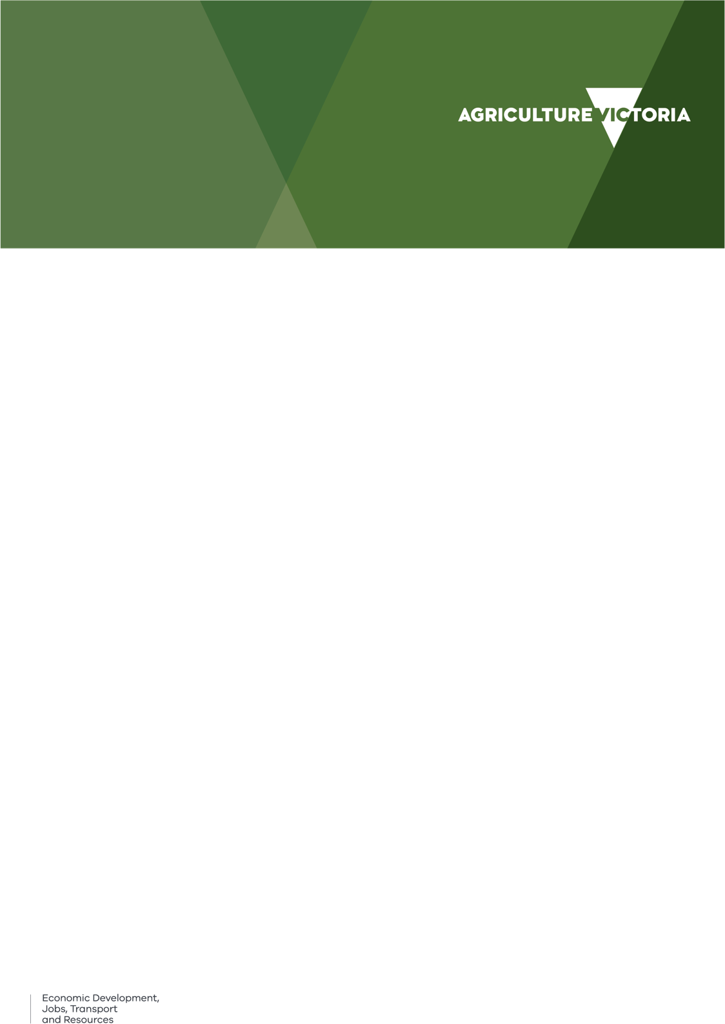
The purpose of this document is to provide guidance to persons responsible for the care and management of livestock during transportation by vessel across Bass Strait, from Victoria to Tasmania.

The guidelines complement the Tasmanian Animal Welfare Guidelines for transport of livestock on Bass Strait, and must be read in association with the Australian Animal Welfare Standards and Guidelines – Land Transport of Livestock, and Part 43 of the Marine Orders.

LEGISLATION
The Australian Animal Welfare Standards and Guidelines – Land Transport of Livestock cover the transport of livestock by road and rail, and by livestock transport vehicle aboard a ship, i.e. roll on, roll off
(Ro-Ro) vehicles.
In Victoria, the Australian Animal Welfare Standards and Guidelines – Land Transport of Livestock are regulated under the Victorian Livestock Management Act 2010.
In Tasmania, the Australian Animal Welfare Standards and Guidelines – Land Transport of Livestock are legislated under the Animal Welfare (Land Transport of Livestock) Regulations 2013.
There are also requirements for the shipping of livestock prescribed in Marine Order Part 43 under the Navigation Act 2012 (Commonwealth). While Marine Order 43 normally applies only to Regulated Australian vessels, the Certificate of Operation of Domestic Commercial Vessels may call up Marine Order 43. Most Bass Strait voyages carrying livestock

are regarded as a short sea voyage (under 24 hours) for the purposes of Marine Order 43.

CONTEXT
The Bass Strait crossing comprises one leg of what must be regarded as a long road journey from property of origin to final destination. Part, if not all, of the journey will fall within the scope of the Australian Animal Welfare Standards and Guidelines – Land Transport of Livestock.

PRINCIPLES RELATING TO TRANSPORT OF LIVESTOCK
Transport can be stressful to livestock; it is therefore essential that effective management practices are in place to minimise any risks to livestock welfare.
Refer to the section within the Australian Animal Welfare Standards and Guidelines – Land Transport of Livestock on the principles relating to the transport of livestock. This provides a detailed list of management practices and conditions to be considered when planning a livestock transport journey and stock preparation.

RESPONSIBILITIES AND PLANNING
Planning should be in accordance with the standards and guidelines in Part A-1 of the Australian Animal Welfare Standards and Guidelines – Land Transport of Livestock.
Responsibilities for livestock welfare in the transport process is as set out in the applicable provisions of Part A-1 of Australian Animal Welfare Standards and Guidelines – Land Transport of Livestock.
When planning the journey, the Bass Strait crossing should not be seen in isolation. The total journey time commences when the loading of livestock commences on the property of origin and ends when unloading of livestock is completed at the final destination.
Persons responsible for planning a journey that includes transporting livestock on Bass Strait should

allow for a total journey time which may exceed 30 hours, including a 12 to 16 hour sea voyage in often unpredictable waters.
Forecast weather and ocean conditions must be taken into account when planning a journey, such as rough waters, strong winds, large swells, high temperature and humidity, all of which will impact the welfare of livestock.
Planning should include contingency arrangements for the care of livestock if sailing is postponed.
When custody of livestock is transferred from a person to another throughout the transport process:
- the person who accepts the livestock into their care and charge accepts responsibility for the welfare of the animals including responsibility for ensuring that they are fit for the intended journey; and
- the person from whom the livestock are accepted is responsible for notifying the person accepting care or charge of any issue that may affect the welfare of the animals during transport, including when they last had access to water, feed or were given a spell.

Owner
The owner or owners’ representative is responsible for the preparation and selection of animals that are fit to undertake the entire journey.

Consignor
The consignor (who may be the owner, owner’s representative, transport operator or transport driver) must ensure the livestock are fit for the intended journey. Refer to Part A-4 of the Australian Animal Welfare Standards and Guidelines – Land Transport of Livestock for pre-transport selection of livestock requirements.
The consignor is responsible for the welfare of livestock rejected for shipping by the shipping company or the Master for any reason.

Livestock transport drivers
Livestock transport drivers should ensure that they minimise total journey time by:
- delivering the livestock to the wharf at a time that does not unnecessarily extend the journey time; and
- collecting livestock promptly at the destination port.
Livestock transport drivers are responsible for ensuring that the intended journey, including the sea leg, will not result in maximum times off water, journey times and requirements for rest periods being breached (refer to Part B of the Australian Animal
Welfare Standards and Guidelines – Land Transport of Livestock for species specific time limits and requirements).

The shipping company
By accepting animals at the wharf for shipping, the shipping company assumes custody, care and charge of the livestock and is responsible for their welfare from when they are:
- accepted for shipping until they are loaded onto the ship.
- unloaded at the wharf until they are collected for transport.
- In the event of animal ill health or mortality during the passage or upon arrival at the destination port, the shipping company will be responsible for the proper treatment, removal or disposal of livestock. The road transport driver becomes responsible for dealing with all aspects of animal welfare as soon as a container or road vehicle has been unloaded from the ship.
The shipping company is responsible for the livestock while in their custody care and charge and this includes:
- providing safe and secure holding facilities, where animals are transported in deck pens; and careful handling of livestock,
- maintaining the ship in a condition that ensures the welfare of the animals,
- maintaining documented arrangements with all port authorities in relation to managing emergencies,
- ensuring that an Animal Welfare Manual, or documented Animal Welfare Procedures are carried on board each vessel covering all aspects of managing the welfare of the livestock, including a procedure for assessing the animal welfare risks before each voyage especially in relation to adverse weather forecast situations, which includes extreme temperatures and high humidity,
- ensuring that staff accompanying the animals have adequate training and are competent to carry out all necessary procedures including euthanasia and managing animal welfare emergencies.
The shipping company should minimise delays in loading and unloading by:
- loading livestock on board vessels in such a way as to enable the animals to be discharged from the vessel as soon after its arrival as is practical; and
- where necessary, prompting livestock transport drivers to collect livestock as soon after discharge as is practical.

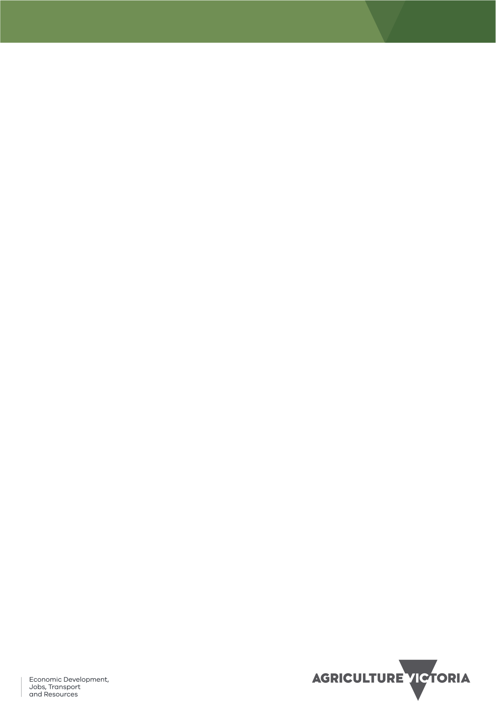
2

The shipping company should ensure that all relevant personnel are aware of the provisions of this guideline.

The Master
The Master takes custody, care and charge of all animals on board ship and becomes responsible for their welfare. In the event of a different person assuming responsibility as the Master of the vessel at any time during the voyage, including loading and unloading of livestock, the Master at the port of departure is responsible and shall be held accountable for all functions and responsibilities accruing to the vessel Master until the point at which that Master transfers responsibility to another person by way of entry in the vessel Log. The Master at the port of arrival is responsible and shall be held accountable for each of the functions and responsibilities associated with animal welfare at the port of arrival.
The Master remains responsible for the ‘fit to load’ assessment, loading density and penning arrangements of animals in deck pens but may delegate these tasks to trained and competent third parties.
The Master is responsible for the safe and secure stowage of any road vehicles or portable equipment.
The decision whether to sail with any or all animals on board rests entirely with the Master.
The Master should ensure that all relevant personnel are aware of the provisions of this Guideline.
The Master must ensure that all deaths and downers during any voyage on Bass Strait are reported to the relevant state animal health authority – Tasmanian Department of Primary Industries, Parks, Water and Environment (phone 1800 675 888 all hours) or Agriculture Victoria (phone Business Hours 136 186, After Hours 1800 675 888) as soon as practical and within 6 hours.
The Master must document the decision process used to justify sailing with livestock on board when a weather forecast exceeds values specified in either
the ship’s Animal Welfare Manual or documented
animal welfare procedures.
The Master must consider changing course, reducing speed, returning to port or seeking sheltered waters if these actions will reduce the risk of adverse animal welfare outcomes due to unexpected rough weather conditions during a voyage unless this threatens the safety of the ship, its crew or increases the risk of pollution.

LIVESTOCK TRANSPORT VESSELS AND FACILITIES FOR LIVESTOCK
Livestock pens and facilities for holding, loading and unloading livestock should comply with the provisions
of Part A - 3 of the Australian Animal Welfare Standards and Guidelines – Land Transport of Livestock except where such compliance would be inconsistent with existing legislation (including Marine Order 43).

Ventilation
Marine Orders Part 43 – for short voyages (<24 hours) section 35 requirements:
    - Livestock must be provided with adequate flow through ventilation in close proximity above and or below the containment unit.
    - Openings in portable equipment, specifically provided for ventilation, are to be so placed as to prevent direct draughts on the livestock.
    - Road transport vehicles which have inadequate flow through ventilation capability when stationary are not to be used for sea transport.
    - The master must ensure that when livestock is carried on enclosed decks in Ro-Ro ships the ventilation system is run continuously.
In addition, air flow should not be obstructed by the positioning of other high-sided vehicles.
Livestock road transport vehicles should not be positioned near any operating motors or refrigeration units emitting toxic fumes which would impact air quality.

PRE-TRANSPORT SELECTION AND PREPARATION OF LIVESTOCK
Livestock being ‘fit for the intended journey’ is an important issue for livestock welfare.
To ensure that the animals are ‘fit for the intended journey’, the pre-transport selection of livestock before the commencement of the journey and at each loading should comply with the following provisions of the Australian Animal Welfare Standards and Guidelines – Land Transport of Livestock:
- The general standards and guidelines in Part A – 4
- The relevant species standards and guidelines in Part B
Water and feed curfews can be an important part of livestock management for transport, depending on the species and pasture conditions. Issues include faecal and urine contamination of livestock, vehicles, and vessels, and slipping and falling of livestock in wet livestock crates.
Cattle and sheep should be withdrawn from green feed for at least 12 hours prior to being loaded onto the road transport vehicle.
Adult sheep and cattle should be fed good quality hay during the curfew period to help firm their faeces,

3

maintain rumen function and sustain them for the journey.
Water can also be withheld but note that water curfews must be managed in the context of the total time off water standards in Part B of the Australian Animal Welfare Standards and Guidelines – Land Transport of Livestock.
Water, food and rest provision should be in accordance with the relevant species standards and guidelines provided in Part B of the Australian Animal Welfare Standards and Guidelines – Land Transport of Livestock.
The total journey time commences when the livestock are first loaded onto the road transport vehicle and ends when the livestock are unloaded from the road transport vehicle at the final destination. This includes time taken in road transport to the port, loading of the vessel, shipping, unloading and transport to the destination.

LOADING, TRANSPORTING AND UNLOADING LIVESTOCK
Livestock should be handled, loaded, transported and unloaded in accordance with the following provisions of the Australian Animal Welfare Standards and Guidelines – Land Transport of Livestock:
- The general standards and guidelines in Part A – 5
- The relevant species standards and guidelines in Part B
Loading plans should allow the placing of livestock so that they can be off loaded as soon as possible after docking unless this compromises other animal welfare aspects such as exposure to seas and weather or poor ventilation.
Animals must be suitably protected from distressful exposure to adverse weather such as rain, wind and sea-spray.
Loading plans should allow for adequate ventilation.
Animals should be unloaded as soon as possible after arrival at the destination. Injuries to stock will be reduced if they are given the opportunity to walk quietly off the vessel or vehicle.
At the destination port there must be arrangements and nearby facilities for the humane unloading, nursing or euthanasia of animals which are downers or unable to walk off because of injury or exhaustion. In the case of animals transported in deck pens the shipping company must make these arrangements and in the case of animals transported in containers or on road vehicles the road transporter is responsible for making the arrangements. Shipping Companies may need to enter into formal arrangements with Port Authorities on a number of matters relating to
management of any animal welfare incident that could arise.

In-transit Inspections
All livestock must be inspected on arrival at port and assessed for fitness to proceed on the road journey. Downer animals must not be subjected to onward transportation unless authorised by a veterinarian in writing.
Livestock in deck pens must be carried such that they can be inspected and assistance rendered where necessary. Livestock in containers or road vehicles should be assessed as effectively as possible during the voyage. Any adverse events or observations must be recorded.
During rough weather the level of inspection will be dictated by safety requirements for personnel. It should be noted that livestock are more likely to go down during rough weather. When inspection has not been possible, livestock should be inspected and assisted if necessary as soon as conditions allow.
A suitable source of lighting should be available to carry out inspections at night.
Any animal found to be down, injured, distressed or with a limb protruding should be given immediate assistance. Every effort should be made to get cast animals to their feet and to relieve stocking density in pens where an animal is down. If necessary and safe to do so, such animals should be humanely destroyed without delay during the voyage in accordance with the standards and guidelines for humane destruction provided in Part A-6 of the Australian Animal Welfare Standards and Guidelines – Land Transport of Livestock, and the species specific guidelines in Part B.
If on-board assistance has been unsuccessful, veterinary assistance with down, injured and distressed animals should be arranged as soon as practical, preferably before the vessel docks, so that veterinary assistance can be provided without delay. Such assistance can be sought from veterinary practitioners or Veterinary Officers or Stock Inspectors from Agriculture Victoria (phone Business Hours 136 186, After Hours 1800 675 888) or the Department of Primary Industries, Parks, Water and Environment in Tasmania (1800 675 888 all hours) who may need to take control of the situation using their powers under animal welfare legislation. The destination harbour master may also need to be informed.

Loading Density
Loading density (space allowance) of livestock should be in accordance with the provisions of the Australian Animal Welfare Standards and Guidelines – Land Transport of Livestock:
- The general standards and guidelines in Part A – 5
- The relevant species guidelines in Part B

4

Single animals or small groups of animals should be transported in stalls to give support during travel. However, they must have sufficient space, and should be secured in a manner to allow them to lie down and readily gain their feet.
The space allowance (loading density) for animals in pens should restrict movement to minimise injury but at the same time allow cast animals to rise with assistance.

HUMANE DESTRUCTION
Where it is necessary to destroy livestock, it should be done in accordance with the following provisions of the Australian Animal Welfare Standards and Guidelines – Land Transport of Livestock:
- The general standards and guidelines in Part A – 6.
- The relevant species standards and guidelines in Part B.
An appropriately trained person, competent in handling the euthanasia equipment and euthanising the species carried, must be on board each voyage carrying livestock.

SPECIES SPECIFIC REQUIREMENTS

Horses
Horses must be transported individually (separate stall, or divider), except mares with foals at foot, which must be stalled together. Foals less than four weeks old should not be transported.
Horse transport must comply with all other requirement under Marine Order 43.
Horses, except young or unhandled animals, should wear head stalls which are fitted so as not to endanger the animal. The lead of the head stall should be secured to the stall using a quick release knot.

Ventilation for horses
Effective airflow reduces the impact of heat during transport and travel sickness in horses.
A mechanical ventilation system will be required to ensure adequate ventilation when transporting horses in enclosed spaces (lower decks) on a vessel.
Standard SB8.8 of the Australian Animal Welfare Standards and Guidelines – Land Transport of Livestock requires horses transported in fully enclosed and environmentally controlled road vehicles to have effective airflow with equipment providing at least 12 air changes per hour.

Pigs
Pigs are susceptible to heat and cold stress during extremes of heat and cold respectively. Higher relative humidity also increases the risk of heat stress.
In hot weather (ambient temperature 27°C or higher), the journey should be managed to minimise the risk of heat stress.
In very hot or humid weather, careful attention should be paid to the airflow of the transport unit; the speed of travel; the number, location and conditions of planned stops; loading density; and condition of pigs being carried.
Where the ambient temperature is expected to exceed 25°C anywhere along the route (land and/or sea), transporters should refer the ‘Is it fit for the intended journey’ guide for pigs published by Australian Pork Limited. This guide contains a Heat Stress Index chart depicting the risk of heat stress in relation to ambient air temperature and relative humidity, and information on managing heat stress risk.
Pigs should be protected from direct sunlight to avoid sunburn.
In cold weather, care should be taken to avoid cold stress, wind chill and rain, particularly in weaner pigs.
In cold weather straw or other dry bedding is desirable.
Pigs should be loaded in accordance with the space allowances in Part B (B9) of the Australian Animal Welfare Standards and Guidelines – Land Transport of Livestock when the temperature is below 25ºC. Pigs need about 10% more floor area when the temperature is over 25ºC.

REFERENCES
- Australian Animal Welfare Standards and Guidelines – Land Transport of Livestock.
- Tasmanian Animal Welfare Guidelines for transport of livestock on Bass Strait.
- Marine Orders – Part 43
- ‘Is it Fit to Load?’ - A national guide to the selection of animals fit to transport (revised edition 2012, published by Meat and Livestock Australia (MLA)).
- ‘Is it fit for the intended journey?’ second edition
2016 guide for pigs (published by Australian Pork Limited).

ACCESSIBILITY
If you would like to receive this publication in an accessible format, please telephone Agriculture Victoria, Chief Veterinary Officer’s Unit, 03 92174200.

5

