Dairy Shed Water
How much do you use?


A comprehensive guide to calculating water use in the dairy shed

The Farm Business Resilience Program is jointly funded through the Australian Government’s Future Drought Fund and the Victorian Government’s Future Agriculture Skills Capacity Fund

Acknowledgements
This booklet has been prepared by Richard Smith, Rachael Campbell, Scott McDonald, Ashleigh Michael and Ann McDowell from Agriculture Victoria, providing information for this document.
Agriculture Victoria would like to acknowledge the authors of the original booklet ‘Dairy shed water How much do you use?’.

Editor
This booklet has been edited by Richard Smith and Rachael Campbell.

We acknowledge and respect Victorian Traditional Owners as the original custodians of Victoria’s land and waters, their unique ability to care for Country and deep spiritual connection to it.
We honour Elders past and present whose knowledge and wisdom
has ensured the continuation of culture and traditional practices.
DEECA is committed to genuinely partnering with Victorian Traditional Owners and Victoria’s Aboriginal community to progress their aspirations.

© The State of Victoria Department of Energy, Environment and Climate Action May 2024.
Creative Commons
This work is licensed under a Creative Commons Attribution 4.0 International licence, visit the Creative Commons website (http://creativecommons.org/licenses/by/4.0/).
You are free to re-use the work under that licence, on the condition that you credit the State of Victoria as author. The licence does not apply to any images, photographs or branding, including the Victorian Coat of Arms, and the Victorian Government and Department logos.
ISBN 978-1-76136-739-7 (print)
ISBN 978-1-76136-740-3 (pdf/online/MS word)

Disclaimer
This publication may be of assistance to you but the State of Victoria and its employees do not guarantee that the publication is without flaw of any kind or is wholly appropriate for your particular purposes and therefore disclaims all liability for any error, loss or other consequence which may arise from you relying on any information in this publication.

Accessibility
To receive this document in an alternative format, phone the Customer Service Centre on 136 186, email customer.service@deeca.vic.gov.au, or contact National Relay Service on 133 677. Available at DEECA website (www.deeca.vic.gov.au).

Contents
Introduction 4
A guide to calculating dairy shed water use 4
Background 5
Licences are required for dairy shed water use 5
Section 1 – Dairy water use statistics 6
Daily water use 6
Predicting ‘reasonable’ daily water use 7
Reasonable water use 7
Achievable water use 8
Section 2 – Calculating your water use in the dairy shed 10
Mapping where the water goes 10
Calculating your current dairy water use 12
Water for yard cleaning 13
Calculate total water use for each yard cleaning hose 14
Flow rate method 14
Calculate total water use for flood wash and hydrant systems 15
Storage volume method 15
Final figure: Yard cleaning 16
Water for milk cooling 17
Calculate total water use for the plate cooler 18
Calculate total water use for evaporative cooling tower systems 18
Final figures: Milk cooling 20
Water for activities in the pit 20
Calculate total water use for activities in the pit 21
Water for fixed cluster and platform sprays 22
Calculate total water use for fixed cluster and platform sprays 22
Water for milking machine and bulk tank/vat cleaning 22
Calculate total water use for cleaning milking machines 24
Calculate total water use for cleaning the bulk tank/vat 25
Method using manufacturer’s specifications 25
Method using size of dedicated hot water service 26
Method for ‘fill and dump’ systems 27
Final figures: Milking machine and bulk tank/vat cleaning 28
Water for other tasks 29
Calculate total water use for other tasks 30
Flow rate by time method 30
Fill and dump method 31
Maximum flow rate rating method 32
Final figures: Other tasks 33
Section 3 – Contained dairy housing, and Automatic Milking Systems (AMS) 34
Feedpads and contained dairy housing 34
Automatic milking systems 35
Section 4 – Water saving options 37
Yard cleaning 37
Further information 38
Milk cooling 38
Further information 38
Activities in the pit 39
Further information 39
Fixed cluster and platform sprays 39
Further information 40
Milking machine and bulk tank/vat cleaning 40
Further information 40
Other tasks 41
Further information 41
Summary of total annual dairy water use 42
Write the totals from each of the dairy processes into the summary table. 42
Based on my calculations from all parts of our dairy shed operation, the estimated total annual water volume currently used for our dairy is: 42
Notes 43
References 44

Introduction

A guide to calculating dairy shed water use
Whether it is washing teats, cleaning machines, or hosing out yards, water plays a key role in the dairy shed.
This booklet has been developed to help dairy farmers determine the current volume of water used in their dairy shed operations, plan for greenfield developments and to clean feedpads. It can be used to ensure the correct quantity and quality of water is supplied in all seasons, especially in years when water is in limited supply.
Knowing this is important for at least five reasons:
- have a greater understanding and appreciation of the amount of water that is used
- identify the scope for water savings and to encourage greater water use efficiency in the dairy
- provide this figure to your water corporation to apply to update an existing licence or to apply for a new water licence
- work out the volume of water you need to purchase if you are in a capped catchment
- better understand water supply to guide current or future effluent system design.
This booklet is designed to help you calculate the water used in each of the main processes undertaken in the dairy shed and for feedpads and contained dairy housing.
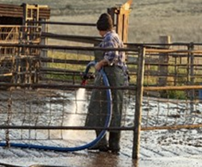 | 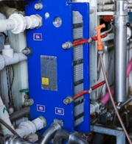 | 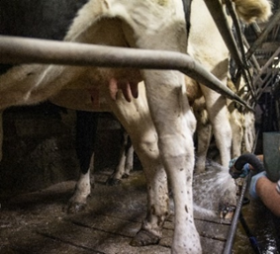
Yard cleaning | Milk cooling | Activities in the pit
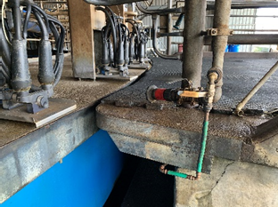 | 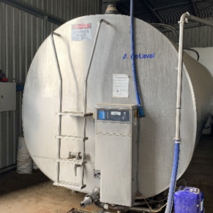 | 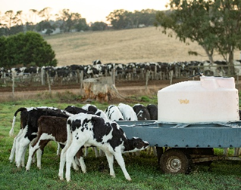
Fixed cluster and  platform sprays | Milking machine and  bulk tank/vat cleaning | Other activities
By recording answers in the spaces provided, the booklet becomes a handy record for future reference. Just remember to use a new booklet for each dairy shed.

Background

Licences are required for dairy shed water use
In Victoria, water for commercial use is regulated by water corporations on behalf of the Minister for Water to ensure the sustainable use of the resource.
Water corporations issue licences to ensure the amount of water taken from streams, rivers, bores, dams and channels is sustainable.
Although the legislation does not currently require water taken from these sources for stock and domestic use to be licensed, all other agricultural uses of water in Victoria, including water for use in dairy sheds, require a licence.
This means:
- all operating dairies require a licence to take and use water
- the volume allocated for dairy shed use in section 51 licences must reflect your actual use
- water used in the dairy shed must be metered in line with national metering standards and Victorian Government policy.

Water corporation | Contact number | Website
Southern Rural Water | 1300 139 510 | https://www.srw.com.au/
Goulburn-Murray Water | (03) 5826 3500 | https://www.g-mwater.com.au/
Melbourne Water | 131 722 | https://www.melbournewater.com.au/
Lower Murray Water | 1800 808 830 | https://www.lmw.vic.gov.au/
Grampians-Wimmera-Mallee Water | 1300 659 961 | www.gwmwater.org.au

Section 1 – Dairy water use statistics
Since 2002, Agriculture Victoria officers have been visiting farms around Victoria to develop effluent management plans for dairy sheds. This included measuring water use or calculating the volume of water used in each of the main processes carried out in the dairy. More than 897 farms had been visited to 2023, and the data from these farms (with complete data sets) has been used to undertake statistical analyses of water use in these dairies.

Daily water use
The volume of water used in each of the 897 dairies visited is presented in Figure 1. Each dot represents the amount of water used in a dairy on a day at mid lactation, or during a time of the year when effluent storage is an issue. The trend line shows there is a strong relationship between water use and herd size, with larger dairies using more water.
Although the volume of water used is correlated to herd size, you will note there is a large variation in water use between high and low users at any herd size. Generally, the highest users do not re-use fresh water for additional processes inside the dairy or recycle effluent for yard cleaning.
Figure 1: Water use per day by herd size, with linear trend line.

Predicting ‘reasonable’ daily water use
Statistics can be used to describe and predict water use trends in a population. The analysis of the large Victorian data set reveals we can expect that 75% of individual dairies would use a daily volume of fresh water below the figures shown in Table 1 below. The 75th percentile threshold has been selected after discussions with industry and is the upper limit of reasonable water use.
Table 1: Predicted 75th percentile for dairy water use per day (L/day) by herd size and dairy type.
Herd Size (milking cows)
Dairy type² | 50-100 | 101-200 | 201-300 | 301-400 | 401-500 | 501-600 | 601-700 | 701-801 | 801-900 | 901+
Swingover | 3240 | 7496 | 12862 | 19955 | 21200 | 12900 | 33700*
Double-up | 5000 | 7739 | 13265 | 18459 | 30000 | 12000*
Rotary |  | 24750 | 22000 | 35572 | 40395 | 35775 | 47500 | 28875 | 45000 | 65000

*Indicates the figure is from a single herd as such there is no reliability in this predicative threshold.
²No figures are presented for walk through or Automatic Milking Systems (AMS) systems due to insufficient data.

Reasonable water use
The original data was collected to work out effluent storage requirements and therefore recorded in litres per day (L/day). However, for licensing or other purposes, it is more convenient to describe water use in terms of megalitres (ML) per year.
Table 2 shows the figures from Table 1 converted into ML per year, after multiplying the figures by 365 days and dividing by 1,000,000 to convert litres to megalitres.
Table 2: Predicted 75th percentile for dairy water use per year (ML/Yr) by herd size and dairy type.
Herd Size (milking cows)
Dairy type² | 50-100 | 101-200 | 201-300 | 301-400 | 401-500 | 501-600 | 601-700 | 701-801 | 801-900 | 901+
Swingover | 1.18 | 2.74 | 4.68 | 7.28 | 7.74 | 4.71 | 12.30*
Double-up | 1.73 | 2.82 | 4.84 | 6.49 | 10.95 | 4.38*
Rotary |  | 9.03 | 8.03 | 12.98 | 14.74 | 13.06 | 17.34 | 10.54 | 16.43 | 23.73

*Indicates the figure is from a single herd as such there is no reliability in this predicative threshold.
²No figures are presented for Walk through or AMS systems due to insufficient data.

These 75th percentile figures are seen by many within the industry as the upper limit of what is ‘reasonable’ dairy water use for different dairy types.

Achievable water use
When we examine the data set, it is important to consider the median figure, this is a critical measure which shows the middle value and is the point in separating the lower half from the top half. The benefit of this method is the value is not skewed by either small or large values in a dataset. This median figure can be seen as an achievable water figure for the dairy types in Table 3 below.
Table 3: Predicted median for dairy water use per day (L/day) by herd size and dairy type
Herd Size (milking cows)
Dairy type² | 50-  100 | 101-200 | 201-300 | 301-400 | 401-500 | 501-  600 | 601-  700 | 701-801 | 801-900 | 901+
Swingover | 2300 | 5260 | 9050 | 11220 | 18250 | 11900 | 33700*
Double-up | 4000 | 5000 | 9000 | 12500 | 30000 | 12000*
Rotary |  | 10000 | 13146 | 22500 | 23883 | 23146 | 29086 | 23049 | 35620 | 35000

*Indicates the figure is from a single herd as such there is no reliability in this predicative threshold.
²No figures are presented for Walk through or AMS systems due to insufficient data.

Figures 2,3 and 4 show the individual water use on the farms based on dairy type. The line displayed on the individual graphs is the 75th percentile line, as mentioned this is the upper limit of what is ‘reasonable’ dairy water use for Victorian dairy farms.
Caution should be exercised regarding the accuracy of 75th percentile when herd size exceeds over 500 cows in swingovers, 400 cows for double-ups, as corrected data for these herds is limited.
Figure 2: Swingover dairies: Calculated annual water use (ML/year) with 75th percentile line for dairy water use by herd size.

Figure 3: Double-up dairies: Calculated annual water use (ML/year) with 75th percentile line for dairy water use by herd size.

Figure 4 Rotary dairies: Calculated annual water use (ML/year) with 75% percentile line for dairy water use by herd size.

Section 2 – Calculating your water use in the dairy shed

Mapping where the water goes
The first step in calculating dairy shed water use is to sketch out how the water moves through your dairy – from the point of entry to the point of exit.
Mapping the flow of water from its source, through the various storage tanks, right through to where it leaves the dairy can help to ensure you account for all water used. It is common to have different sources for different processes, or more than one source for each process depending on the time of the year.
Tracking the various pathways water takes also makes sure you don’t double count it – especially if re-using water from one process for another task in the dairy.
While you are doing this exercise it is worth thinking about the source used for each task. Is the source and quality of water the most appropriate for that task? Are other sources available that are not being utilised – like rainwater for instance?
Draw arrows joining each entry source with the exit point, picking up the storage points, water uses and recycling/re-use options on the way. Add notes/amend as necessary.
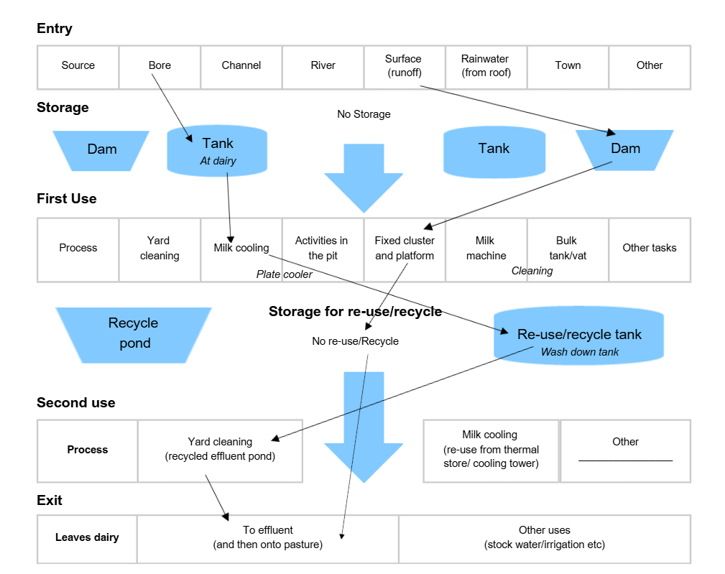
Here is an example of how the map may look.
Your turn – draw arrows showing the various pathways water takes through
your dairy.
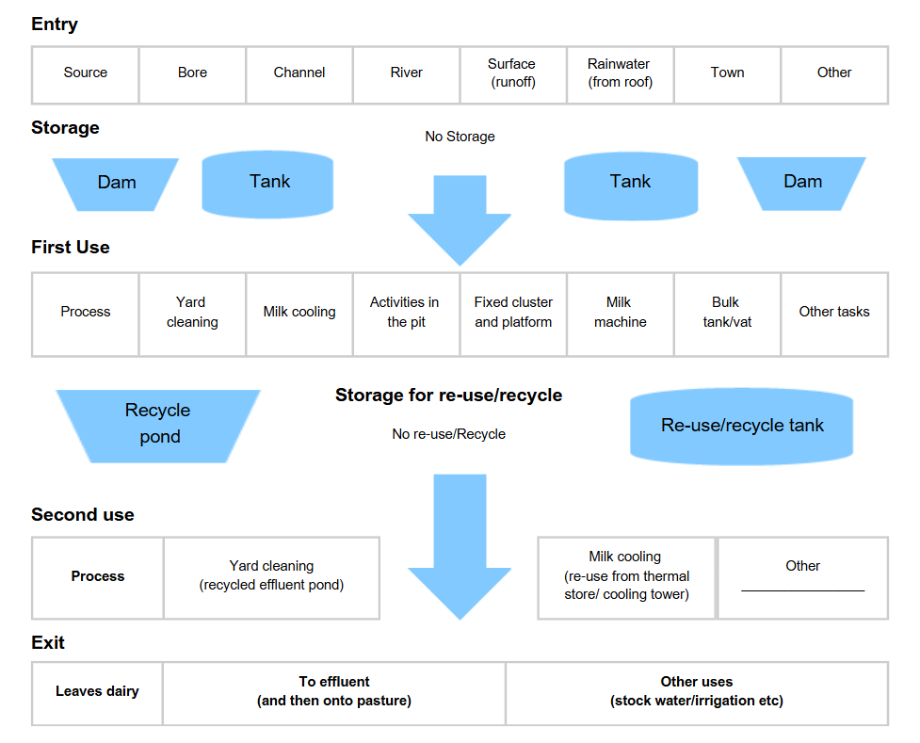

Calculating your current dairy water use
Now that you have mapped how water moves from the point of entry, through the various dairy processes to the point of exit, you can get started calculating the total annual volume of water you use.
You estimate your total dairy water use by calculating the daily water used for each of the dairy processes. Add these together to come up with a total figure.
The remaining pages in this section guide you through how to calculate water use for each process of your dairy shed operation. Generally, the water use estimates are undertaken for a day at mid lactation - as a day representative of average daily water use for the year. Once you have worked out the water used for each process, write your answer in the summary table on page 39.
Finally add up the totals for each dairy shed process in the summary table on page 39 to calculate your total annual dairy shed water use.
Dairy processes that use water
Tasks water is used for | Details on page
Yard cleaning |  | 16
Milk cooling |  | 20
Activities in the pit |  | 21
Fixed cluster and platform sprays |  | 22
Milking machine and bulk tank/vat cleaning |  | 28
Other tasks (include water used for feedpads or contained housing, see Section 3) |  | 33
Total annual use in ML |  | 42
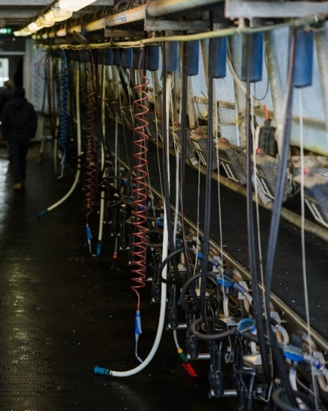 | 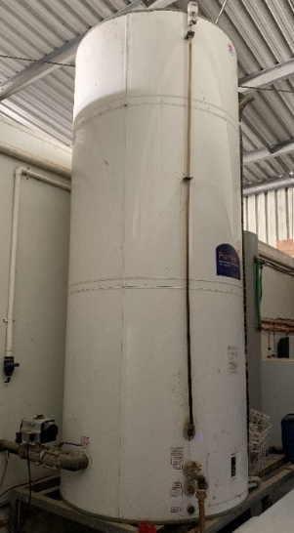

Water for yard cleaning
Yard cleaning represents the largest single use of water in many dairies and includes all water used to wash down the holding yards.
Water facts and figures: Yard cleaning
Hoses | Flow rates can vary significantly so measure each one separately i.e. flow rate measured in litres per minute (L/min) for a 38 mm hose can range between 130 L/min -190 L/min.  High volume, medium pressure hoses deliver around 200 L/min.  Hosing yards can take anything between 10 minutes and 45 minutes per milking.
Hydrants | Can deliver up to 2,000 L/min.  Most outlets only operate for 1-2 minutes at each cleaning.
Flood wash | The volume of flood wash tanks is typically between 20,000 and 30,000 L. Elevated tanks are sometimes smaller.
Pipe risers | You will have to make an educated guess if the yards are cleaned by systems where the flow rates and/or storage volumes cannot be measured, such as in direct-feed pipe riser systems.

Remember:
Include... | Water from the plate cooler used for yard cleaning (it’s much easier to estimate the volume in this section). Include plate cooler water in only one section (don’t double count).
If recycled effluent water  is used (eg for yard wash).... | Only estimate the percentage of ‘new’ top-up fresh water used to supplement the recycled effluent.
Exclude... | Water used by yard hoses that service the pit, these are accounted for later.  Water used by sprinklers or other methods that keep the cows cool or the yard wet. These are picked up in later sections too.

Calculate total water use for each yard cleaning hose

Flow rate method
You will need a watch or phone to count the seconds and a large container of a known volume – an extra pair of hands might help too.
First steps |  | Calculate, then record below | Calculate, then record below | Calculate, then record below
Work out the volume of the measuring container/barrel in litres | Examples  Container-250L | Hose 1  L | Hose 2  L | Hose 3  L
Record how long it takes in seconds to fill the container/barrel | Red hand hose  100 sec | sec | sec | Sec
Estimate average time in minutes spent using hose each day at mid lactation | 45 min | min | min | Min
Estimate the number of days per year the yard is cleaned | 365 days/yr | days/yr | days/yr | days/yr
Calculate
Litres of container/barrel divided by the number of seconds it takes to fill | L/sec  250÷100=2.5 | L/sec | L/sec | L/sec
Litres per second multiplied by 60 seconds in a minute | L/min  2.5×60=150 | L/min | L/min | L/min
Litres per second multiplied by 60 seconds in a minute | L/min  2.5×60=150 | L/min | L/min | L/min
Litres per minute multiplied by average minutes spent using this hose each day at mid lactation | L/day  150×45= 6,750 | L/day | L/day | L/day
Litres per day multiplied by number of days yard is cleaned per year | L/yr  6750×365= 2,463,750 | L/yr | L/yr | L/yr
Add up water used by all hoses and then divide by 1,000,000
Total water volume used by yard cleaning hoses each | 2.5 ML/yr |  |  | ML/yr*
*Transfer this number to final figures: yard cleaning on page 16
Calculate total water use for flood wash and hydrant systems

Storage volume method
If you are unsure about how to calculate the volume of a tank, see page 13.
First Steps Calculate, then record below
Record the volume of the storage tank | Examples  Big Tank-22,500 L | Tank 1  L | Tank 2  L | Tank 3  L
Turn off replenishment valve, estimate proportion of the tank used each day | 40 % | % | % | %
Estimate the number of days per year the yard is cleaned | 365 days | days/yr | days/yr | days/yr

Calculate

Litres of tank multiplied by % of tank used daily, divided by 100 | L/day  (22500×40) ÷100  =9000 | L/day | L/day | L/day
Litres per day multiplied by number of days the yard is cleaned per year | L/year  9000×365= 3,285,000 | L/year | L/year | L/year
Add up water used by all storage tanks and then divide by 1,000,000
Total water volume used by yard cleaning hoses each year | 3.3 ML/yr |  |  | ML/yr*

*Transfer this number to final figures: yard cleaning
on page 16

Final figure: Yard cleaning
There is one last step to go. Add up the figures from the hose and the flood wash and hydrant systems calculations to find the total volume of water used in yard cleaning each year.
Total water volume used by yard cleaning hoses each year | Example  2.5 ML/yr | ML/yr
Total water volume used by flood wash or hydrant systems each year | 3.3 ML/yr | ML/yr
Total volume of water used by yard cleaning each year | 5.8 ML/yr | ML/yr*
 | Transfer this number to the summary table on page 42

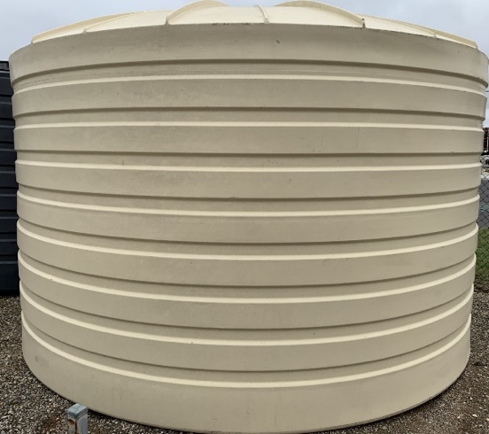
Need a reminder on how to calculate the volume of a tank?
Radius = 1.7 m
Height = 2.3 m
To calculate the volume of a tank: Volume of tank = π x r² x h Where π(pi) = 3.14 Where r = radius (half of the diameter in metres)
Where h = height (in metres) Then to convert volume (m³) into litres (L) multiply the answer by 1,000.
Example
Radius (r)= 1.7 Height (h)= 2.3
Volume (m³) 3.14× (1.7)²×2.3= 20.87

20.87×1,000=20,870L

Need a reminder on how to convert gallons to litres?
Gallons (Aust) | 1,000 | 5,000 | 10,000
Litres | 4,500 | 22,500 | 45,000

Recycling dairy effluent from appropriately designed effluent systems for yard washing reduces water used and storage pond sizing required but can have disadvantages with build-up of salts known as struvites, which is a magnesium ammonium phosphate compound. This is the same chemical that causes kidney stones. Struvite accumulation can reduce pump and dairy effluent system efficiency.
Remember: recycled effluent can only be used outside the dairy.

Water for milk cooling
After yard washing, milk cooling systems often use the next largest volume of water in the dairy. Any water used by the milk cooling system needs to be included in this section – by the plate cooler, cooling tower and associated systems.

Water facts and figures: Milk cooling
Plate coolers | Plate coolers generally use twice the daily milk volume of water to cool the milk. However, this can be variable.  Newer plate coolers with glycol chillers roughly use the same volume of water as the daily volume of milk.
Evaporative cooling towers | Cooling towers fitted with drift eliminators use very little water – less than 2% of the storage volume daily.  Losses from other types can be substantial, particularly if located where the wind can blow the water droplets away.
Closed; pre-cooling systems | Systems like ice-banks or refrigerated thermal stores use very little water.  Assume the water use by these systems is nil.
Gycol cooler | Chiller systems circulate a glycol solution through plate coolers and cools the milk to within 2 degrees of the water temperature. Glycol chillers are an effective refrigeration system that are widely used in dairy farming to keep milk cool and increase its longevity.
Remember:
Allow for new ‘top-up’ water... | Although most water used in evaporative cooling towers is stored and re-used a number of times, new water is required to top these systems up from time to time.  Only include estimates of the volume of water required to top up the system.
Exclude... | Water used for milk cooling if it is then directed to storage for re-use in another dairy process such as yard cleaning – you account for it elsewhere in this booklet, so do not complete this section.  However, if a large proportion of this water is lost (i.e., from an overflowing storage tank) you will still need to complete this section.

Calculate total water use for the plate cooler
Remember not to count plate cooler water again here if it is re-used for yard cleaning or another process in the dairy.
Disconnect the water outlet pipe of the plate cooler so the outflow can be measured. This may require you to attach a flexible rubber hose to the outlet so the flow can be directed to the measuring bucket/barrel.
First steps Calculate, then record below
Work out the volume of the measuring container/barrel in litres | Examples  160 L | Barrel or container  L | Barrel or container  L
Record how long it takes in seconds to fill the container/ barrel once plate cooler is turned on | Plate cooler  120 sec | Plate cooler 1  sec | Plate cooler 2  sec
Average time in minutes the plate cooler water is running per day at mid lactation | 300 min | min | min
Estimate the number of days per year the plate cooler is used | 365 days/yr | days/yr | days/yr

Calculate
Litres of container/barrel divided by the number of seconds it takes to fill | L/sec  160÷120= 1.333 | L/sec | L/sec
Litres per second multiplied by 60 seconds in a minute | L/min  1.333×60= 80 | L/min | L/min
Litres per minute multiplied by average minutes the plate cooler is being used each day in mid lactation | L/day  80×300= 24,000 | L/day | L/day
Litres per day multiplied by number of days plate cooler is used per year | L/yr  24,000×365= 8,760,000 | L/yr | L/yr

Add up water used by all plate coolers and then divide by 1,000,000*
Total water volume used by plate coolers each year | 8.8 ML/yr |  | ML/yr*

*Transfer this number to final figures: milk cooling on page 20

Calculate total water use for evaporative cooling tower systems

First steps Calculate, then record below
Record the volume of the storage tank | Examples  Big Tank-45,000 L | Tank 1  L | Tank 2  L
Turn off replenishment valve, estimate proportion of the tank used each day | 2 % | % | %
Estimate the number of days per year the cooling tower is in use | 365 days/yr | days/yr | days/yr

Calculate
Litres of tank multiplied by % of tank used daily, divided by 100 | L/day  (45,000×2) ÷100  =900 | L/day | L/day
Litres per day multiplied by number of days the cooling tower is used per year | L/year  900×365= 328,500 | L/year | L/year
Add up water used by all storage tanks and then divide by 1,000,000
Total water volume used by evaporative cooling tower systems each year | 0.4 ML/yr |  | ML/yr*
*Transfer this number to final figures: milk cooling on page 20
Remember some plate coolers divert water to flood wash tanks then halfway through milking start to overflow into the yard. This needs to be factored into the calculations.

Final figures: Milk cooling
There is one last step to go. Add up the figures from the plate cooler and evaporative cooling tower systems to find the total volume of water used in yard cleaning each year.
Total water volume used by plate coolers each year | Example  8.8 ML/yr | ML/yr
Total water volume used by milk cooling towers each year | 0.4 ML/yr | ML/yr
Total volume of water used for milk cooling each year | 9.2 ML/yr | ML/yr*
Transfer this number to the summary table on page 42
on page 39

Water for activities in the pit
Activities in the pit that require water include washing the platform, the outside of the clusters and pipe work, pit area as well as washing teats and test buckets etc. These activities are generally undertaken using manually held hoses. This section excludes fixed hoses, or systems that clean the platform and outside of clusters automatically (especially in rotary dairies) because these are accounted for in the next section.
Water facts and figures; In the pit

Teat wash hoses - A typical 12.5 mm teat wash hose delivers around 25 L/min if turned on full. A typical 19 mm hose will deliver about 40 L/min if turned on full. A typical 25 mm hose delivers about 60 L/min if turned on full.
Remember:
Exclude -Hoses that are also used to clean the yard if they have already been accounted for in the ‘yard cleaning’ section. Fixed hoses or sprays that automatically clean clusters and/or the platform as these are accounted for in the next section.

Calculate total water use for activities in the pit

First steps Calculate, then record below
Work out the volume of the measuring bucket/barrel in litres | Examples  Bucket-9L | Hose 1  L | Hose 2  L | Hose 3  L
Record how long it takes in seconds to fill the bucket/barrel | Teat wash hose  27 sec | sec | sec | sec
Estimate average time in minutes spent using hose each day at mid lactation | 60 min | min | min | min
Estimate the number of days per year the pit is cleaned | 365 days/yr | days/yr | days/yr | days/yr
Calculate
Litres of bucket/barrel divided by the number of seconds it takes to fill | L/sec  9÷27=0.33 | L/sec | L/sec | L/sec
Litres per second multiplied by 60 | L/min  0.33×60=20 | L/min | L/min | L/min
Litres per minute multiplied by average minutes spent using this hose each day at mid lactation | L/day  20×60=1,200 | L/day | L/day | L/day
Litres per day multiplied  by number of milking days per year | L/yr  1,200×365= 438,000 | L/yr | L/yr | L/yr

Add up water used by all pit hoses and then divide by 1,000,000
Total water volume used for pit cleaning each year | 0.4 ML/yr |  |  | ML/yr*

*Transfer this number to summary table on page 42

Water for fixed cluster and platform sprays
Fixed cup and platform hoses or sprays are mainly associated with rotary sheds. Their purpose is to keep the platform and clusters clean and wet to ensure that manure doesn’t stick, making cleaning at the end of milking easier.

Water facts and figures: Fixed cluster and platform sprays
Outlets in the dairy - Water use by each outlet can vary enormously - generally set up to deliver between 30 and 90 L/min.
Remember: Exclude water used by manually held hoses. These are being accounted for
in other sections

Calculate total water use for fixed cluster and platform sprays
Before you start, you may need to attach a flexible hose to the outlet to direct the flow into the measuring bucket or barrel.
First steps Calculate, then record below
Work out the volume of the measuring bucket/barrel in litres | Examples Bucket – 25L | Outlet hose 1 | Outlet hose 2 | Outlet hose 3
Record how long it takes in seconds to fill the bucket/barrel | Cluster hose  25 sec | sec | sec | sec
Estimate average time in minutes spent using sprays each day at mid lactation | 300 min | min | min | min
Estimate the number of days per year that sprays are used | 365 days/yr | days/yr | days/yr | days/yr
Calculate
Litres of bucket/barrel divided by the seconds it takes to fill | L/sec  25÷25=1 | L/sec | L/sec | L/sec
Litres per second multiplied by 60 | L/min  1×60=60 | L/min | L/min | L/min
Litres per minute multiplied by average minutes spent using these sprays each day at mid lactation | L/day  60×300=  18,000 | L/day | L/day | L/day
Litres per day multiplied by number days sprays are used per year | L/yr  18000×365= 6,570,000 | L/yr | L/yr | L/yr

Add together water used by all fixed sprays and then divide by 1,000,000
Total water volume used by sprays each year | 6.6 ML/yr |  |  | ML/yr*
*Transfer this number to summary table on page 42

Water for milking machine and bulk tank/vat cleaning
Significant volumes of water are used in the wash regimes to clean the inside of the pipe work, clusters and vat after milking and milk pick-up.
Water facts and figures: Milking machines and bulk tank/vat cleaning
Milking machines | The volume of each rinse and detergent cycle within a wash regime can vary. A general rule of thumb is 5 - 10 litres of water per cluster per cycle per wash.  For example, a 32-unit swingover uses about 8 L x 32 units x 3 cycles per wash x 2 washes per day = 1,536 L/day.
Bulk tank/vat | Older vats require around 1-3% of the vat capacity for cleaning. Newer vats require 1-2% of the vat capacity for cleaning as they are more efficient. Bulk tanks and vats are usually cleaned after every pickup – once daily, twice daily or every other day.  Domestic hot water services used to heat water for vat washing are generally 250 L, 315 L or 400 L in volume.

Remember
Include | Water from sources like rainwater, town water etc.
Exclude | Do not include the cleaning of ancillary milking equipment (i.e. test buckets) or ancillary vats in this section – include these in the next section.

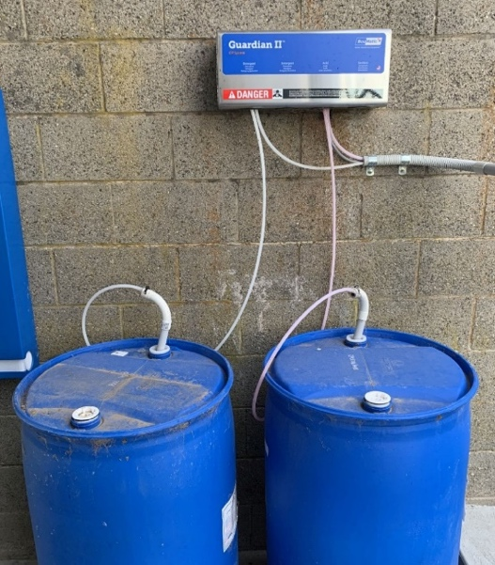

Calculate total water use for cleaning milking machines
When you are working out the total number of times the wash barrel is filled per wash, don’t forget to count all cycles after a milking (i.e., rinse, detergent wash, sanitising rinse).
When you are working out the total number of washes per year, don’t forget to exclude the times when the dairy is not in use. The total number of washes will depend on the number of milkings (and so washes) undertaken at different times of the year (i.e. once, twice or three times daily).
First steps Calculate, then record below
Work out the volume of the wash barrel that is used for cleaning in litres | Examples  Cherry-200 L | Wash Barrel 1  L | Wash Barrel 2  L
Record total number of times the wash barrel is filled per wash | fills/wash  3 | fills/wash | fills/wash
Number of washes per year | 680 washes/yr | washes/yr | washes/yr

Calculate
Litres of wash barrel multiplied by number of fills per day | L/day  200×3 =600 | L/day | L/day
Litres per day multiplied by number of washes per year | L/yr  600×680= 408,000 | L/yr | L/yr

Add up water used by all wash barrels and then divide by 1,000,000
Total water volume used by milking machine cleaning each year | 0.4 ML/yr |  | ML/yr*

*Transfer this number to final figures: milking machine and bulk tank/
vat cleaning on page 28

Calculate total water use for cleaning the bulk tank/vat
There are three ways you can estimate water use for the bulk tank/vat cleaning:
- manufacturer’s specifications method
- method for re-circulating cleaning systems using size of the dedicated hot water service
- ‘Fill and dump’ method.

Method using manufacturer’s specifications
You will need to get a copy of the manufacturer’s specifications for your bulk tank/vat to be able to complete these calculations. Ring your local dealer or try the web if you can’t find the paperwork.
When you are working out the total number of washes per year, consider times when there is no pick-up required, as well as times with twice daily, daily or every other day pick-up schedules.
First Steps
Check the specs for the volume of water used per cycle | Example  Main Vat  L/Cycle  150 | Bulk tank/vat 1  L/Cycle | Bulk tank/vat 2  L/Cycle
Check the specs for the total number of cycles per wash | Cycles/wash  4 | Cycles/wash | Cycles/wash
Number of washes per year | washes/yr  330 | washes/yr | washes/yr

Calculate
Litres per cycle multiplied by number of cycles per wash | L/wash  150×4=600 | L/wash | L/wash
Litres per wash multiplied by number of washes per year | L/yr  600×330=  198,000 | L/yr | L/yr

Add together water used by all bulk tanks/vats and then divide by 1,000,000
Total water volume used by bulk tank/vat cleaning each year | ML/yr  0.2 |  | ML/yr

*Transfer this number to final figures: milking machine and bulk tank/vat cleaning on page 28

Method using size of dedicated hot water service
Only use this method to estimate the water used in newer re-circulating bulk tank/vat cleaning systems where the manufacturer’s specifications are not known.
To determine the volume of the hot water service that is used for cleaning the bulk tank/vat, check the ‘rating plate’ attached to the hot water service – it should state the volume of hot water. Vat technicians report that it is common for the wash programs to use about 1.5 times the volume of the hot water service for each wash.
When you are working out the total number of washes per year, consider times when there is no pick-up required, as well as times with twice daily, daily or every other day pick-up schedules.
First steps
Check the rating plate for the volume of hot water used | Bulk tank/vat  Vat wash | Bulk tank/vat | Bulk tank/vat
 | Hot water service L  400 | Hot water service L | Hot water service L
Number of washes per year | washes/yr  330 | washes/yr | washes/yr
Calculate
Litres of hot water multiplied by 1.5 | L/wash  400×1.5=600 | L/wash | L/wash
Litres per wash multiplied by number of washes per year | L/yr  600×330=  198,000 | L/yr | L/yr
Add together water used by all bulk tanks/vats and then divide by 1,000,000
Total water volume used by bulk tank/vat cleaning each year | ML/yr  0.2 |  | ML/yr
*Transfer this number to final figures: milking machine and bulk
tank/vat cleaning on page 28
This method makes assumptions about the hot water service being sized appropriately, according to the need stated by the manufacturer. Only use this method if the previous method cannot be used.

Method for ‘fill and dump’ systems
If your vat utilises a wash barrel you could estimate the total volume used by counting the number of times the barrel is filled and dumped for every wash. Make sure you account for all cycles in each wash (usually 4 or 5 cycles per wash).
When you are working out the total number of washes per year, consider times when there is no pick-up required, as well as times with twice daily, daily or every other day pick-up schedules.
First steps
Work out the volume of the wash barrel that is used for bulk tank/ vat cleaning in litres | Example  150L | L | L
Record total number of times the wash barrel is filled per wash– count all cycles in each wash | Wash barrel  Vat wash barrel  fills/wash  4 | Wash barrel 1  fills/wash | Wash barrel 2  fills/wash
Number of washes per year | washes/yr  330 | washes/yr | washes/yr

Calculate
Litres of wash barrel multiplied by number of fills per wash | L/wash  150×4=600 | L/wash | L/wash
Litres per wash multiplied by number of washes per year | L/yr  600×330=  198,000 | L/yr | L/yr

Add together water used by all bulk tanks/vats and then divide by 1,000,000
Total water volume used by bulk tank/vat cleaning each year | ML/yr  0.2 |  | ML/yr

Transfer this number to final figures: milking machine and bulk tank/vat cleaning on page 28

Final figures: Milking machine and bulk tank/vat cleaning
There is one last step. Add up all the figures from the milking machine cleaning and bulk tank/ vat cleaning calculations to find the total volume of water used in milking machine and bulk tank/vat cleaning each year.
Total litres used each year for milking machine cleaning: | Example  0.4 ML/yr | ML/yr
Total litres used each year for bulk tank/vat cleaning: |  | ML/yr
Manufacturer’s specification method | 0.2 Ml/yr
Hot water service volume method
Fill and dump method
(Circle which method you used.)
Total volume of water used by milking machine and bulk tank/vat cleaning each year | 0.6 ML/yr | ML/yr
 |  | *Transfer this number to summary table on page 42
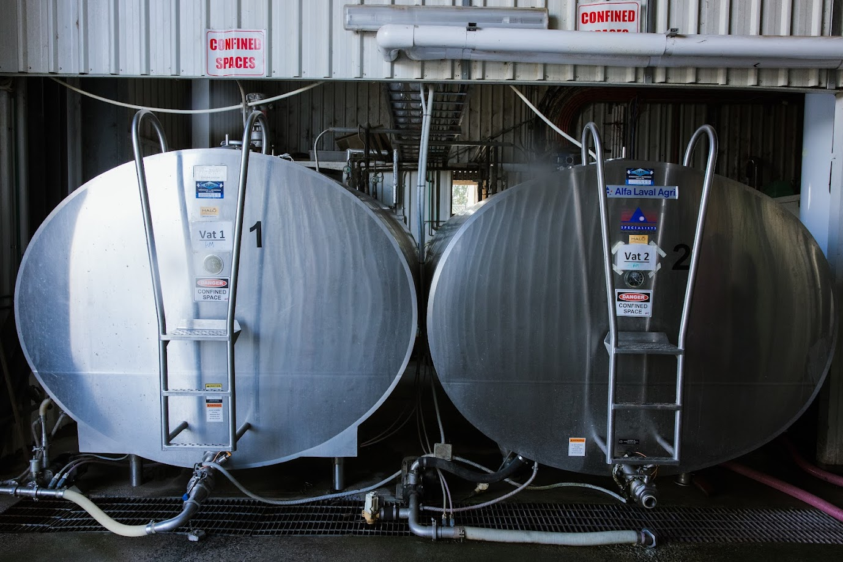

Water for other tasks
Water is required for a range of other tasks – including flushing effluent from feedpads, yard sprinklers, fly mist sprays, washing ancillary milking equipment after milking, calf feeding equipment, ancillary vats, other equipment, cleaning related areas not already included (except for irrigation purposes), showers and toilets in dairy etc.
Water facts and figures: Other tasks
Mister heads | Mister heads use very small volumes
‘Knocker’ type sprinklers | Knocker type sprinklers deliver about 25 L/min at each sprinkler head.  An allowance of 0.5-1 L per cow per hour is common for spray cooling dairy cows.
Garden hoses | Under town pressure (4.5 bar) garden hoses typically deliver about 60 L/min.
High pressure cleaners | These devices typically use 6-10 L/min.
Feedpads/contained housing | Include water used to clean feedpads/contained housing here
Remember
Exclude | Water used for ‘stock and domestic’ and irrigation.

Think about any other tasks that use water in and around the dairy. You can use one of three methods to help you work out the water use:
- flow rate by time method
- fill and dump method
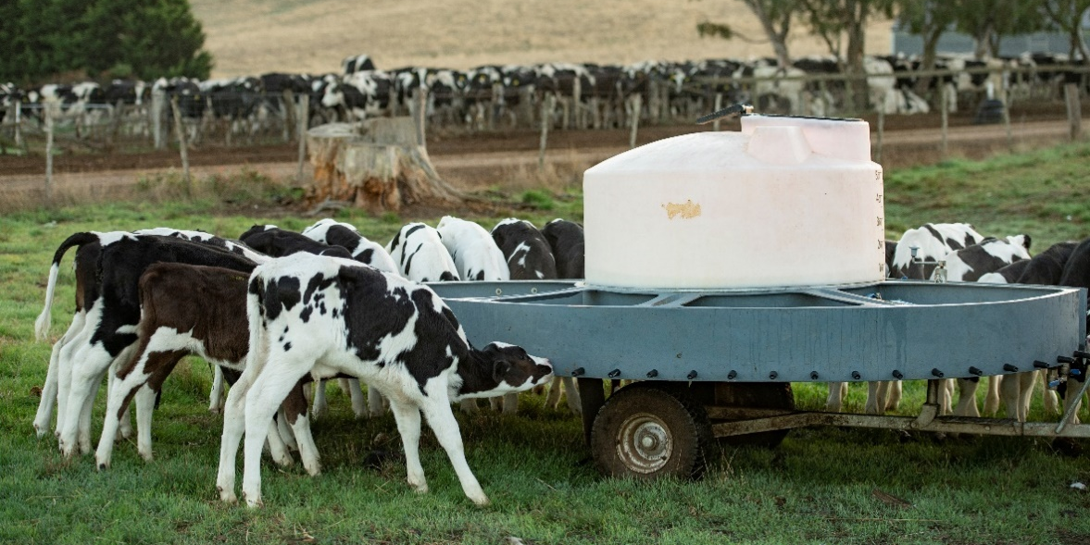
- for sprinklers or misters, most have a maximum flow rate rating.
Almost any water use can be estimated by using one or other of these methods. Choose the most appropriate for your circumstances.

Calculate total water use for other tasks

Flow rate by time method

First steps Calculate, then record below
 |  | Task 1 | Task 2 | Task 3
Work out the volume of the measuring bucket/barrel in litres | Examples  Bucket-25L | L | L | L
Record how long it takes in seconds to fill the bucket/barrel | Task  Equipment hose  19 sec | sec | sec | sec
Estimate average time in minutes spent completing tasks/using hose each day | 15 min | min | min | min
Estimate the number of days per year the task is carried out | 150 days/yr | days/yr | days/yr | days/yr

Calculate
Litres of bucket/barrel divided by the seconds it takes to fill | L/sec  25÷19=1.32 | L/sec | L/sec | L/sec
Litres per second multiplied by 60 | L/min  1.32×60=79 | L/min | L/min | L/min
Litres per minute multiplied by average minutes spent completing tasks/using hose each day | L/day  79×15=1,185 | L/day | L/day | L/day
Litres per day multiplied by number of days other tasks completed per year | L/yr  1,185×150= 177,750 | L/yr | L/yr | L/yr
Add together water used for other tasks and then divide by 1,000,000
Total water volume used used for other tasks each year | 0.2 ML/yr |  |  | ML/yr*
*Transfer this number to final figures: other tasks on page 33

Fill and dump method
Be sure not to include water used in tasks already calculated using the ‘flow rate by time’ method.
First steps Calculate, then record below
 |  | Task 1 (Specify) | Task 2 (Specify) | Task 3 (Specify)
Work out the volume of the container being used for the task. | Examples  Wash trough 150L | L | L | L
Estimate total number of times the container is filled and then emptied per day | Task (specify)  Wash trough  2 fills/day | (specify)  fills/day | (specify)  fills/day | (specify)  fills/day
Number of days per year the task is carried out | 365 days/yr | days/yr | days/yr | days/yr

Calculate
Litres of container multiplied by the number of fills per day | L/day  150×2=300 | L/day | L/day | L/day
Litres per day multiplied by number days per year the task is carried out | L/yr  300×365= 109,500 | L/yr | L/yr | L/yr
Add together water used by all of these tasks and then divide by 1,000,000
Total water volume used by these tasks each year | 0.1 ML/yr |  |  | ML/yr*

*Transfer this number to final figures: other tasks on page 33

Maximum flow rate rating method
If your sprinklers and misters have a maximum flow rate rating, use this to estimate their water use in L/min. This way eliminates the need for manual measurement. Just multiply the flow rate rating by the number of sprinkler outlets.
First steps Calculate, then record below
 | Example  Yard Sprinklers | Sprinkler system 1 | Sprinkler system 2
Number of sprinkler outlets in use | outlets  8 | outlets | outlets
Look up flow rate of  sprinkler outlets | L/min  60 each | L/min | L/min
Average time in a day the sprinkler system runs | Min  100 | min | min
Estimate number of days per year the system is used | days/yr  60 | days/yr | days/yr
Calculate
Litres per minute multiplied by number of sprinkler outlets to give total litres per minute | L/min  60×8=480 | L/min | L/min
Litres per minute multiplied by average time in minutes sprinkler system runs per day | L/day  480×100=48,000 | L/day | L/day
Litres per day multiplied by number of days per year the sprinkler system is used | L/yr  48000×60=  2,880,000 | L/yr | L/yr
Add together water used by all sprinkler systems and then divide by 1,000,000
Total water volume used by these tasks each year | 2.9 ML/yr |  | ML/yr

*Transfer this number to final figures: other tasks on page 33

Final figures: Other tasks
There is one last step for this section. Add up all the figures from the different tasks to give your total volume used in all other tasks requiring water in the dairy per year.
Total litres used each year for other tasks | Example
Flow rate by time method (specify task) | Equipment hose  0.2 ML/yr | ML/yr
Fill and dump method (specify task) | Wash trough  0.1 ML/yr | ML/yr
Maximum flow rate rating method (specify task) | Sprinklers  2.9 ML/yr | ML/yr
Total volume of water used by other tasks each year | 3.2 ML/yr | ML/yr
*Transfer this number to the summary table on page 42

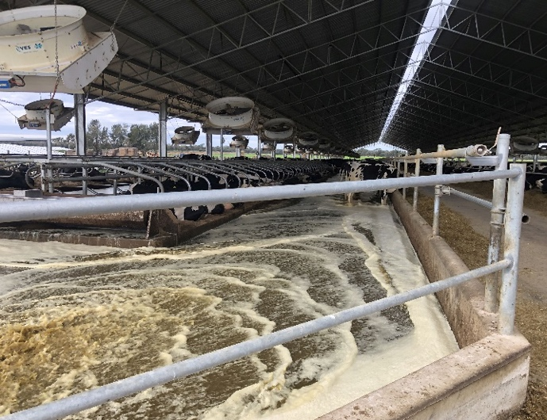 | 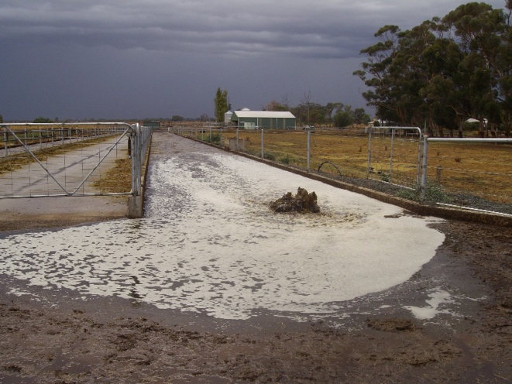

Section 3 – Contained dairy housing, and Automatic Milking Systems (AMS)

Feedpads and contained dairy housing
The following section is replicated from the National Dairy Feedpads and Contained Housing Guidelines, 2024.
A key step before constructing a dairy complex, is understanding the volumes of water beyond typical stock drinking water, that are required to operate the facility. Water is required for:
- flushing and removal of effluent from cow alleys
- supplying cooling systems such as sprinklers
- servicing any automatic milking systems housed within the facility
- cleaning manure build up around facility entry and exits points
- cleaning manure from around troughs in raised crossover sections
- pressure spraying mechanical stationary screens used in the solid separation process.
The amount of water required to operate cooling systems, remove manure, bedding material and flush cow alleys can be significant for various facilities depending on herd capacity and occupation times and should not be under-estimated.
These volumes are in addition to any water requirements to milking areas where they are separate from the housing system.
For example, concrete feedpads using flush systems have recorded consumption rates of more than 61,000 litres of water per cleaning cycle for a 500-cow herd. In contained housing facilities, water volumes to flush cow alleys several times throughout the day has been recorded at more than 400,000 litres per day. Some facilities catering for much larger herds, (i.e. more than 3,000 cows) budget on a total water use of 780,000 litres per day.
From a site planning perspective there are critical decisions to be made. These include:
- Where will this water be sourced from and is it a reliable all year-round?
- How will this water be stored and delivered to the facility to match volume and peak demand?
- How will the quality of the water be monitored and maintained?
- How many times throughout the day should cow alleys be flushed?
- How will this water be captured and collected at the end of the facility?
- How will it be stored, reused or irrigated to fodder crops and pastures?
- What options are available to utilise recycled effluent from the effluent storage pond?
There are several factors, from a design perspective, which influence the overall water consumption required to operate these facilities and the frequency in which cleaning processes are used.
It is critical in the planning phase of the development to estimate expected water consumption.
Typically, water requirements for cow alleys will depend on the width and length of area being cleaned, the roughness co-efficient of the concrete and slope, with a recommended minimum depth of wave height of 50mm and a recommended velocity of 1 metre per second to adequately remove deposited manure or 1.5 metres per second for sand bedding deposited in the cow alley.
For example, a concrete alley of 5m width and length of 160m would require an estimated 24,400 litres per flush for cleaning at a 1% slope, compared to 14,300 litres per flush, should the slope be set at 2%.
Dry scraping prior to flushing can reduce the volume of water required for wash down.
A key starting point in understanding potential water consumption is commencing with the existing dairy complex* and conducting a full water audit to determine if overall water use is compatible with industry water use data for a similar herd size and dairy type. Once the dairy complex consumption has been determined, available tools such as effluent design calculators can be used to estimate potential water use. Combining this information will not only assist with reviewing the manure system requirements, but also assist in identify options for recycling effluent to reduce freshwater consumption.
It is also important to consider evaporation rates from farm dams, particularly if used to supply the facility with freshwater, as volumes and supplies may be compromised during the summer months.
*Dairy complex: Land where dairy cattle are milked, contained, loaded or unloaded; manure and effluent are stored and treated, cattle feed is prepared, handled or stored. The dairy complex does not include manure and effluent reuse areas (Dairy Australia and Agriculture Victoria. 2023).

Automatic milking systems
In this section we discuss the potential water consumption of automatic milking systems (AMS). It is important to remember the information contained in this section only covers the water used by the AMS system itself.
The water consumption required for plant cleaning such as cleaning the AMS boxes themselves or cleaning the races and yards associated with the machine are not included. Vat wash is also not included. Understanding potential water requirements is important for planning green-field developments.

In most AMS water use occurs in three components
- Milk clean: Which occurs every time a cow is milked described below as ‘milking event’, the amount used depends on settings used and the type of AMS
  - local cleaning
  - cleaning of teats and udders
  - rinsing after each milking.
- System or main clean: Which occurs two to three times a day depending on set-up. These cleans comprise hot and cold washes and disinfectant.
  - pre-rinse
  - main clean
  - post rinse.
- Separation clean: In several machines there is a milk quality system, that analyses and detects non-drinking quality milk. Once milking finishes, lines are flushed.
Water use is not evenly distributed between these areas with the main cleaning requiring the most water.
A limited number of studies have examined the water use requirements of AMS as a guide to potential water consumption.
A study conducted in Ireland of a 49-cow herd water consumption of 445 L/day per machine, and a per milking event figure of 4.3L was observed (Shortall et al. 2018).
A study in the Czech Republic found the average water consumption per milking was 3.48L, a daily figure per unit was not provided. To determine an estimate of the water used the study found however, an average of 2.7 milking per cow per day and approximately 100 cows a daily figure of 940L was calculated (Vaculík et al. 2021).
The results from overseas studies have shown that water consumption is not consistent throughout the year. With several factors being identified as contributors, such as: performance, detections of non-drinking quality milk, and climatic conditions.
The influence and impact on water use by the number of separations required can be seen by Vaculík et al. (2021) with 45.5L a day recorded from 3.5 separations. High water use in some systems was due to the machine not being used to its capacity, and the running of main cleans when the machine was inactive.
Care is to be taken, as most AMS are not generally set with water conservation as a main objective. The reduction of programmed cleanings can impact milk quality, due to scaling of the milk pipes as well as contributing to increasing cell counts.
For farmers to better understand the water use in their AMS operation, a key recommendation is to install water meters to better track their water use and be very clear on the specifications outlined by the supplier.

Section 4 – Water saving options
Now you should have a good idea about reasonable water use, achievable water use (from Section 1) and how much water you are using in the dairy shed (from Section 2).
How does your current use compare with the reasonable water use for your dairy type on page 4?
Which part of your operation uses the most water or has the best scope for water savings?
Minimising dairy water use can reduce farm costs for water, pumping and storage. Conserving supply is also an ever-increasing priority on many farms, for our rural communities and for the environment.
Check back to the map you created on page 8. Is there an alternative source of water that is not being utilised? Are you using an appropriate water source for each of the dairy processes? What about capturing rainwater from the roof of the dairy and surrounding sheds?
Some of the main options for reducing water use in your dairy are detailed below, together with some sources of further information.

Yard cleaning
Water efficient dairy sheds can use a smaller proportion of the water used by less efficient dairy sheds. A key reason for this efficiency is these farms re-use water from the second effluent pond for yard wash. The reduced water and less solids arriving in the ponds equates to a smaller pond system being required.
- Recycle water by diverting plate cooler water into storage tanks for reuse, for example in yard cleaning.
- Recycle water by installing a second effluent pond and using this water for yard cleaning. Large single ponds are also sometimes suitable if set up with recycling in mind. Recycled effluent water should not be used inside the dairy shed. Consideration should be given to whether flood washes, hydrants or hoses are used with recycled second pond effluent.
- Handle the cows quietly and minimise the time they spend standing in the yard to reduce the amount of manure that needs to be cleaned up.
- Use high-volume, low-pressure systems to clean yards effectively.
- When designing new dairy yards or feedpads, utilise appropriate slopes and dimensions to promote cow flow and movement and site wash-down outlets to suit.
- Fix leaking pipes and hoses.
- Use yard scrapers and backing gate designs to breakdown manure deposits before cleaning.
- Calculate the volume of water required to clean yard, rather than dumping the whole tank every milking.
Re-evaluating the source of water used for dairy wash can pay big dividends. Is there a cheaper source and/or a less wasteful option to clean your yards?

Further information
Contact your local Agriculture Victoria office and ask for the Dairy Services Team or visit https://agriculture.vic.gov.au/livestock-and-animals/dairy/managing-effluent for the latest information on effluent management.
Saving water in dairies. Information sheets from Dairy Australia. Available at https://www.dairyaustralia.com.au/land-water-and-climate/water/saving-water-on-farm#.Yo6_c6BByUk

Milk cooling
Dairies can use large volumes of water for pre-cooling milk every day. A large proportion of farmers already save water by directing the used plate cooler water for yard wash or use a thermal store so the water can be used again and again.
- Set up a system to store and re-use plate cooler water. Consider a modern cooling tower or thermal store to cool the water prior to re-use.
- Consider collecting water from the roof to top up the tanks storing water for milk cooling.
- Ensure the plate cooler is not over-using water. Check with your technician that it is correctly sized and set up. Industrial plate coolers use less water for cooling a given volume of milk and so are more efficient.
- Link plate cooler water flow rate to milk pump flow rate with variable speed pumps or switches so that the water flow rate is proportional to milk flow rate.
- Turn off the water supply to the plate cooler immediately after cows have left the platform.
- Decommission old evaporative cooling towers, particularly if they lose excessive water through spray drift.

Further information
Contact your local milking machine technician or dairy refrigeration specialist.
Saving water in dairies. Information sheets from Dairy Australia. Available at https://www.dairyaustralia.com.au/land-water-and-climate/water/saving-water-on-farm#.Yo6_c6BByUk
Farm Environmental Tracker is an environmental self-assessment tool, which can assist in measuring your farm’s performance and identify improvement opportunities. Available at https://myda.dairyaustralia.com.au/env/s/login/
Information about the regulations to control Legionella in cooling towers in Victoria is available at https://www.health.vic.gov.au/water/cooling-tower-systems

Activities in the pit
It is easy to spray lots of water around when milking – particularly if you are waiting for cows to finish milking out. In times of short supply this is one area where small savings can be made with little effort. However, do not compromise milk quality or udder health when looking for water savings.
- Re-use water by diverting warm plate cooler water into a storage tank for pit use.
- Repair and replace broken nozzles or leaking hoses.
- Equip hoses with trigger (spring-loaded) nozzles that must be held open.
- Pre-wet pipe work, clusters, walls and concrete to prevent manure sticking to surfaces.
- Use mesh gloves to help remove manure from surfaces.
- Use good quality water and individual wipes to clean and dry teats prior to milking.

Further information
Saving water in dairies. Information sheets from Dairy Australia are available at https://www.dairyaustralia.com.au/land-water-and-climate/water/saving-water-on-farm#.Yo6_c6BByUk

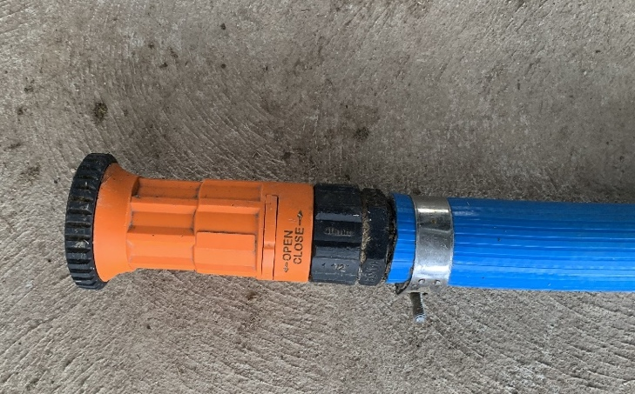 | 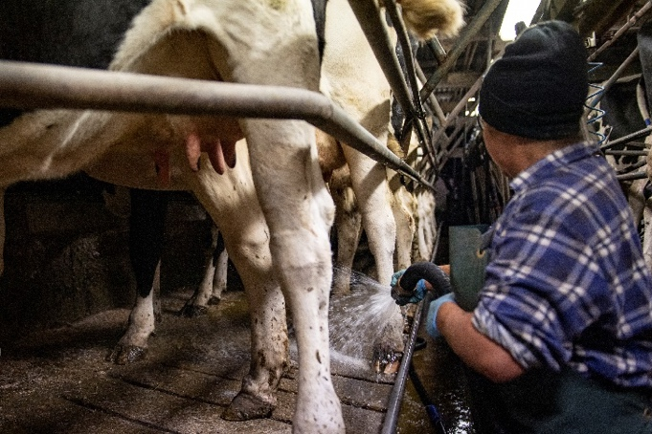

Fixed cluster and platform sprays
Fixed hoses can use huge quantities of water which is difficult to capture for re-use in the dairy.
- Size pump, hose and nozzles to deliver desired water volume at low to medium pressure.
- Turn off cup and platform sprays immediately after cows have left the platform to reduce unnecessary wastage.
- Consider using platform spray strategically, rather than for the entire milking (i.e. for the last round only).

Further information
Saving water in dairies. Information sheets from Dairy Australia are available at https://www.dairyaustralia.com.au/land-water-and-climate/water/saving-water-on-farm#.Yo6_c6BByUk

Milking machine and bulk tank/vat cleaning
Reducing the quantity of water used for cleaning the milking machine and the bulk tank/vat may put milk quality at risk. Generally, only small amounts of water can be saved and changes to the cleaning regimes should only be attempted in association with your dairy hygiene adviser and dairy company field officer.
- Your milking machine technician or vat supplier may be able to adjust the cleaning program to get the same results with less water. Savings are only likely to be minor, but they may be significant in times of severe shortage.

Further information
Contact your local milking machine technician, vat supplier or dairy hygiene adviser. Saving water in dairies. Information sheets from Dairy Australia are available at https://www.dairyaustralia.com.au/land-water-and-climate/water/saving-water-on-farm#.Yo6_c6BByUk

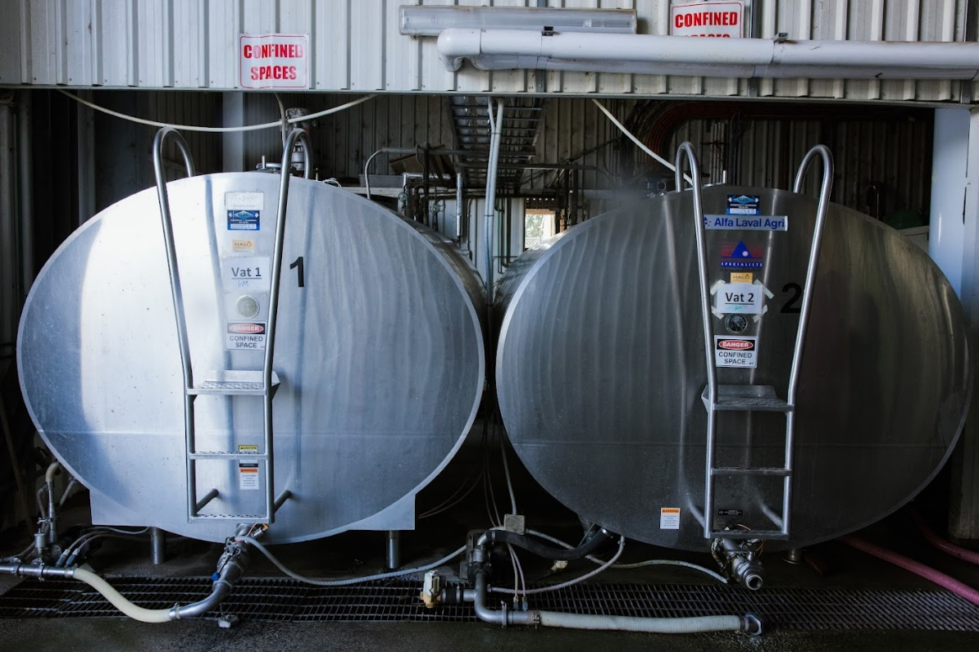

Other tasks
Substantial quantities of water can be used for other tasks, particularly if the systems are left running for prolonged periods such as holding yard sprinkler systems.
- Consider providing shade, improving air flow and changes to cow management to reduce the need to use water to cool cows.
- Run yard sprinklers at ‘2 minutes on - 10 minutes off’ to conserve water when cooling cows.
- Ensure the water used is effective in doing its job.
- Use detergents to improve cleaning efficiency.
- Fix leaks and install water efficient appliances.
- Use high pressure cleaners to clean off vehicles, machinery or other tasks.

Further information
Contact your local Agriculture Victoria office and ask for the Dairy Services Team or visit https://agriculture.vic.gov.au/livestock-and-animals/dairy/managing-effluent for the latest Information notes on effluent management.
Saving water in dairies. Information sheets from Dairy Australia are available at https://www.dairyaustralia.com.au/soils-and-water#.Yo6_c6BByUk
Cool cows – dealing with heat stress in Australian dairy herds. Booklet from Dairy Australia is available at https://www.dairyaustralia.com.au/resource-repository/2023/08/11/feeding-cool-cows-research-fact-sheets

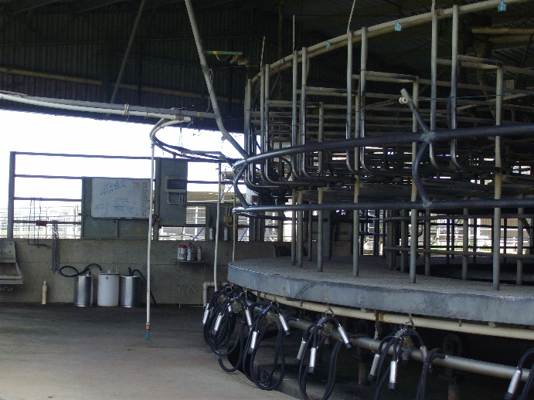 | 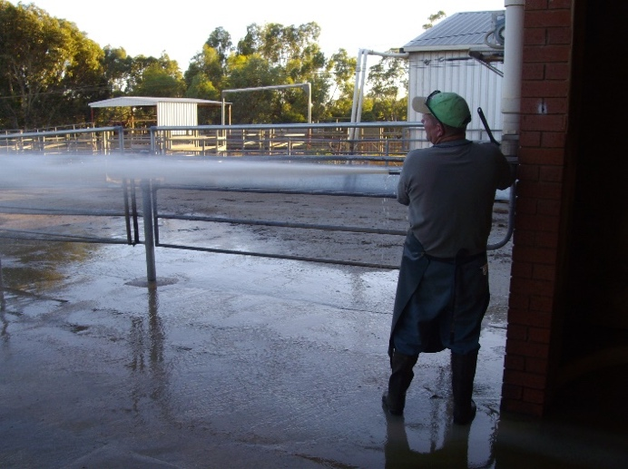

Summary of total annual dairy water use

Farmers name: Date of estimate:
Address of dairy:
No. of milking cows:
Dairy type (please circle): Double up Swingover Rotary Other

Write the totals from each of the dairy processes into the summary table.
Process water is used in: | Water source(s) | Annual volume
Yard cleaning  (pages 10-13) |  | ML/yr
Milk cooling  (pages 14-17) |  | ML/yr
Activities in the pit  (pages 17-18) |  | ML/yr
Fixed cluster and platform sprays  (pages 19) |  | ML/yr
Milking machine and bulk tank/vat cleaning  (pages 20-25) |  | ML/yr
Other tasks (Please specify)  (pages 26-30) |  | ML/yr
Total volume in megalitres (ML) |  | ML/yr

Based on my calculations from all parts of our dairy shed operation, the estimated total annual water volume currently used for our dairy is:

ML/yr

Notes

References
Dairy Australia and Agriculture Victoria (2024). National Guidelines for Dairy Feedpads and Contained Housing. Melbourne, Dairy Australia.
Shortall J, O'Brien B, Sleator RD and Upton J (2018) ‘Daily and seasonal trends of electricity and water use on pasture-based automatic milking dairy farms’, Journal of Dairy Science, 101 (2) 1565-1578.
Vaculík P, Jehlička T, Kažimírová V and Smejtková A (2021). ‘Water Consumption in the Automatic Milking Systems’, Acta Technologica Agriculturae, 24 (3):136 - 142.


Keep this booklet for your records

