BeeMAX
Victoria’s new beekeeper registration and surveillance system

If you keep bees in Victoria, you must be registered with Agriculture Victoria. This is a requirement under the Livestock Disease Control Act 1994 and Regulations 2017.

What is BeeMAX?
Agriculture Victoria has launched the new BeeMAX beekeeper registration and surveillance database to help all beekeepers work together with government to protect our valuable apiary industry.
BeeMAX strengthens Victoria’s bee biosecurity by combining and enhancing the existing registration and surveillance databases used by beekeepers and Agriculture Victoria apiary staff. It will make sharing information between more than 9000 Victorian beekeepers and government faster and easier.
Using this real-time beekeeper and surveillance data will improve our reporting and analysis helping to identify trends and increase our understanding of potential or actual threats to bee health and the apiary industry.
Creating a BeeMAX account is free, quick and easy to use. For more information or to create your new BeeMAX account visit www.agriculture.vic.gov.au/bees
If you haven’t received your registration renewal or you are having trouble setting up your BeeMAX account contact the Beekeeper Registrar on 1800 356 761.
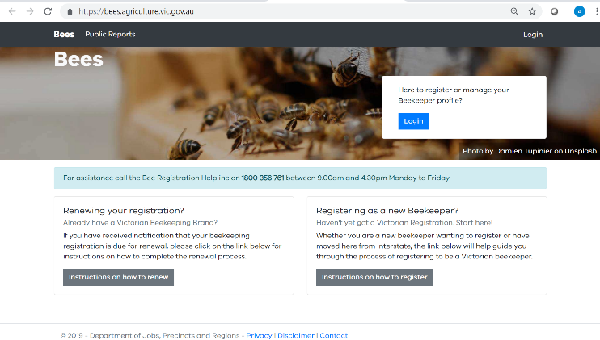

What can I use BeeMAX for?
All beekeepers will need a BeeMAX account to register or renew their registration. Once you have created your BeeMAX account you can maintain your own record and update your contact details, hive numbers and apiary site locations in real time.
Best of all, the electronic diary function in BeeMAX is a one stop shop to record all your biosecurity activities and observations including:
- pest and disease inspections and testing
- swarm collection data
- the movement of bees and equipment; and
- biosecurity training completed.
Keeping a record of your biosecurity activities is now mandatory and using the electronic diary in BeeMAX is one way to meet your record keeping obligations in the Livestock Disease Control Regulations 2017 (Regulations).

how will beemax help protect our honey bees?
The Regulations were updated on 12 June 2019, adopting the requirements in the Australian Honey Bee Industry Biosecurity Code of Practice. The aim of making these changes is to improve the standard of beekeeping across Victoria.
BeeMAX is the next step to protect Victoria’s apiary industry. We will use the data captured to identify trends, potential risks and improve our preparedness and emergency response capability for an exotic honeybee pest or disease.
It wasn’t long ago that Victoria’s beekeeping industry was threatened by the deadly Varroa mite when it was intercepted at the Port of Melbourne in 2018.
Government, industry and the community worked together to respond to the detection and, thankfully, there have been no further detections since.
This was only possible because of the information provided to Agriculture Victoria by beekeepers, through their registration and surveillance activities. It was a reminder to everyone to be vigilant in protecting Victoria’s apiary and pollination industries.

Is the information in beemax protected ?
Absolutely. Any beekeeper information provided to the department can only be accessed by departmental apiary staff for the purposes of administering the Livestock Disease Control Act 1994 and Regulations 2017.
The department is committed to protecting your privacy. All personal information will be handled in accordance with the department's Privacy Policy and the Privacy and Data Protection Act 2014. Information may be provided to Victorian and local government agencies, where it is deemed necessary to identify hive ownership.
For more information, a copy of the privacy statement can be found at www.djpr.vic.gov.au/privacy. Enquiries can be directed to the department's Privacy officer by email at: privacy@agriculture.vic.gov.au

acknowledgement
This factsheet was produced by Cynthia Kefaloukos, Apiary Pest and Disease Officer, Chief Plant Health Officer Unit, February 2020

