Prescription/treatment information – Large animals – Side 1
The information provided sets out for vets to discuss with clients about the treatment that has been provided to their animals.
Your pet received antibiotics today – this means your vet:
Check box - Found evidence of a bacterial infection that may not improve without antibiotics.
Check box - Investigated and treated any underlying non-bacterial diseases.
Check box - Considered other treatment options.
Check box - Took a sample to identify the bacteria and the effective antibiotics.
Check box - Selected the appropriate drug, dose and duration to treat the infection.
Check box - Referred to Australian antibiotic prescribing guidelines.
It is important that you:
- Give the antibiotics as prescribed on the label even if symptoms improve.
- Monitor your animal/s closely and contact your vet if it does not improve or have side effects.
- Schedule vet revisits if requested.
- Understand that further tests and treatments may be required if the condition does not improve.
Play your part in preventing antibiotic resistant infections.
For more information visit agriculture.vic.gov.au/amr
Not All Bugs Need Drugs
Agriculture Victoria logo

Prescription/treatment information – Large animals – Side 2
Why didn’t your pet receive antibiotics today?
Check box – Your vet has assessed your animal/s and decided antibiotics are not necessary right now.
Check box – Many conditions, like viral infections, will get better without antibiotics.
Check box – Further tests may be required to decide which antibiotic to use, if any.
It is important that you:
- Give any medications as prescribed and follow your vet’s advice.
- Monitor your animal/s closely and contact your vet if they do not improve or has side effects.
Why animals should only receive antibiotics when absolutely necessary?
- Antibiotic use can cause ‘resistance’, where the bacteria adapt so the antibiotic no longer works.
- You can catch antibiotic resistant bacteria from your animal/s, meaning antibiotics may not work next time you get sick.
- Antibiotics can upset the natural balance of good bacteria in the body and cause negative side effects.
- Some antibiotics can also cause negative side effects or allergic reactions.
Play your part in preventing antibiotic resistant infections.
For more information visit agriculture.vic.gov.au/amr
Not All Bugs Need Drugs
Agriculture Victoria logo
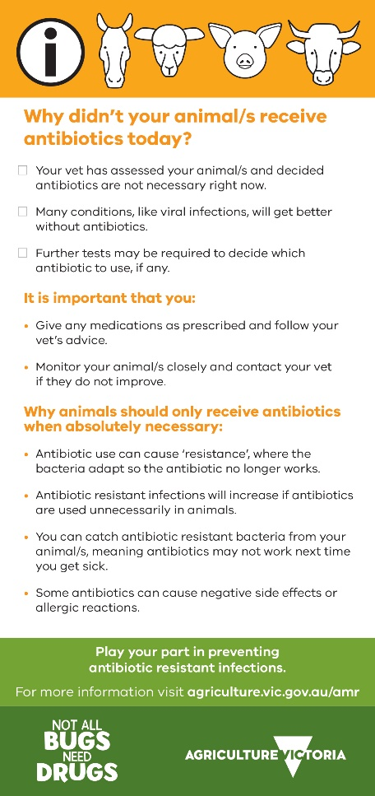
Developed and designed by Agriculture Victoria
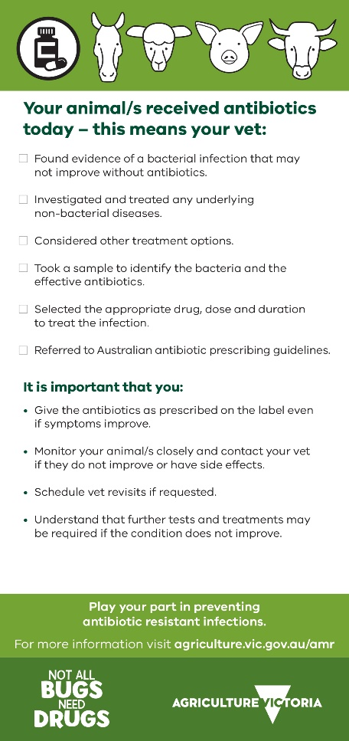

Play your part in preventing antibiotic resistant infe

