Agriculture Victoria
Livestock Exporters’ Manual
for NLIS in Victoria

liveSTOCK Exports
in Victoria

Foreword
Victoria is Australia’s largest food and fibre exporter, accounting for 25 per cent of Australian food and fibre exports. In 2017-18, our state’s total food and fibre exports were valued at $12.8 billion. Our red meat industry is heavily reliant on export markets with over 60% of boxed red meat being exported.
In addition to this the value of the live export trade in Victoria was $301 million in 2016, of which 34% were breeding dairy cattle destined for China. Trading partners expect excellent standards and high integrity in the certification of both boxed and live exports. Traceability forms an integral part of this supply chain confidence.
The live export industry is worth $1.5 billion to the Australian economy and is a significant trade market for the livestock sector. Without continued improvement in the integrity of the live export trade Australia and the red meat industry runs the risk of losing live export markets and affecting other livestock product markets.

Ben Fahy
Manager Livestock Traceability
Agriculture Victoria
Contents

Accessibility 3
Foreword 2
The Importance of the National Livestock Identification System (NLIS) 4
The NLIS 4
What are the requirements 4
Industry requirements 5
Meeting your requirements 5
Functionalities of a Live Exporter NLIS Database Account 6
Capabilities on Live Exporter NLIS accounts 7
Victorian Port PIC’s 8
Definitions 8
Contacts 9
Fact Sheet: NLIS Requirements for Livestock Exporters 10
Fact Sheet: Transferring Livestock on the NLIS Database- Livestock Exporters 13

Accessibility
If you would like to receive this publication in an accessible format, please telephone Department of Jobs, Precincts and Regions Customer Service Centre on 136 186.
This document is also available in PDF and Word format at www.agriculture.vic.gov.au on the Livestock Exporter page.

The Importance of the National Livestock Identification System (NLIS)
The NLIS is Australia’s system for identifying and tracking livestock and is underpinned by legislation in each state or territory. Individual industry sectors, including Livestock Exporters, must meet their legislated requirements to ensure accurate and complete information can be obtained through the NLIS database for individual livestock as required.
Identification and traceability of livestock from property of birth to point of slaughter is vital in ensuring long term protection of Australia’s local and international markets. Livestock which have been cleared for live export have to meet importing country requirements and traceability must be maintained from property of origin through to the point of export.

The NLIS
The NLIS combines three elements to enable the lifetime traceability of livestock.
- Identification of a physical location by means of a Property Identification Code (PIC)
- Individual animal identifier (a visual or electronic ear tag known as a device)
- Web-accessible database to store and correlate movement data and associated details

As livestock are bought, sold and moved along the supply chain, they must be tagged with an NLIS accredited tag or device. Each movement they make to a location with a different PIC is recorded centrally on the NLIS database through an individuals’ NLIS account. NLIS accounts are free to open and operate.
Using the livestock movement information stored on the database, the NLIS provides a life history of an animal’s residency, determines where livestock have congregated and identifies which livestock have been in contact with each-other.
The information in this manual provides guidance to Livestock Exporter requirements when exporting from Victoria, how to meet these requirements, background information and where to find additional resources. This document relates specifically to Victorian requirements, for interstate requirements please check with local jurisdictions.

What are the requirements
NLIS requirements in Victoria are legislated under the Livestock Disease Control Act 1994 and Livestock Disease Control Regulations 2017 which set out requirements for individual industry sectors, including Livestock Exporters, to regulate and maintain identification and traceability requirements.
Agriculture Victoria has a compliance program for the Livestock Exports industry, non-compliance with requirements may result in investigation by Agriculture Victoria.

Industry requirements
- Individual livestock are required to be tagged with an approved NLIS device, breeder or post-breeder, prior to dispatch from the property.
- Movements of livestock between properties of different PICs must be recorded on the NLIS database.
- Movements must be recorded within 2 days of the introduction of livestock onto a property.
- Where livestock are moved off the property, they must be transferred to the appropriate destination PIC. For exported livestock, this is to the Port PIC then to EEEEEEEE. If livestock are rejected from export, this may be through a saleyard or directly to another property. The responsibility for transfer is with the owner who introduces the livestock onto the property or alternatively with saleyard managers if sold through a saleyard.
- Livestock which die on property should be transferred to ‘deceased’ on the NLIS database.
- Current Holdings can be monitored through the ‘Active Devices on PIC’ report found on your NLIS database account. Current Holdings should not continuously build up on a pre-export quarantine property PIC as animals are largely being introduced and moved off the property within a short time frame. If an animal is no longer physically on the property but has not been transferred to the appropriate destination PIC, it will be displayed in the ‘Active Devices on PIC’ report, this gives an inaccurate record of where livestock physically are located.

Meeting your requirements
In order to maintain the traceability of individual livestock throughout their lifetime, each animal needs to be identified according to requirements prior to dispatch from their property of birth.
White breeder tags are applied to cattle prior to dispatch from their property of birth. If a tag is lost or is a non-functioning tag, it is replaced with an orange post-breeder device, unless it is still on its property of birth.
Electronic (Sheep & Goat) NLIS tags come in year of birth colour breeder tags and pink post breeder tags. The appropriate tag must be applied.
Movement information needs to be recorded using the relevant individual NLIS devices for the livestock being moved and the PICs of properties the livestock are introduced to. It is the responsibility of the owner of any cattle, sheep or goats introduced to or dispatched from a property, to ensure that the movement is recorded on the NLIS database within 2 days after the introduction of those animals or, prior to removal from the property if earlier than 2 days after introduction.
- Transfers must be recorded on the NLIS database within 2 days of the introduction.
- For Livestock Exporters, this includes transfers from pre-export quarantine properties to Port PICs and subsequently to EEEEEEEE when exported.
Inaccurate current holdings build up where an RFID is listed against a PIC and the animal is no longer physically on that property. This occurs when animals are not transferred to their destination PIC when moved off the property.
- It is your responsibility to ensure accurate movements are recorded when animals are moved off the property for export.
- If an animal was not exported, it should not be transferred to EEEEEEEE.
If you export sheep or goats, NLIS requirements in Victoria require sheep and goats born in Victoria after 1 January 2017, and sheep or goats born interstate after 1 January 2019 and introduced to a Victorian property, to be identified with an Electronic (Sheep and Goat) NLIS tag, prior to dispatch from the property.

Functionalities of a Live Exporter NLIS Database Account
The NLIS database is a web-accessible database used to store and correlate movement data and associated details required for livestock traceability. When animals are moved from one property to another with a different PIC, the movement is recorded centrally on the NLIS Database by people with NLIS accounts which are free to open and operate.
In order to complete movement upload information and meet your requirements, you will need to apply for and have access to a NLIS database account.
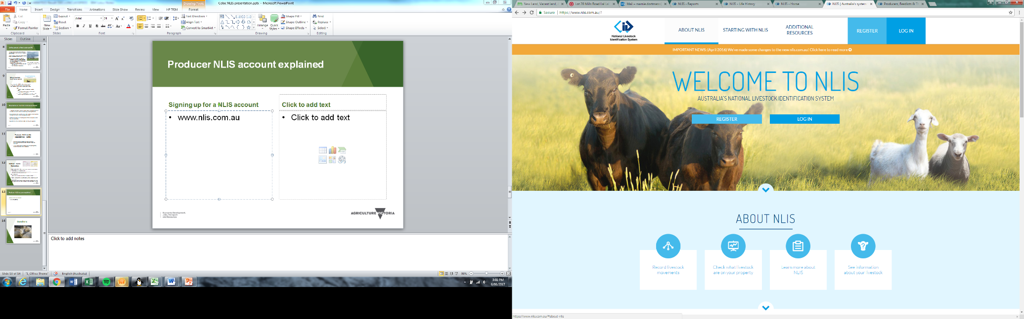
To sign up or log into the NLIS database: www.nlis.com.au.

Capabilities on Live Exporter NLIS accounts
There are many more capabilities of a Live Exporter NLIS account than listed. By logging into your NLIS account and scrolling through the drop-down list (I want to…) you will be able to explore these in more detail. The help tools function at the top of the NLIS log in screen lists all the tech tips available to assist you in completing and understanding NLIS transfers and reports.
Tech-tips for many of these report capabilities are available at: www.nlis.com.au/General/Help/HelpTools2.aspx
- Change contact details- how to change your contact details. NOTE- ensure your email is correct as all NLIS emails will be sent to the email address linked to your NLIS account.
- Livestock movements- how to transfer livestock onto and off your property. Note: It is the responsibility of the owner of any cattle, sheep or goats introduced to or dispatched from a property, to ensure that the movement is recorded on the NLIS database within 2 days after the introduction of those animals or prior to removal from the property if earlier than 2 days after introduction.
- Transfer correction- how to correct or remove one or all devices in an NLIS upload.
- Assign device status- how to place a status on a device; eg. Lost, inactive or damaged.
- Deceased livestock on PIC- how to transfer a device to deceased on the NLIS database. This must only be completed for animals that are known to be dead. If this transfer is completed an animal cannot be transferred on the NLIS database in future.
- Replaced tags transaction- how to link an old NLIS device (non-reading, ripped out) with a new NLIS device.
- Beast enquiries report- allows you to check the PIC of consignment (source PIC), RFID, NLISID, EU status of individual animals.
- Check ERP PIC status- check if a device has an Extended Residue Program status linked to it.
- Livestock movement reports- reports that show all NLIS uploaded animal movements onto or off your PIC within a certain date range.
- Active devices on PIC report- report which includes all active devices listed against your PIC.
- PIC reconciliation- manual and file upload- how to complete a PIC reconciliation to determine and upload the actual number of devices (used & unused) listed against your PIC.
- Search the PIC register- how to search a PIC to find out the owner and location of their property.
- Boxed cattle query- allows you to identify which PICs may have consigned animals that have been boxed together at a previous transit centre or export depot.
- Period on consigning PIC
- Properties of Residence for LiveExport

Victorian Port PIC’s
Livestock Exporters are required to ensure transfers are completed from pre-export quarantine properties onto the relevant port PIC prior to transferring to EEEEEEEE. For full traceability of individual livestock, it is important to know which port livestock have been exported from. It is also important that the livestock transferred to EEEEEEEE, is an accurate representation of animals that have been exported.
In order to complete transfers onto and off a port PIC as required, you will need to have the Port PIC listed against your NLIS account.
The PICs for Victorian ports are listed:
- Port of Portland Pty Ltd 3PTAR001
- Tullamarine Airport 3PTAL003
- Avalon Airport 3PTAW007
- Port of Geelong 3PTAC006
- Port of Melbourne 3PTAF005
- Gippsland Ports 3PTAT008
Once animals are exported, they must be transferred to EEEEEEEE within 2 days of export.

Definitions
- National Livestock Identification System (NLIS)- National system for identifying and tracking livestock in Australia.
- Property Identification Code (PIC)- Code of letters and numbers identifying a point where livestock are kept, agisted, congregated and/ or sold. A legal requirement and allow records of contact details for owner/ manager of livestock on that property.
- Pre-export Quarantine Property- Property used to congregate live export consignments for period of time prior to shipping. Required to be registered as an approved facility with Department of Agriculture, Water and Resources (DAWR). Animals may re-enter the national trade from these properties if rejected for export.
- EEEEEEEE (8E’s)- Property Identification Code used to identify ‘exported’ status, livestock must be transferred to 8E’s within 2 days of being exported.
- NLIS Device- Accredited NLIS tag affixed or not affixed to livestock.
- Radio Frequency Identification (RFID)- Internal microchip number specific to individual NLIS devices.
- NLIS ID- External number printed on individual NLIS devices, correlates on the NLIS database to the RFID of that device.
- Current Holdings- NLIS devices recorded against a PIC. Current Holdings build up if livestock are not transferred to their appropriate destination PIC after leaving the property, this then gives an in-accurate representation of where livestock are located.
- EU Status- Eligibility of livestock to be sold to European Union markets and whether they meet the EU Cattle Accreditation Scheme requirements.

Contacts
If you require further information or assistance regarding your NLIS requirements, contact details or other information, various contacts are listed below.
- For NLIS Database assistance, contact the NLIS Database Helpline: support@nlis.com.au or 1800 654 743
- For Agriculture Victoria PIC assistance, contact the Agriculture Victoria NLIS Helpline: 1800 678 779
- For enquiries about NLIS transfers and assistance within Victoria, contact Senior Officer NLIS (Agriculture Victoria): 03) 5336 6835
- For general information or to access Agriculture Victoria NLIS information, visit www.agriculture.vic.gov.au
- For NLIS Database information and to apply for a database account, visit www.nlis.com.au



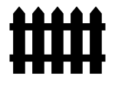
It is vital that livestock can be identified and tracked from their property of birth to slaughter. Traceability- the ability to follow an animal from one point in the supply chain to another – enables monitoring for disease, food safety and underpins protection of Australia’s local and international markets.
As a business involved in the congregation, transportation and mixing of livestock, ensuring that you use robust traceability practices and meet legislative requirements is very important.

-

INTRODUCTION

Live
stock

E
xporters, including operators of a quarantine property/depot must meet a
number of
requirements including livestock identification, National Livestock Identification System (NLIS)
d
atabase
transfers and movement declarations, to support their industry and to work within the legislated
requirements.

Live
stock

E
xport companies, q
uarantine properties and depots must have a:

Property Identification Code (PIC)

All properties where livestock are grazed or kept, congregated for transport or sale, or
properties where a livestock business operates, require a PIC. This defines the
property where
livestock are kept and who has responsibility for the livestock.

PICs can be applied for online at
pic.agriculture.vic.gov.au

or by calling the Agriculture Victoria NLIS
Helpline
1800 678 779
.

National Livestock Identification System
(
NLIS) database account

Live exporters and associated agents require a live exporter or an agent NLIS database
account in order to record livestock movements. A live exporter’s or an agency Property
Identification Code (PIC) is used when applying for a NIS

database
account.

A NLIS account can be applied for online at

www.nlis.com.a
u

or by calling
1800 654 743
.

PROPERTY TO PROPERTY

MOVEMENTS OF LIVEST
OCK

A property to property movement occurs when an animal moves between two different PICs. This includes
introductions onto pre
-
export quarantine properties, ports and transfers to EEEEEEEE

(8
E’s
-

exported)
, as
well as private sales of animals, animals being agisted or lent and animals traded through online selling
platforms such as AuctionsPlus, Gumtree and
Facebook.

Fact Sheet: NLIS Requirements for Livestock Exporters
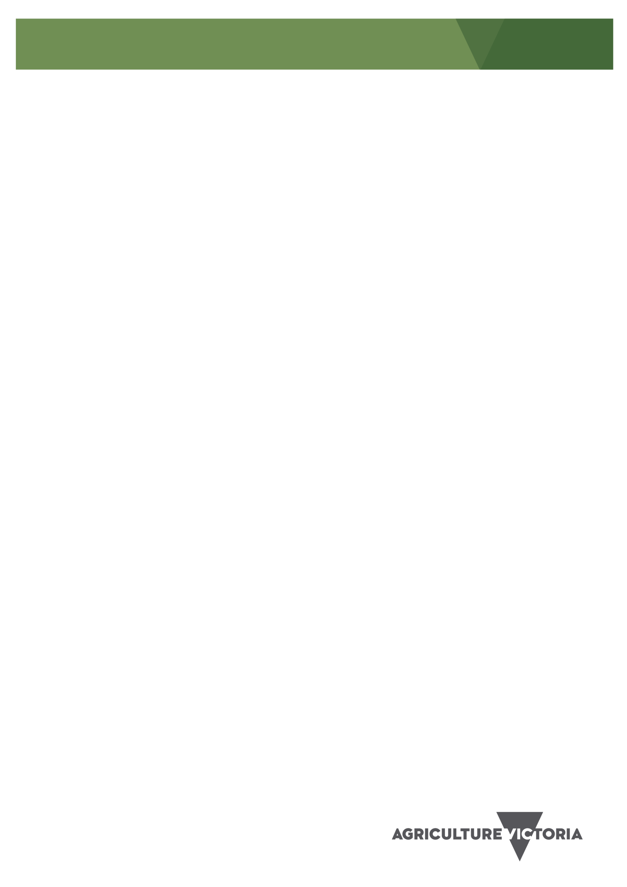

All livestock must be transferred onto the appropriate PIC on the NLIS database within
2
days

of
introduction onto a property, port or export vessel/plane.

The NLIS database transfer is the responsibility of the owner of the introduced livestoc
k, but a third party
may be engaged to complete the transfer, including the livestock agent or livestock manager.

Legislation
requires a Livestock Exporter to complete the required transfer of livestock to EEEEEEEE when exported.

EXPORT CERTIFICATION

Liv
e
stock

E
xporters are required to apply for export certification prior to livestock being moved to a pre
-
export quarantine property or depot. The certification includes a statement from the
L
ive
stock

E
xporter that:

•

cattle to be exported are NLIS identified
and registered on the NLIS database against the PIC on
which they currently reside

•

all movements of the cattle from each property, until they are exported or rejected for export,
will

be
recorded on the NLIS database by the live exporter, including
to any

assembly
/
depot

properties
,
port

PIC and from there to the ‘exported’ PIC EEEEEEEE (8E’s)
.

CORRECTLY TAGGED LIV
ESTOCK

Cattle, sheep and goats must remain tagged with an NLIS
-
accredited tag or device from dispatch off the
property of birth to slaughter or e
xport.

Cattle:

•

breeder tags are white and are used to permanently identify cattle before they leave their
property of birth.

•

post breeder tags are orange and are used to permanently identify introduced cattle, not already
identified or that have lost their original tag.

Sheep and goats:

•

breeder tags are multi coloured and are used to permanently identify sheep and goats before

they leave their property of birth.

•

post breeder tags are pink and are used to permanently identify introduced sheep and goats, not
already identified or that have lost their original tag.

Sheep or goats born post 1 January 2017 must be tagged with an el
ectronic NLIS tag.

Sheep or goats born interstate post 1 January 2019 must be tagged with an electronic NLIS tag prior to

dispatch from a Victorian property.

NLIS cattle and sheep tags can be ordered online at
tags.agriculture.vic.gov.au

or by calling
18
00
678
779
.

CONTACTS

Agriculture Victoria Contacts

Agriculture Victoria NLIS Helpline operates between 9.00am and 4.30pm Monday to Friday.

Phone: 1800 678 779

Website
:

www.agriculture.vic.gov.au/nli
s

NLIS Database Helpdesk Contacts

NLIS Ltd operates the NLIS Database Helpdesk from 9am
-
5
pm (Sydney time), Monday
-
Friday.

Phone: 1800 654 743

Email
:

support@nlis.com.au

Livestock traceability protecting your livestock, your neighbour
s
’

and the viability of the entire industry
.

ACCESSIBILITY

If you would like to receive this publication in an
accessible format, please
Department of Jobs, Precincts
and Regions Customer
Service Centre on 136 186.

This document is also available in
PDF or Word

format at
www.
agriculture
.vic.gov.au



Fact Sheet: Transferring Livestock on the NLIS Database- Livestock Exporters
It is vital that livestock can be identified and tracked from their property of birth to slaughter. Traceability- the ability to follow an animal from one point in the supply chain to another – enables monitoring for disease, food safety and underpins protection of Australia’s local and international markets.

Transferring livestock on the NLIS Database

Property to
P
roperty National Livestock Identification System (NLIS) transfers

The operators of properties receiving cattle, sheep or goats in preparation for live export are required by law
to record the movement on the NLIS database within
2
days

of arrival of the livestock onto the property. All
movements of cattle, sheep or goats

between two different PICs, including to the port and exported (8Es)
must be recorded on the NLIS database and are termed
P
roperty to
P
roperty movements.

Live
stock

E
xport companies, operators of quarantine/depot facilities and their contracted agents nee
d to
work together to complete NLIS transfers as required. The live exporter, as owner of the livestock, is
responsible for the transfers being done correctly.

The following information
must

be uploaded to the NLIS database when cattle, sheep or goats arrive at a
property, a port or are exported

•

NLIS ID or RFID number for each animal (NLIS tags external and internal numbers)

•

PIC of the place where the livestock are moving from

•

PIC of the plac
e where the livestock are moving to (EEEEEEEE for export)

•

date of the movement

•

vendor declaration serial number

Live exporter NLIS account

Persons managing NLIS transfers must have a NLIS
database
account in order to transfer livestock

between PIC’s
.
NLIS

a
ccounts can be applied for at

www.nlis.com.a
u

or
by calling
1800 654 743
.

Cattle can be transferred in a number of ways on the NLIS database including the use of specifically
designed software as an interface
.

Live
stock movements related to export

Each arrow indicates where an NLIS transfer is required (movement of livestock to a different PIC), also
known as Property to Property transfers
.







Collection, quarantine properties and depots

Property to
P
roperty transfers are required when livestock move between each of these properties if
they have a different PIC.

Ports

Victorian Port PICs start with a 3PT. All livestock must be transferred on the NLIS database from the
previous property or depot to the port where the livestock were loaded onto the vessel or plane.

It is important that the port NLIS transfer is compl
eted so the port where the livestock left

Australia is known for tracing purposes
.

Exported livestock

All livestock being exported must be transferred from the port PIC to EEEEEEEE (8Es) on the NLIS
database once they have left the port. This signifies that livestock have been exported.

Failure to accurately transfer livestock to E
EEEEEEE

results in the
livestock being registered
against a property PIC on the NLIS database where they will remain as
current h
oldings on that
property forever. This does not allow accurate tracing of livestock
.

Rejected animals

Any
livestock

that are rejected at any stage along the export process must be transferred on the
NLIS database to the correct property PIC within 2 days of their arrival. The only exception is if an
animal goes directly to a saleyard or processor where the saleyard man
agers and processors are
responsible for notifying the database.

The correct National Vendor Declaration with the correct
property of dispatch PIC must be used.

Communication of correct information to the NLIS database is a legal requirement under the Liv
estock
Disease Control Act 1994 and penalties apply for non
-
compliance
.

Property 1

Property

blood testing
(
)

Property 2

Property 3

Quarantine Property / Depot

Port

Exported

Rejected
livestock

Property

Saleyard

Processor

CONTACTS

Agriculture Victoria Contacts

Agriculture Victoria NLIS Helpline operates between 9.00am and 4.30pm Monday to Friday.

Phone: 1800 678 779

Website
:

www.agriculture.vic.gov.au/nli
s

NLIS Database Helpdesk Contacts

NLIS Ltd operates the NLIS Database Helpdesk from 9am
-
5
pm (Sydney time), Monday
-
Friday.

Phone: 1800 654 743

Email
:

support@nlis.com.au

Livestock traceability protecting your livestock, your neighbour
s
’

and the viability of the entire industry
.

ACCESSIBILITY

If you would like to receive this publication in an
accessible format, please
Department
of Jobs, Precincts
and Regions Customer Service Centre on 1300 502 656

This document is also available in
PDF or Word

format at
www.
agriculture
.vic.gov.au

