Setting up a Live Export NLIS Database Account

The National Livestock Identification System (NLIS) database is operated by Integrity Systems Company (ISC). It holds movement records for NLIS accredited devices using their RFID and/or associated NLIS ID numbers, along with information regarding individual animals, residue, disease and market access statuses.

Accessing the NLIS Database
Live Exporters (including operators of quarantine properties/ depots and their associated agents) must have a Live Exporter NLIS database account on the NLIS database and obtain a user ID and password in order to record livestock movements.
The below information details how to apply for a Live Exporter NLIS database account.

Step 1:
Access the NLIS database at: www.nlis.com.au
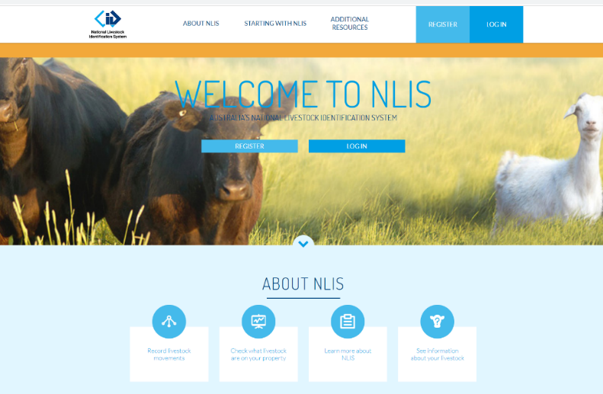

Step 2:
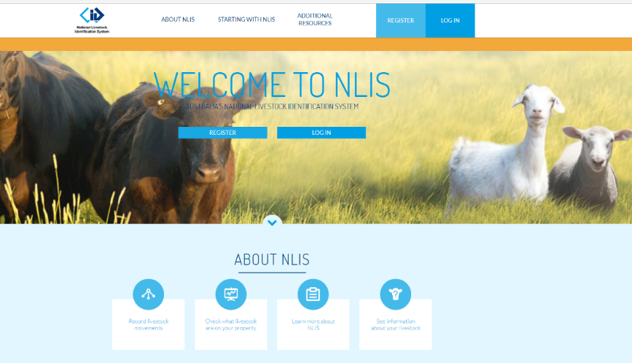
Click on the ‘Register’ button on the home page.

Step 3:
Fill in your details as directed. Options will appear step by step after agreeing to the NLIS Terms of Use.
You will be prompted to indicate what type of account you are applying for, eg: Producer or other (Live Exporter).
You will need to have a Property Identification Codes (PIC) or your agent PIC and an email address to complete the information required.
Please be aware that new account requests may need to be validated by your State authority. It could take up to 7 days for the account to be activated.
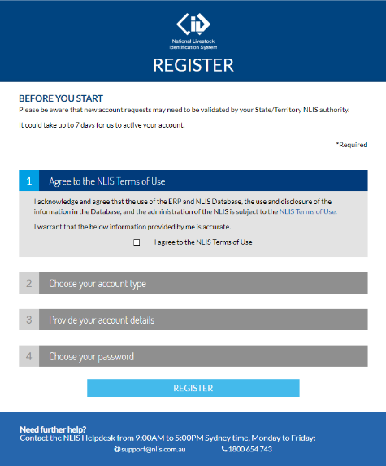

Step 4:
Your details will be added to the system and you will receive an email with a secure username and password to access your NLIS information.

Additional information:

Agriculture Victoria Contacts
Agriculture Victoria NLIS Helpline operates between 9.00am and 4.30pm Monday to Friday.
Phone: 1800 678 779
Website: www.agriculture.vic.gov.au/nlis

NLIS Database Helpdesk Contacts
Integrity Systems Company operates the NLIS Database Helpdesk from 9.00am-5.00pm (Sydney time), Monday to Friday.
Phone: 1800 654 743
Email: support@nlis.com.au

Livestock traceability protecting the viability of the entire industry.

