BestWool/BestLamb – Group Profile
South West Prime Lamb Group – August 2022

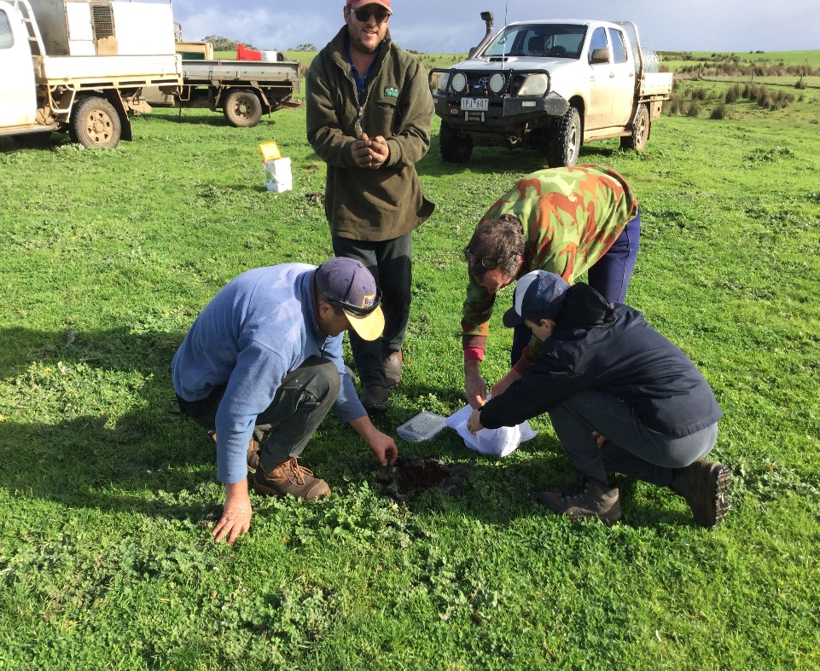

Releasing dung beetles (Bubas bison) at the Keiller’s property Cashmore Park.

Group coordinator Esmee de Looff
Group project officer Kate Joseph
Agriculture Victoria demonstration coordinator Bindi Hunter
District Hamilton, Heywood, Cashmore, Cavendish
Enterprise mix prime lamb, merino, cattle.
Dung beetles have been the focus of on-farm demonstrations underway with the South West Prime Lamb Group (SWPLG). Despite a wealth of cattle related research, there is limited research on dung beetles in sheep production systems.
The group established an Enhanced Producer Demonstration Site (EPDS), co-funded by Agriculture Victoria and Meat & Livestock Australia (MLA) and sought support through the Dung Beetle Ecosystem Engineers (DBEE) project.
Johno, Brigita and Dean Keiller hosted dung beetle demonstrations on their property ‘Cashmore Park’ near Portland. The Keillers were interested in the nutrient cycling qualities of dung beetles and had released several colonies around ten years ago to establish more species on their farm.
Establishing what’s out there
Cashmore Park was one of eight farms to undertake monthly trapping , with an aim to identify beetle activity within sheep dung at different times of the year. By understanding these time frames, seasonal gaps can be found and filled by introducing varying beetle species.
Nine species were found on ‘Cashmore Park,’ including six introduced and three native species. A further two species were found on other group members’ properties.

Onthophagus taurus was the most commonly trapped beetle, found from late spring to autumn in large numbers. O. taurus is a small, introduced beetle, but in the large numbers observed at Cashmore Park, they are capable of shredding dung pats within a day, making them valuable for cleaning pastures and cycling nutrients. The three-horned dung beetle, Onthophagus mnisznechi (Fig. 1), was also found in good numbers throughout the year burying sheep dung. This native species evolved to feed on the coarse pellet-like droppings of marsupials and was previously dismissed as a non-dung burier but proved it is adapting to livestock dung with dung-filled tunnels observed to a depth of 20 cm.

Most of the species trapped at Cashmore Park are active over the warmer months and a noticeable gap in abundance was observed in winter and early spring. To help bridge that gap, Johno has selected three winter-active species (Othophagus vacca, Bubas bison and Copris hispanis) and has established on-farm dung beetle nurseries to breed up populations for release.

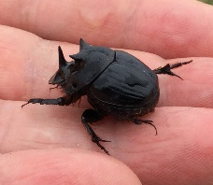

Figure 1: Native three-horned beetle
Benefits for soil fertility
The Keillers also hosted dung burial trials to demonstrate and measure changes in soil fertility from the action of the winter-active species Bubas bison on three different soil types. Bubas bison is one of the four deep tunnelling dung beetles found in Australia, known to bury dung to 60cm. The trial compared 50x50 cm plots of Dung+Beetles, Dung Only and Control (no dung or beetles). Five kilograms of sheep dung was added over ten weeks to the Dung+Beetle and Dung Only plots and 15 pairs of B. bison were added to the Dung+Beetle plots. Spare plots were excavated in spring to observe the action of dung beetles, and soil testing was undertaken across treatments the following winter at 0-10, 10-30 and 30-60cm.
Figures 2- 6 show the excavated plots including dung tunnels approximately 40cm long and around 2.5cm across found beneath the beetle plots, with egg chambers at the base. Large numbers of earthworms were found under the plots and wrapped around the dung tunnels and plant roots had clearly travelled down the soil profile through dung tunnels.
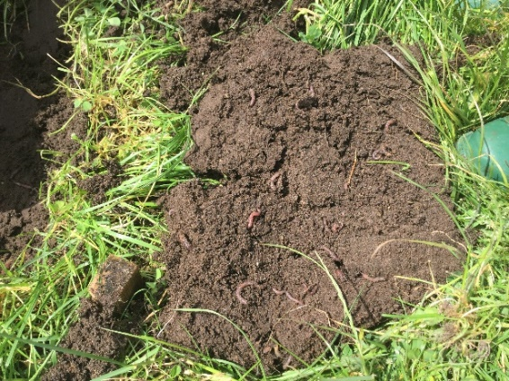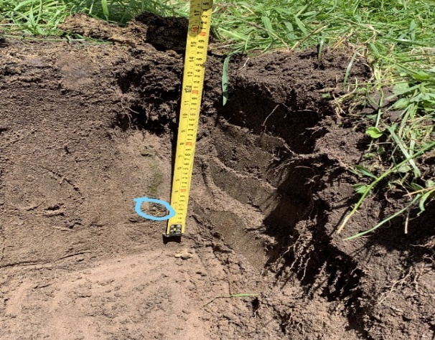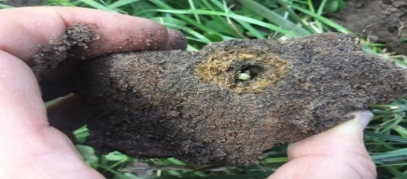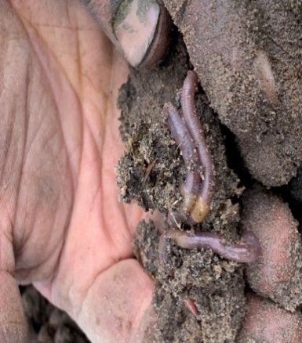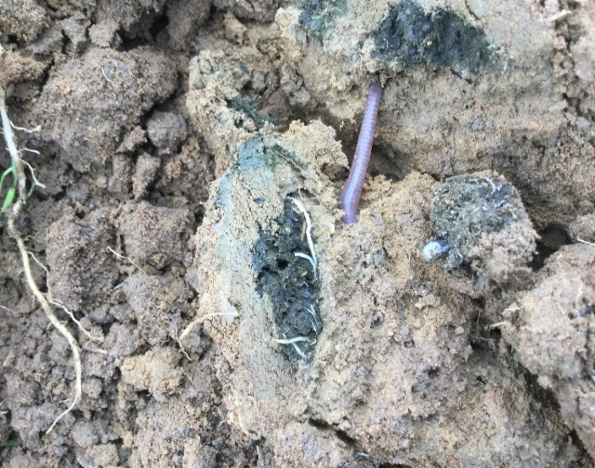
3
4
5
6

Figure 2. Plant roots and an earthworm travelling through the dung tunnels.
Figure 3. Dung beetle egg buried at 37cm in dung tunnel.
Figure 4. Part of the tunnel containing a dung beetle egg in a ball of dung.
Figure 5 & 6. Large numbers of earthworms were found under the Dung+ Beetle plot.
Soil testing showed that the burial action of dung beetles had increased phosphorus (Olsen P) and potassium (Colwell K) to depth (Figs. 7 and 8). Dung Only plots had the highest surface phosphorus and potassium levels, however dung beetles had mobilised nutrients moving them down the soil profile into the 10-30 and 30-60 cm.
We would expect that the tunnelling activity from dung beetles and the increased nutrient levels at depth drives plant roots further down the soil profile, allowing them to access moisture from deeper down. This action could potentially increase the growing season, with removal of dung from the surface also reducing pasture fouling and the potential for nutrient runoff.

Figure 7: Dung Only, Dung+Beetle and Control Olsen Phosphorus June 2021- 1 year after burial

Figure 8: Dung Only, Dung+Beetle and Control Colwell Potassium June 2021- 1 year after burial
Next steps
Whilst these demonstrations have finished, the SWPLG are continuing involvement with dung beetles and recently began a project investigating the effects of drenches and the development of drench tolerance within dung beetle populations.
As for Cashmore Park, the Keillers have set aside a dung beetle refuge area in cattle paddocks that will remain free of recently drenched animals and insecticides while dung beetle populations are bred and released. For Johno, success will be when he starts to find wild bred populations of the spring and winter active O. vacca and B. bison.
Information sheets have been developed for the beetle found on SWPLG farms using identification photos by Russ Barrow (DBEE). To view these, click on the links below.
- Aphodius fimetarius - Introduced
- Bubas bison - Introduced
- Euoniticellus fulvus - Introduced
- Euoniticellus pallipes - Introduced
- Geotrupes spiniger - Introduced
- Onitis aygulus - Introduced
- Onthophagus australis - Native
- Onthophagus binodis - Introduced
- Onthophagus mniszechi - Native
- Onthophagus posticus – Native
- Onthophagus taurus - Introduced
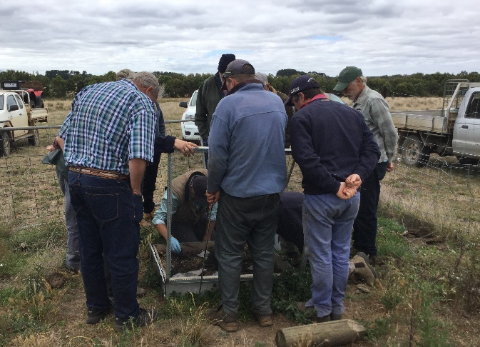

Figure 9: Inspecting a dung beetle nursery at Cashmore Park
For more information, contact Bindi Hunter at bindi.hunter@agriculture.vic.gov.au or Kate Joseph at primeag@westvic.com.au

Disclaimer
This publication may be of assistance to you but the State of Victoria and its employees do not guarantee that the publication is without flaw of any kind or is wholly appropriate for your particular purposes and therefore disclaims all liability for any error, loss or other consequence which may arise from you relying on any information in this publication.
Issued August 2022



