BestWool/BestLamb – Group Profile
Pyrenees and Smeaton Network Groups – May 2022

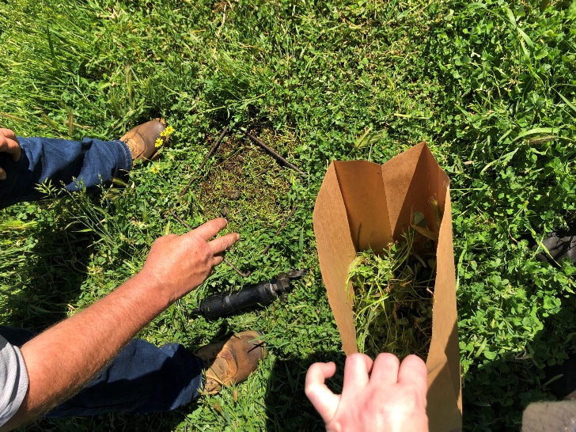

Collecting pasture cuts for dry matter analysis on one of the Howell trial paddocks.

Group(s) coordinator – Neil James, Agriculture Victoria
Group enterprises – lamb and wool production, mixed farming and cropping.
A producer demonstration project, ‘Precision soil mapping in central Victorian pastures’ is investigating the benefits and costs of precision soil mapping and variable rate applications (VRA), compared to traditional soil testing and fertiliser/ameliorant applications. The comparison is undertaken through a paired-paddock demonstration across four sites in Central Victoria. The project is a collaboration between the Pyrenees and Smeaton BestWool/BestLamb groups, Precision Agriculture Pty Ltd and Agriculture Victoria, with funding from Meat & Livestock Australia (MLA).
The comparison includes the costs of soil testing (precision versus traditional), the costs of fertiliser and ameliorant applications (VRA versus applications decided by a producer steering committee), pasture growth and species composition. All four sites vary in terms of soil constraints and the host producers’ goals for their paddocks.
Producers Scott, Liz and Daniel Howell are hosting one of the sites on their 1330 hectare property at Mt Lonach near Amphitheatre. The Howell’s soil type is a granite-based sandy loam which has leaching potential. They became interested in the project having previously undertaken some precision soil testing, which helped them understand the variability of nutrients across their paddocks.

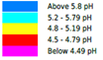
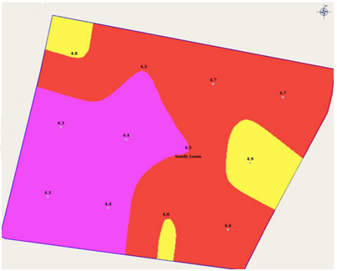
Figure 1. The variability of pH across one of the trial paddocks.
The trial paddocks were soil tested by Precision Agriculture using one-hectare grid sampling, whereby the paddock was broken down into a grid pattern and intensively sampled. Based on soil test results, several maps were produced using the data from each grid (see figure 1).
The results of the sampling indicated variability across several analytes including pH, phosphorus and potassium, and these analytes will be the focus during the trial (agreed upon by Scott and the project steering committee). Certain areas of the paddock had adequate levels, meeting Scott’s target, while some areas of the paddock were well under target levels.
Scott has set nutrient targets for his property;
- a minimum of 5.2 pH (CaCl)
- an Olsen P of 15
- approximately 150 mg of potassium.
The required fertiliser to achieve these targets was applied using variable rate spreading technology. The spreader, guided by GPS has the ability to spread higher rates where more is required or no fertiliser where targets are already at the optimum level (see figure 2).

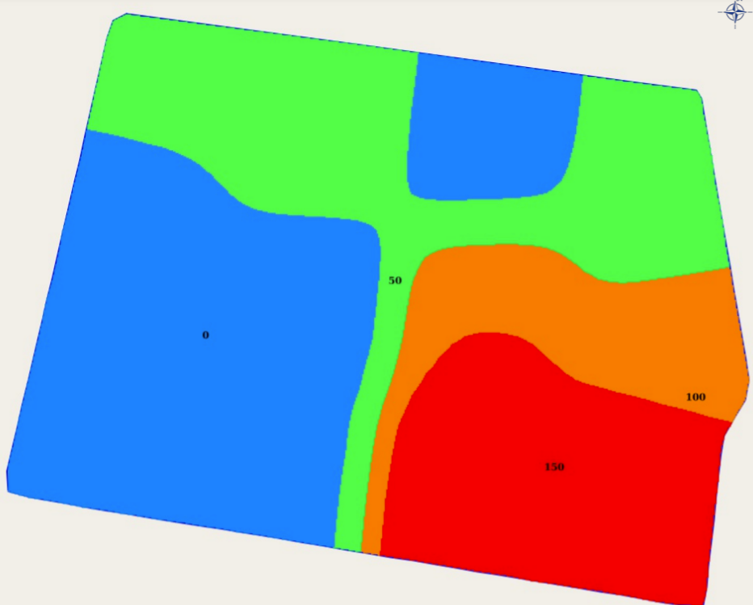
Figure 2. Variable rate Muriate of Phosphate (MOP) fertiliser map to target 150 mg potassium.
The nutrient base supports productive perennial pastures of primarily phalaris and sub clover. Historically, the property had large, set-stocked paddocks which led to stock camps and an uneven distribution of manure across the paddocks. Through the grid sampling, Scott has been able to identify these stock camps as well as areas that require more nutrition. The process of soil testing has helped Scott make better input decisions and when asked what he hopes to achieve from the project he said, ‘more efficient use of fertiliser’.
The big question is, will the precision soil testing and variable rate spreading prove economical and improve productivity in pastures?
The demonstration results will help determine whether more producers take up this technology.
The project continues until late 2024.
For more information about the project contact Neil James, Agriculture Victoria on 0417 353 929 or email, or Sebastian Ie, Precision Agriculture Pty Ltd at email.

Disclaimer
This publication may be of assistance to you but the State of Victoria and its employees do not guarantee that the publication is without flaw of any kind or is wholly appropriate for your particular purposes and therefore disclaims all liability for any error, loss or other consequence which may arise from you relying on any information in this publication.
Issued May 2022







