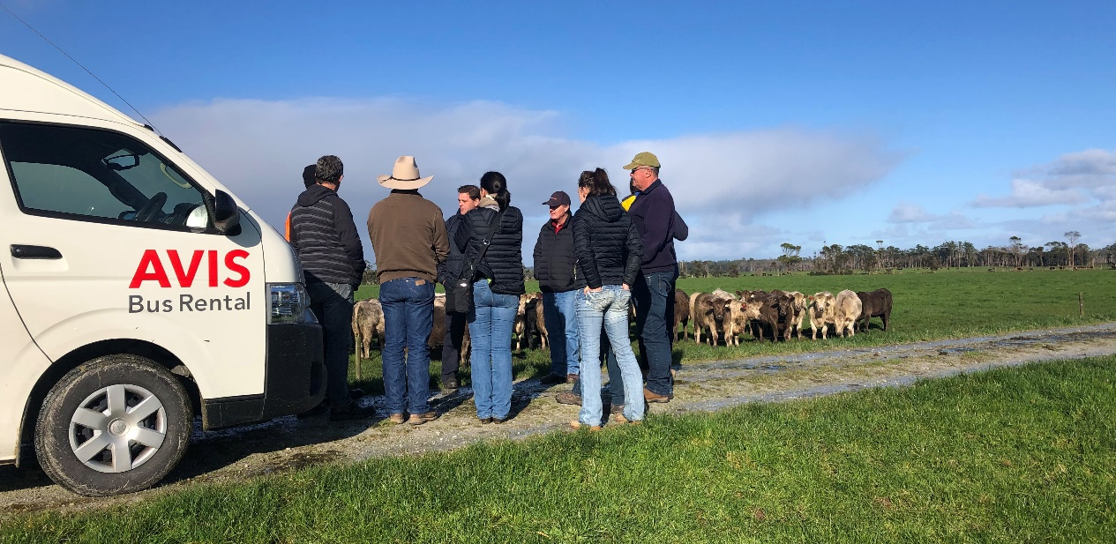
Picture: Upper Murray BetterBeef Group, Tasmania, 2019
Coordinator – Chris Mirams
Groups – Upper Murray and Mudgegonga
- Upper Murray group formed in 2013. Currently has 12 businesses ranging from: Khancoban, Tintaldra, Corryong, Biggara, Bringenbrong, Tooma to Towong Upper
- Mudgegonga group formed in 2011 and currently has 12 businesses ranging from Mudgegonga, Rosewhite, Porepunkah, Yackandandah to Wodonga.
Enterprise mix
- Both groups mainly self-replacing beef herds, with a couple of producers backgrounding steers (either finishing steers or supplying feedlots).
Tasmanian tours lead to fodder beet trials
With the aim of considering innovations in the beef industry, Chris Mirams arranged a study tour of Tasmania for two of the BetterBeef groups he coordinates. The Mudgegonga group (who have merged with the Burgoigee Creek group) went in 2017, supported by funding from the MLA Donor Company (MDC). The Upper Murray group toured in 2019. Twenty producers in total visited Tasmania.
The focus was on alternative beef operations and pasture systems, as well as exploring ways to expand businesses without being debt-funded. Near Launceston, both groups observed fodder beet crops being used to address the winter feed deficit in beef production. The practice had the added benefit of preserving pastures and adding weight to the cattle.
These crops were on irrigated land (4 ML average on top of the annual average rainfall of 665 mm) with well-drained soils. The crops were yielding 24,000 kg DM/ha. Large mobs of cattle were grazed on rotation. One producer had heifers in mobs of 300 gaining 0.8 kg/ head/day. Another producer had mobs of steers on rotation to add weight before market.
Fodder beet is a well-known crop in New Zealand and is being used on dairy farms in south western Victoria for the autumn feed gap. The Tasmanians showed how it can be used in beef systems. Seeing what the crop was delivering had members wondering if fodder beet could fit into their systems at home?
Both the Upper Murray and Mudgegonga groups were interested in trialling its use. At the same time, Nick Linden from Agriculture Victoria, Rutherglen, was searching for producer demonstration sites (PDS) in the region to test new approaches to filling seasonal feed gaps. Nick and Chris had a conversation, and the two topics merged into one.
Each BetterBeef group now has a 2 ha PDS fodder beet trial site. A critical aspect of the trials (monitored by Agriculture Victoria) is reviewing gross margins. While it is an expensive crop to establish, the potential returns can be high.
The Upper Murray site is on a member’s farm near Corryong and the Mudgegonga farm site is at Murmungee close to Beechworth. The sites provide a practical hands-on demonstration engaging many farmers through setting up the sowing (mid-November) and for monitoring the grazing and weight gain.
Chris said, “Fodder beet is a more complex feed type in terms of ‘growing it and grazing it’ than for example, merely changing the variety of rye grass.” Paddocks need to be selected on soil type and good drainage with preparation of a fine seed bed for sowing with a precision seeder. Timing for weed control applications is critical and requires chemicals used for horticulture and not the commonly used agricultural chemicals.
Once the crop is established, the cattle need to be inducted to fodder beet requiring behavioural adaption as well as an adjustment to their rumen. On the Tasmanian tour the group saw different grazing systems, where some farmers used fodder beet as the sole feed with a run-off paddock separated by a hot wire. Another system incorporated a high protein silage feed. Chris said, “Working out how to graze fodder beet in a simple system will be the key to its uptake by the cattle.”
Although the two sites are different in rainfall average, irrigation water availability, soil types etc. there are many aspects of the trial that will be relevant to both groups. Future field days will be held at each site involving ‘cross-pollination’ between the groups.
Chris said “The fodder beet trials are an example of how valuable it is to take a group to a different environment, to get off our own patch, see other farms using different technologies and then linking that to what may work at home. Through trialling we may crack a new technology for the wider farming region.”
