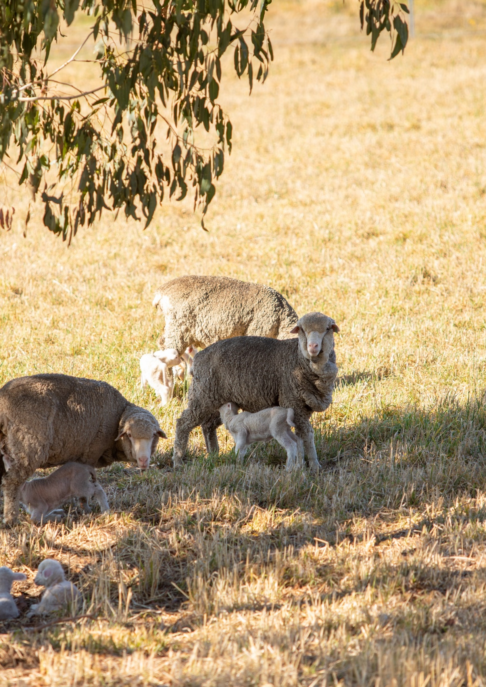
Victorian Agriculture and Climate Change Council
Annual Report
December 2022

Contact:
For further information about the Victorian Agriculture and Climate Change Council, please contact:
Agriculture Victoria
Melbourne, Victoria 3000
vaccc@agriculture.vic.gov.au

Accessibility
If you would like to receive this publication in an accessible format, such as large print or audio, telephone contact the Agriculture Victoria Customer Service Centre on 136 186.

Disclaimer
This publication may be of assistance to you but the State of Victoria and its employees do not guarantee that the publication is without flaw of any kind or is wholly appropriate for your particular purposes and therefore disclaims all liability for any error, loss or other consequence which may arise from you relying on any information in this publication. While every effort has been made to ensure the currency, accuracy or completeness of the content we endeavour to keep the content relevant and up to date and reserve the right to make changes as require. The Victorian Government, authors and presenters do not accept any liability to any person for the information (or the use of the information) which is provided or referred to in the report.

Authorised and published by the Victorian Government,
1 Treasury Place, Melbourne
Printed by Finsbury Green
ISSN 2653-794X - Print
ISSN 2653-7958 - Online (pdf/word)

Quote from alexandra gartmann, victorian agriculture and climate change counCIL chair
“Through 2022, the Victorian Agriculture and Climate Change Council focused on engaging with farmers, industry and community groups across Victoria.
We heard that there is great ambition, motivation to act, and an appetite to drive change towards a climate-resilient agriculture industry.
We look forward to providing further advice in 2023, driving benefits and actions for Victoria and for the Victorian agriculture industry.”
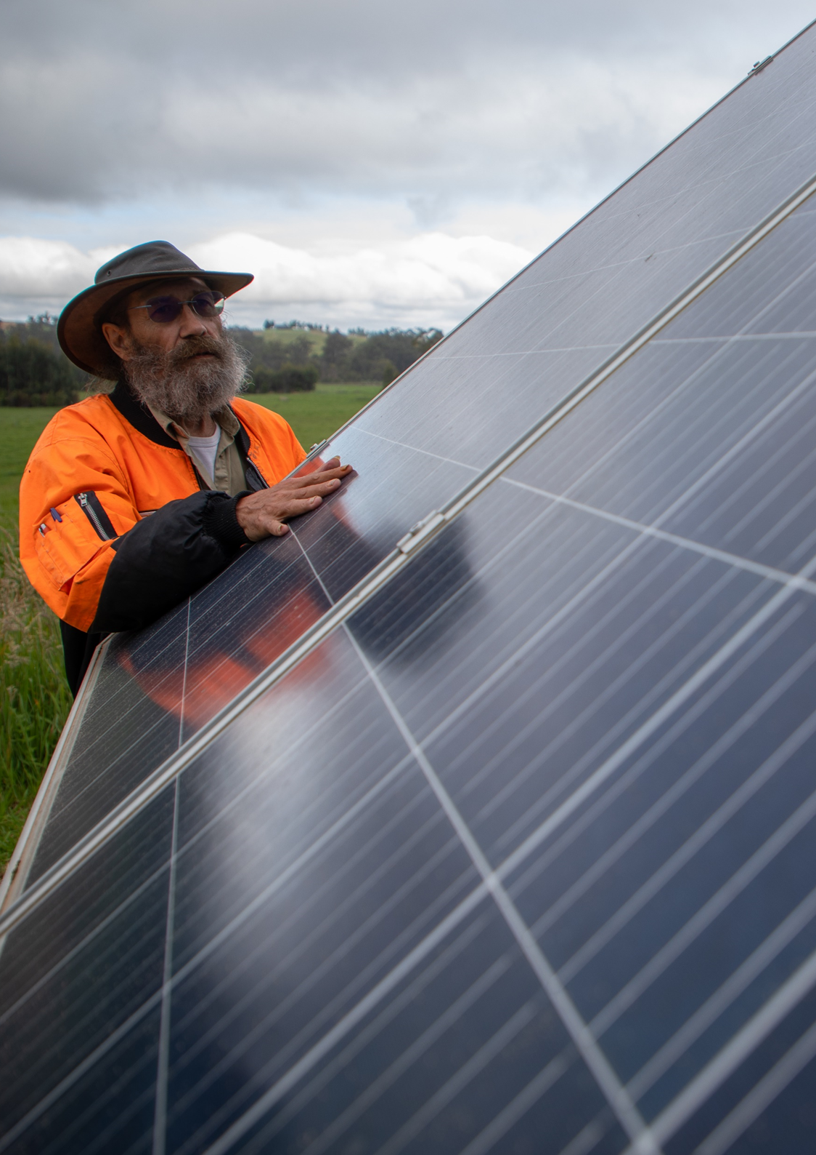

Membership
- Alexandra Gartmann (Chair) - Leader of rural, agriculture and community organisations. Currently serving on different boards including One Basin CRC, Nufarm, Australian Wool Testing Authority.
- Mark Wootton AO (Deputy Chair) - A beef and wool farmer who is well-known as a pioneer in carbon-neutral farming.
- Fiona Conroy - Sheep and cattle producer and partner of Nicon Rural Services with experience is carbon-neutral farming.
- Lisa Dwyer - A dairy farmer and non-executive director of Racing Analytical Services Limited.
- Professor Richard Eckard - Professor and Director of the Primary Industries Climate Challenges Centre at the University of Melbourne.
- Gillian Hayman - Managing Partner at Montrose Dairy and runs her own consultancy business in Gippsland
- Jack Holden - General Manager – Director on the MLA board and General Manager of Sustainability, Asia Pacific at the Fonterra Group
- Professor Lauren Rickards (from August 2022) – Lead author with the Intergovernmental Panel on Climate Change’s Working Group on Impacts, Adaptation, and Vulnerability and professor at La Trobe University.
- Caroline Welsh - Currently serves as the Deputy Chair of GWMWater and as a member of the Future Drought Fund Consultative Committee.

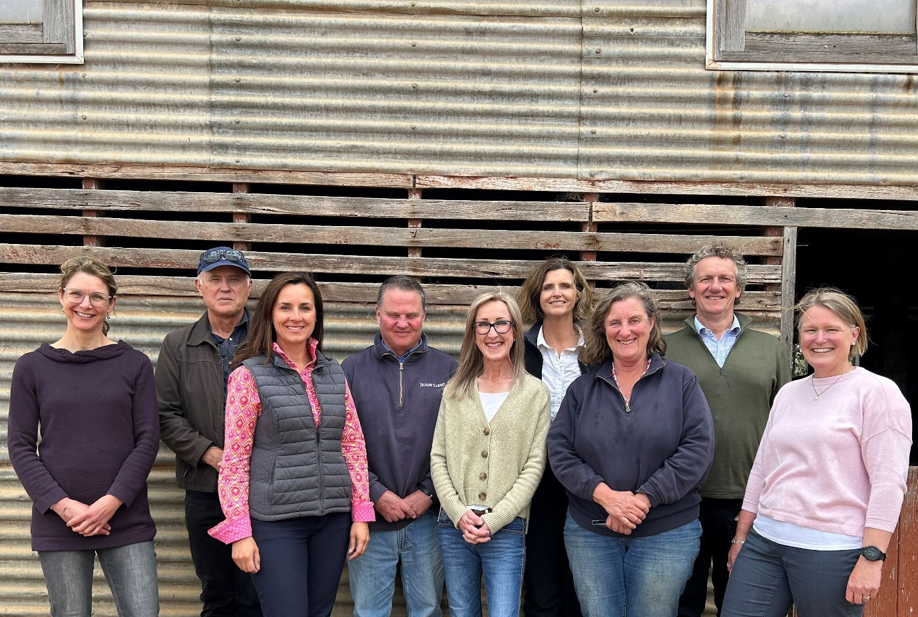

Section 1 – Overview

The Victorian Agriculture and Climate Change Council is a ministerial advisory committee that provides advice to the Minister for Agriculture on the impacts and opportunities of climate change.
The Council provides independent and strategic advice to the Minister for Agriculture on how the Victorian agriculture sector can prepare for and respond to the impacts and opportunities of climate change. Up to nine Council members bring a broad cross-section of experience across Victoria’s regions and farm enterprises, each with their own unique skills, networks, and subject matter expertise.
The Council is a non-statutory body established by the Minister for Agriculture. Council members provide expert advice and lead engagement with a wide range of experts, industry, and regional communities to assist the development of responses to the impact of climate change.
Specifically, the role of the Council is to:
- Provide independent advice about the state-wide challenges faced by the agriculture sector from climate change and support the Minister for Agriculture to develop actions that respond to climate change and reduce emissions as well as build the resilience of the sector
- Identify networks and approaches to engage and manage key stakeholders in the sector
- Provide advice on other strategic components of the government’s climate change responses for the agriculture sector.
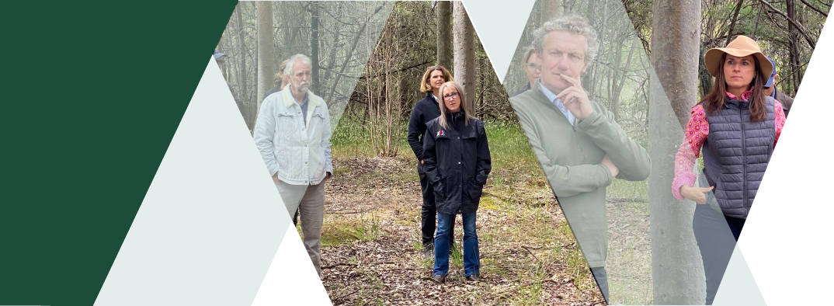

The Council continues to provide expert advice and support engagement with key stakeholders to assist the agriculture sector respond to climate change.
Appointed in December 2020, the Council has been operating for two years. The Council has advised three Victorian Agriculture Ministers and has assisted Agriculture Victoria in the design and implementation of climate change programs and services relevant to the agriculture sector. The Council also engages with key stakeholders to assess different views on strategic climate change matters.
The Council has met formally on nine occasions since 2020 and has attended and facilitated additional out-of-session workshops throughout that time. Under its Terms of Reference, the Council is required to prepare an annual report for the Minister.
This annual report covers the Council’s second year of operation, from December 2021 to December 2022.

Obligations
- The Council is expected to meet four times per calendar year to ensure the Terms of Reference are met. Members are expected to attend all meetings, however, a minimum attendance of 75 per cent is required unless otherwise approved by the Chair.

Gender composition
- The gender balance of the Council is taken into consideration when members are appointed. Over the 2022 reporting period, membership included six people that identify as female and three that identify as male.

Accountability and secretariat
- Agriculture Victoria provides secretariat support to the Council. Further information on the work of the Council is available on the Council’s webpage.
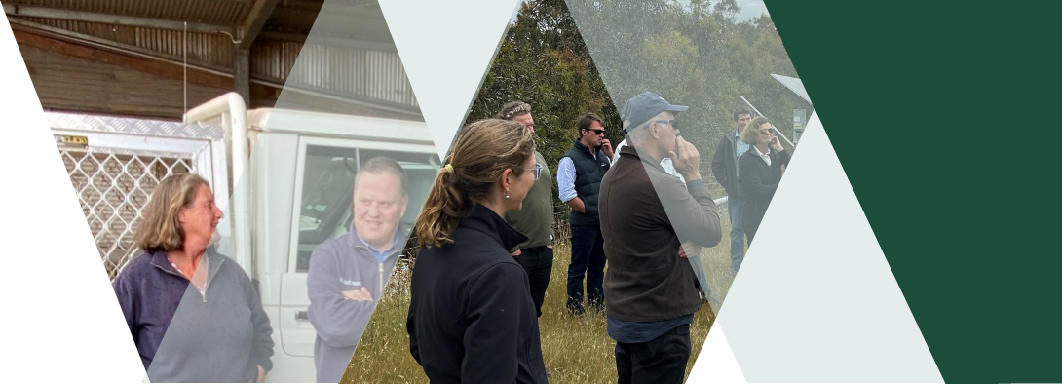

Section 2 – Advice to the Victorian Government

The Council’s advice to the Victorian Government has been shaped through different discussions between members, external stakeholders and Agriculture Victoria.

The Victorian agriculture sector is significant and diverse. It is comprised of stakeholders who have diverse views, interests, and farming-related enterprises.
The individual context of each stakeholder will be different and this context must be considered for state-based emission reduction activities to be successful.
The agriculture sector does not operate in isolation. Sectors across the economy and nationally are intertwined and there are cross-sectoral impacts and opportunities that need to be considered. Businesses in the agriculture supply chain (e.g. buyers of agricultural products) are driving change in the sector. The international policy frameworks, new international requirements, national policies, and consumer expectations are all contributing to market signals that are putting pressure on these farm and value chain businesses to enact changes.

In 2022, the Council has identified priority areas for Victorian Government consideration that would support the agriculture sector to respond to the impacts and opportunities of climate change.

Science:
- Continue to research, develop and support the commercialisation of new technologies that are cost-effective and practical for farmers to reduce emissions and increase resilience.

Policy:
- Coordinate and lead the sector to take collective action by partnering with stakeholders across the supply chain and advocating for Victorian farmers nationally.
- Consider a place-based approach to incentivise action from the sector.
- Close the gap between emissions reduction and adaptation to support farm resilience.
- Support the design of programs that reduce the climate risk for farmers.

Engagement
- Amplify the insights and outcomes from the On-Farm Emissions Action Plan Pilot.
- Focus on targeted and consistent climate and emissions information and align messaging between government agencies.

Section 3 – 2022 Highlights

Hosted a Private Sector Roundtable with key industry stakeholders to discuss climate action.
- The Council convened a roundtable with selected business leaders in the food and agriculture sector to discuss opportunities and barriers to further reduce agricultural emissions while building sector adaptation capabilities and resilience.
- The meeting provided a corporate agribusiness-based view on what is needed to drive further climate action on-farm, including:
  - The need to deliver clear and consistent messages on climate change, carbon, and emissions to build knowledge and understanding.
  - The need for continued and increased stakeholder collaboration to enable partnerships across the supply chain and to agree on frameworks, tools, and data needed to measure emissions.
  - The need for the food sector to demonstrate a clear value proposition to farmers in taking action, including future market pressures and opportunities as well as the implications of a high carbon footprint.
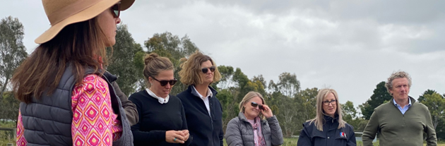

Supported the launch and implementation of the On-Farm Emissions Action Plan Pilot
- Supported the design of the three-year pilot that will work with up to 250 farm businesses to estimate their farm emissions profile and develop an action plan to reduce emissions, with $5 million in grant funding available to implement recommended actions.
- The Council provided detailed technical advice through a series of workshops to support the development of the farm emissions assessments and the action plan template. Their detailed advice assisted the pilot team to develop templates and information that farmers can more easily engage with.
- Council members supported the Minister for Agriculture to formally launch the pilot at Mt Lavinia Farm in May 2022. 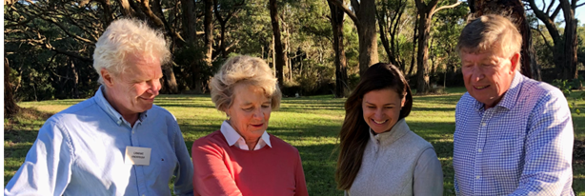

Advised the 2035 Interim Target Panel on the Victorian agriculture sector’s progress in reducing emissions.
- The Council met with the 2035 Interim Target Panel to support the panel in its advice to the Minister for Climate Action on an economy-wide emissions reduction target. Members had the opportunity to provide learnings on the Victorian agriculture sector’s progress and opportunities in reducing emissions. Key points highlighted by the Council include:
  - An important driver for change in the sector is expected to come from businesses across the supply chain and international market signals.
  - Barriers to reducing emissions include a limited understanding of the risks the sector is facing, low climate understanding among farmers and advisors, limited solutions, and the gap between emissions reduction and adaptation.
  - Efforts should be directed to improve climate understanding and further support research on new and emerging technologies, along with the development of a strategy to make them commercially available.
  - Rapid action from the government is needed to match the escalating risk the local economy is facing from climate change to ensure the sector is well prepared to adapt.
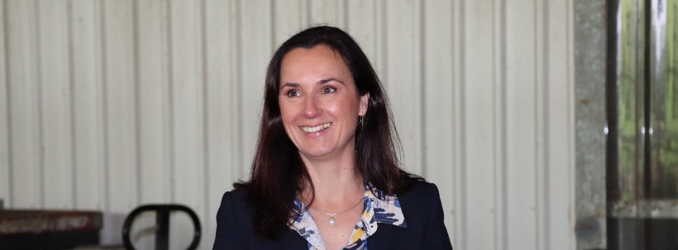

Increased the Council’s connections and promoted peer-to-peer learning opportunities
- The Council continued their engagement with counterparts in New Zealand to learn from their experiences and challenges with the He Waka Eke Noa Primary Sector Climate Action Partnership, which is currently working with primary producers to “know their emissions number” and develop a pricing mechanism as an incentive to reduce agricultural emissions.
- Council members have hosted farm tours on their own properties, including Jigsaw Farms to hear about the challenges of achieving carbon neutrality.
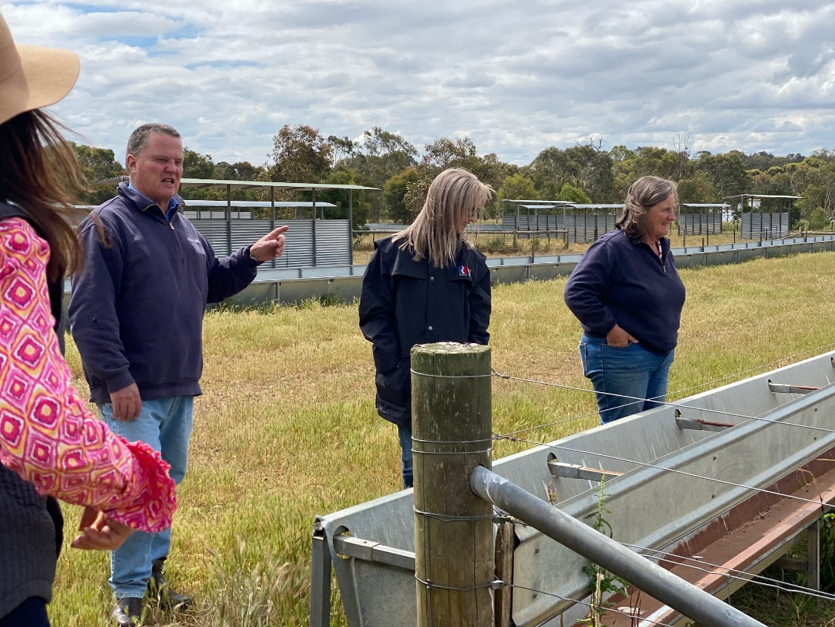

Co-delivered the Victorian Agriculture and Climate Change Statement (the Statement)
- The Statement articulates a shared vision between government and industry to contribute to a climate-resilient, net-zero emissions economy and represents a collective commitment to a profitable and productive agriculture sector that takes ambitious action on climate change.
- The Council, along with Agriculture Victoria, facilitated many conversations on climate change with a broad cross-section of farmers, industry and community groups across Victoria, to support the development of the Statement. In total, over 90 stakeholders and 45 organisations contributed to developing the Statement and shaping the way forward.
- Council members supported the Minister for Agriculture along with key industry stakeholders to formally launch the Statement at Ellinbank SmartFarm in September 2022.
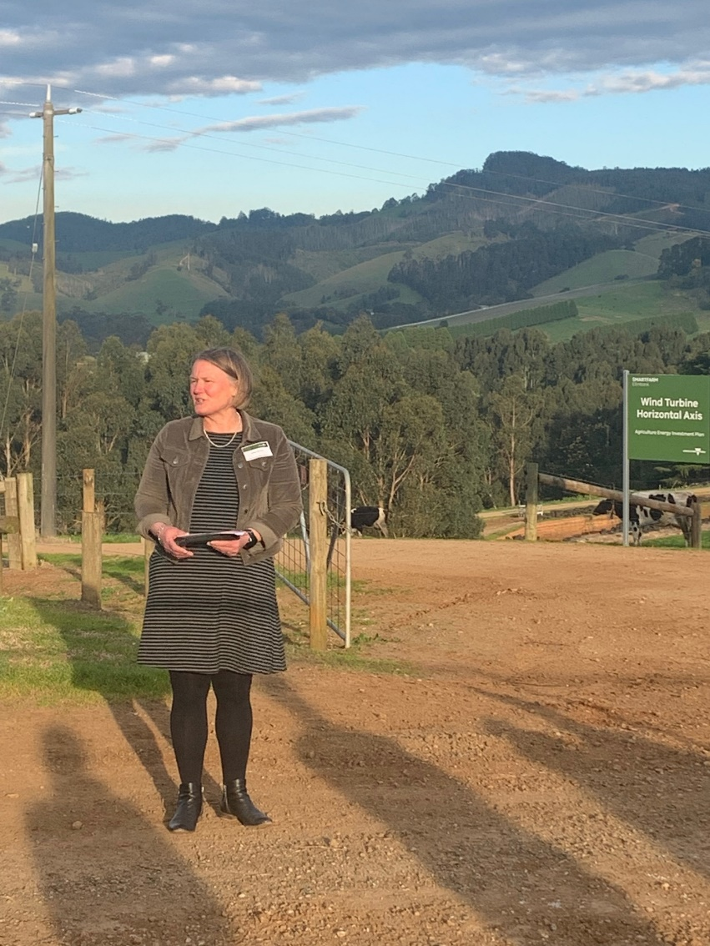
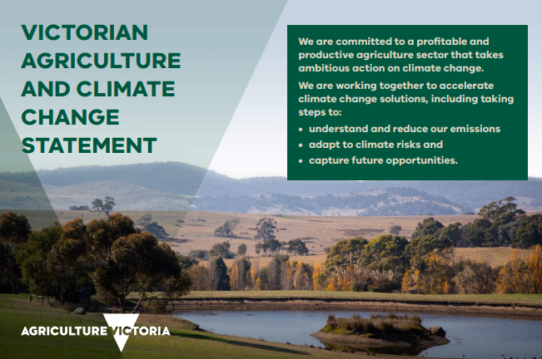

To learn more about the Statement and about becoming a partner email climatechange@agriculture.vic.gov.au

Section 4 -2023 Priorities
- Throughout 2023, the Council will continue to play a key role in supporting the Victorian Government, industry and agricultural communities to work together to address critical climate change issues, complementing the increasing focus on climate change globally and across the sector. Priorities for 2023 have been shaped by the Council’s work through 2022, the floods impacting farmers in the same year and the commitment achieved through the Victorian Agriculture and Climate Change Statement. The Council’s priorities for 2023 are:

Engagement
- Support further engagement with key stakeholders to identify collaborative pathways to reduce emissions on-farms, and to meet emissions reporting requirements across the supply chain.
- Host targeted roundtables for priority working areas.
- Communicate early insights from the On-Farm Emissions Action Plan Pilot program with key stakeholders.

Policy
- Position adaptation as an enabler of mitigation in policy development and advocate for further commitments to deliver the Primary Production Adaption Action Plan.
- Support the early design of the second Agriculture Sector Pledge.

Science
- Identify potential opportunities to upskill stakeholders’ knowledge and understanding of climate change science, adaptation and mitigation through research.

Coordination:
- Advocate for further coordination between government departments, agricultural stakeholders, and the Australian Government to increase support for climate change action in the agriculture sector.

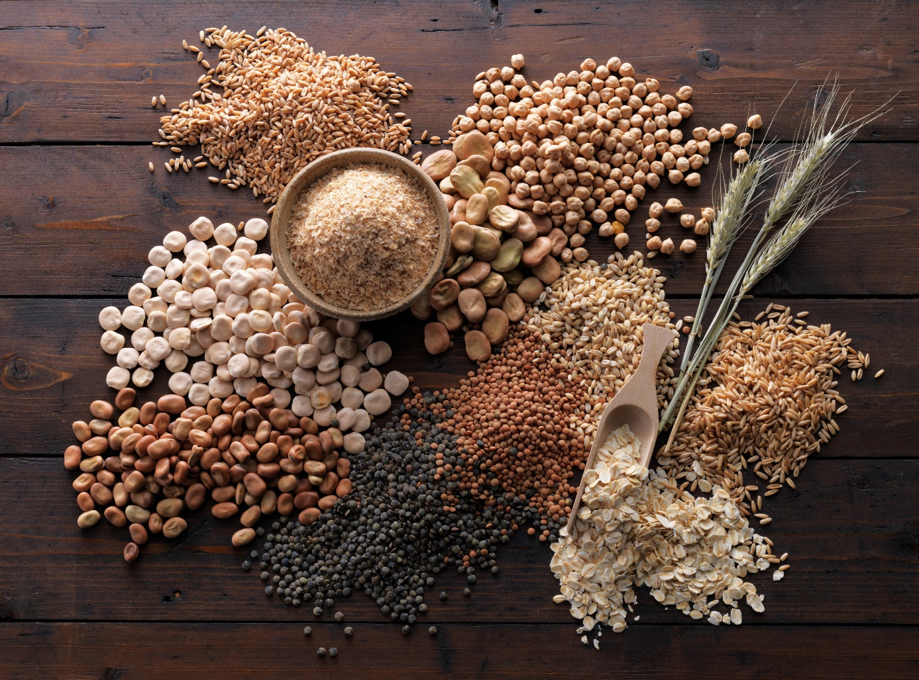
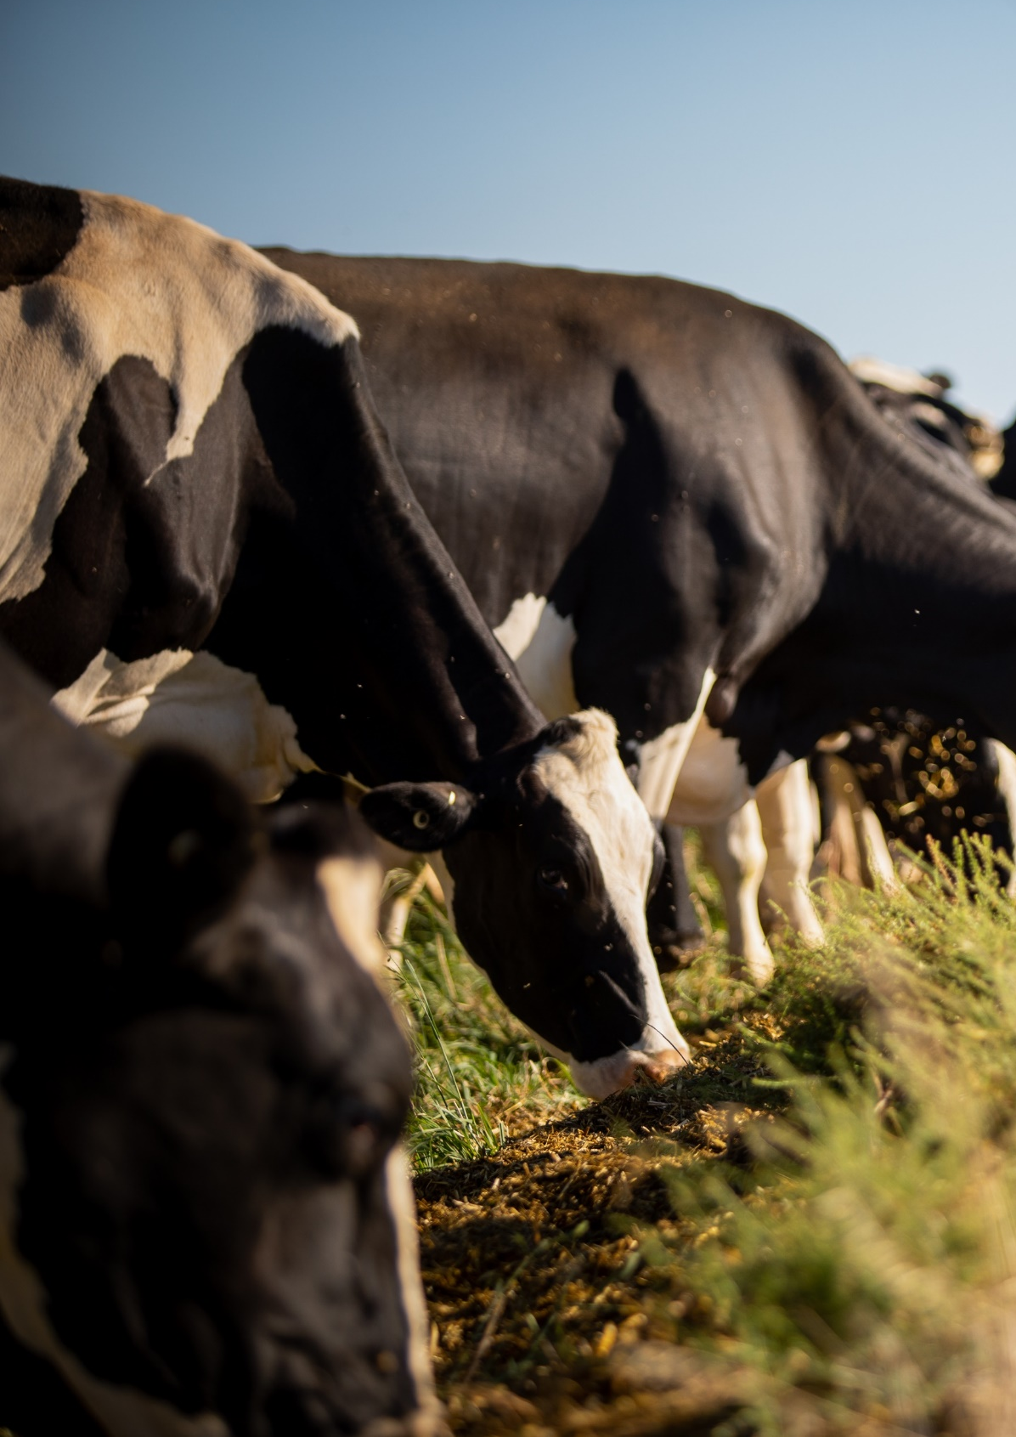
Victorian Agriculture and Climate Change Council
Annual Report
December 2022

