Young Farmers

Upskill and Invest Scholarship

Program Guidelines 2025

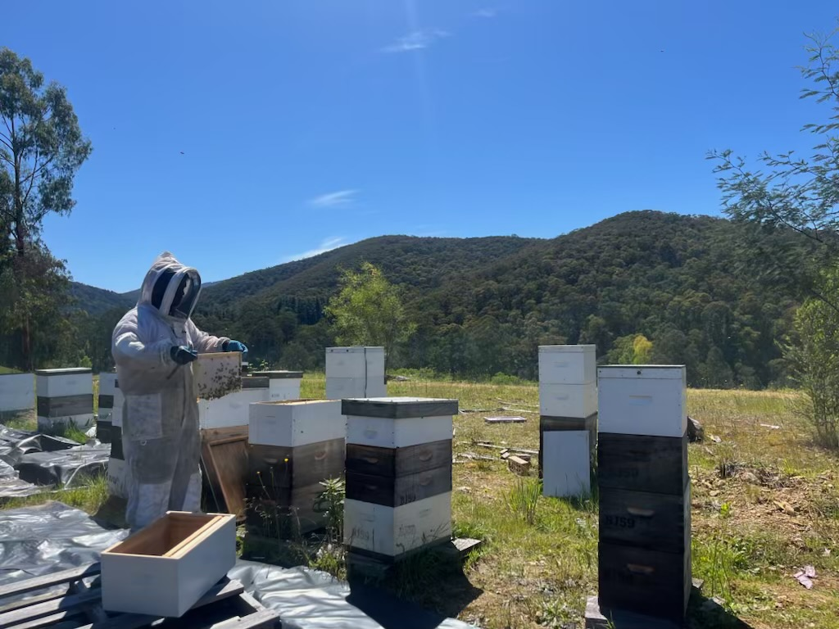
Photo credit
Anurag Bhangu, 2024 Scholarship recipient.

Acknowledgment
We acknowledge and respect Victorian Traditional Owners as the original custodians of Victoria's land and waters, their unique ability to care for Country and deep spiritual connection to it. We honour Elders past and present whose knowledge and wisdom has ensured the continuation of culture and traditional practices.
We are committed to genuinely partner, and meaningfully engage, with Victoria's Traditional Owners and Aboriginal communities to support the protection of Country, the maintenance of spiritual and cultural practices and their broader aspirations in the 21st century and beyond.
© The State of Victoria Department of Energy, Environment and Climate Action 2025
This work is licensed under a Creative Commons Attribution 4.0 International licence. You are free to re-use the work under that licence, on the condition that you credit the State of Victoria as author. The licence does not apply to any images, photographs or branding, including the Victorian Coat of Arms, the Victorian Government logo and the Department of Energy, Environment and Climate Change (DEECA) logo. To view a copy of this licence, visit http://creativecommons.org/licenses/by/4.0/
This publication may be of assistance to you but the State of Victoria and its employees do not guarantee that the publication is without flaw of any kind or is wholly appropriate for your particular purposes and therefore disclaims all liability for any error, loss or other consequence which may arise from you relying on any information in this publication.
Accessibility
If you would like to receive this publication in an alternative format, please telephone the DEECA Customer Service Centre on 136186, email customer.service@deeca.vic.gov.au or via the National Relay Service on 133 677 www.relayservice.com.au. This document is also available on the internet at www.deeca.vic.gov.au.

Contents
1. What is the Young Farmers Upskill and Invest Scholarship Program? 2
2. Who can apply? 2
3. Who cannot apply? 2
4. What might be funded? 2
Upskill activity - eligible study and training 2
Invest activity - eligible expenditure 2
5. What will not be funded? 3
Ineligible upskill study or training include but are not limited to: 3
Ineligible invest activities, include but are not limited to: 3
6. What are the funding details? 3
7. What are the assessment criteria? 3
8. What is the application process? 4
9. What is the notification process? 4
10. Key dates 4
11. Checklist 4
12. What are the funding conditions? 4
Funding agreements 4
Payments 5
Variations to the proposed activities 5
Goods and Services Tax (GST) and Tax implications 5
Monitoring 5
Legislative and regulatory requirements 5
Acknowledging the Victorian Government’s support 6
Privacy 6
Review and amendments 6
13. Additional information 6

What is the Young Farmers Upskill and Invest Scholarship Program?
The scholarship provides new farmers and people wanting to get into farming with up to $5,000 towards training or study (Upskill activity), and up to $5,000 to invest on-farm or into professional development to support the learnings for the upskill (Invest activity).

Who can apply?
Applicants must be:
- aged between 18 and 40 years at the time of the application close date
- working in a food and fibre farm business in Victoria at least three days per week, for the past three months
- an Australian citizen or permanent resident currently residing in Victoria; and
- have at least two years of total experience on-farm.
Those from diverse backgrounds and industries are encouraged to apply.

Who cannot apply?
The following cannot apply for a scholarship:
- Visa holders (non-permanent residents)
- Victorian Public Service employees.

What might be funded?

Upskill activity - eligible study and training
Applications will be considered for any form of study or training that supports the applicant to build a productive and profitable career in agriculture, including professional short courses or workshops, as long as it:
- involves a minimum of 16 contact hours (this may involve more than one course or workshop, and may be across multiple institutions or organisations, or offered online)
AND
- is delivered by a registered training organisation (RTO).
OR
- is delivered by any other reputable organisation approved through discussion with the Department. For further information, contact the Young Farmer Coordinator.
Study or training in the areas of business planning and management, risk management and financial literacy are encouraged. Upskilling in climate adaptation and mitigation, specific skills or farm safety could also be a focus, but applicants should not be limited to these areas.
The Victorian Skills Gateway and training.gov.au provide information on vocational training and Learn Local organisations. Further information is also available from local industry or training organisations or local Victorian Farmers Federation branches.
The duration of study for which the scholarship applies should not be more than two years, unless otherwise agreed in writing by the Department.
Applicants need to provide a clear study plan and timeline in their application.
Scholarships will be awarded based on the information provided in applications. Therefore, it is important that applicants take adequate steps to ensure that the cost and timing of the proposed study plan is accurate.

Invest activity - eligible expenditure
Invest activity funds must:
- be directed towards activities that will support the application of learnings from the chosen Upskill study or training
- be expended within six months of completion of study or training (unless otherwise agreed in writing by the Department)
- not be undertaken before the Upskill activities are completed. If an Invest activity is undertaken before the Upskill activities are completed, the Department may seek reimbursement of the scholarship funds.
Applicants will need to demonstrate in their application a clear link between the skills acquired through the Upskill activity and the application of those skills in the Invest activity. Invest activities that focus on putting skills into practice and focus on additional support and training (such as professional services, consultants, business management support) are encouraged.

What will not be funded?

Ineligible upskill study or training include but are not limited to:
- travel, accommodation and childcare
- international training courses (unless the applicant can demonstrate there is no equal learning opportunity in Australia)
- training that has already commenced or been completed at the time of application. However, longer duration courses and training with distinct components (i.e., individual subjects) not yet undertaken at the time of applying may be eligible for reimbursement. Examples include future semesters of an Agribusiness Diploma or the second or subsequent year of a related degree. In these circumstances the subjects must be completed before the Invest activities commence.

Ineligible invest activities, include but are not limited to:
- activities located outside the State of Victoria
- activities that are required by law or that replace an individual’s, group’s, or government’s legal responsibility for sustainable management of resources under their control, unless able to demonstrate specific value to the project. For example, training to gain a licence required by law to undertake an activity is not eligible (such as dairy licencing fee, driver’s licence).
- day-to-day operating costs of the business. For example, rent, power, cleaning, telephones, laptops, administration, legal or insurance costs, preparation of tax returns.
- routine or ongoing maintenance including standard variable inputs. For example, seed, fertiliser, chemical, fodder, standard boundary and house fencing that would fall within a landholder’s normal responsibility.
- purchase, lease or acquisition of land, livestock, permanent or temporary water rights
- purchase, leasing or maintenance and repair of transportation vehicles such as utility vehicles, boats, cars, quad bikes, motorbikes, trailers, and trucks
- drainage works, unless identified as part of an integrated local catchment plan or with technical input
- works, activities, or purchases already undertaken prior to submitting your application for the scholarship
- works that have been paid for from other sources for the same or similar project.

What are the funding details?
The total funding available for the 2025 round is $125,000.
Scholarships valued up to $10,000 are available consisting of:
- up to $5,000 for Upskill activities
- up to $5,000 for Invest activities.
Approximately 12-14 scholarships are awarded per round.
Scholarship recipients are expected to pay for their Upskill and Invest activities and will be reimbursed via a claims process.
Recipients can apply for upskill and invest activities more than $5,000 and cover the shortfall themselves.
If you are experiencing financial hardship or there are special circumstances which may impact your ability to accept this scholarship as per the Program Guidelines, please contact the Young Farmer Coordinator.

What are the assessment criteria?
First, applications will be checked for eligibility to make sure that the applicant and their activity are eligible for funding. After that, eligible applications will be assessed using the criteria listed below. Each criterion is given a percentage weighting to indicate its relative importance in the assessment process.
Criteria
- Describe your aspiration to build skills and boost your food and fibre agricultural career prospects. (25%)
- Provide a clear, detailed study plan and timeline that sets out how you will achieve your aspirations through the scholarship.
  - Your Upskill activity study plan should detail the: (25%)
- education institution / training organisation name
- course name and code (if applicable)
- course commencement date
- total course duration (units/hours)
- cost of tuition.
  - Your Invest activity plan should detail the: (25%)
- name of the activity and / or items requested.
- total values of the activity and or items requested.
- Describe how the knowledge and skills obtained through selected study or training will benefit your career in agriculture. (25%)

What is the application process?
Applications are submitted online using the Grants Online portal. You can submit an application from 12noon 3 June 2025. To apply, go to the grant program webpage https://agriculture.vic.gov.au/support-and-resources/networks/young-farmers/young-farmers-scholarships and click on the ‘Start New Application’ button.
To return to a saved draft application, click on the ‘Access Saved Application’ button.
Make sure your application is submitted by 5:00pm AEST on 23 July 2025.
Note: Late and incomplete applications will not be considered.

Shortlisting
The Scholarship Selection Committee (the Committee) will assess all applications and shortlist applicants for an online interview. Applicants may be required to provide proof of identity at the interview.
The Department considers diversity criteria when assessing applications to ensure that each year’s cohort includes a diverse range of scholarship recipients, including by geographic location, industry, gender, cultural background, employment type (e.g. owner or employee) and professional experience.

What is the notification process?
Successful and unsuccessful applicants will be notified by email after the assessment process is completed. All decisions are final and are not subject to further review. Successful applicants will be invited to attend an event to receive their scholarship certificate. A photo opportunity will be requested to promote the scholarship program.

Key dates
Applications open | 12noon 3 June 2025
Applications close | 17:00pm 23 July 2025
Successful Applicants notified by email | August 2025
Scholarship agreements executed | September 2025
Awards Ceremony Activities commence | Late November 2025
Activities completed, and acquittal reports submitted | 30 June 2028

Checklist
Read these guidelines and the information about this program at https://agriculture.vic.gov.au/support-and-resources/networks/young-farmers/young-farmers-scholarships before applying and complete the following checklist.
Have you:
- read these guidelines carefully?
- checked if you are eligible for this scholarship funding?
- checked if your activities are eligible for this scholarship funding?
- checked that you would be able to comply with all relevant laws and regulations in delivery of your activity?

What are the funding conditions?

Funding agreements
Successful applicants must enter into a funding agreement with Department of Energy, Environment and Climate Action (DEECA). The Victorian Common Funding Agreement is used for funding agreements with individuals.
It is recommended that applicants review the terms and conditions before applying. Information about the Victorian Common Funding Agreement is available on https://www.vic.gov.au/victorian-common-funding-agreement.
The activity does not include using the Funding for political campaigning or advocacy activities for political parties.

Payments
Scholarship recipients have up to two years (from the time they are awarded the scholarship) to complete their agreed Upskill activities. Funds will be provided to reimburse the tuition expenses paid by the scholarship recipient.
Upskill activity funding payment will be reimbursed when the recipient:
- provides evidence of acceptance and enrolment at their chosen institution(s) (for example, a letter from the institution)
- provides an invoice for tuition fees from the training provider and evidence of payment (for example, receipt, Commonwealth Assistance Notice or Fee Account Statement).
Invest activity funding will be reimbursed when the recipient has:
- completed the Upskill activity and provided a certificate of completion
- provided proof of purchase of agreed Invest activity for example, a receipt
- completed the monitoring activity, refer to monitoring section.
When scholarship recipients have fulfilled these requirements, they will receive a payment via electronic funds transfer to a nominated bank account. Payment may take up to four weeks to process.

Variations to the proposed activities
It is possible to vary your proposal after you have received funding. However, any changes must be discussed with and approved by the appropriate DEECA officer via youngfarmer.coordinator@agriculture.vic.gov.au as soon as possible.
Variations cannot exceed the amount agreed in the funding agreement. You are ineligible to spend funds on any activities not outlined in your application until changes have been approved.

Goods and Services Tax (GST) and Tax implications
The Young Farmer Upskill and Invest Scholarships are GST exclusive.
If applicants are registered for GST, the application amount for both Upskill and Invest should be GST exclusive.
If applicants are not registered for GST, the application amount should include GST as shown in the example below.
Table 1. Examples of GST Cost Calculations
 | Registered for GST | Not registered for GST
Proposed Upskill activity, e.g., Grazing course | $2,600.00 | $2,600.00
GST | $236.36 | $236.36
Total Upskill requested | $2,363.64 | $2,600.00
Proposed Invest, e.g., soil moisture monitoring tool. | $3,000 | $3,000
GST | $272.73 | $272.73
Total Invest requested | $2,727.27 | $3,000.00
Total funding requested | $5,090.91 | $5,600.00
Applicants should consult the Australian Taxation Office or seek professional advice on any taxation implications that may arise from this scholarship funding.
Successful applicants without an ABN will need to provide a completed Australian Taxation Office form ‘Statement by a Supplier’ so that no withholding tax is required from the scholarship payment.

Monitoring
Scholarship recipients are required to comply with project monitoring and reporting requirements as outlined in the funding agreement. On completion of the Upskill and Invest components, each Scholarship recipient will be required to provide feedback on their experience. Questions will be provided at the appropriate time.
Responsibility of scholarship recipients
Scholarship recipients are expected to manage all aspects of their scholarship independently (this includes Upskill activity study arrangements and Invest activities) and must notify the Department in writing of any changes to their contact details.

Legislative and regulatory requirements
In delivering the activity scholarship recipients are required to comply with all relevant Commonwealth and state/territory legislations and regulations, including but not limited to:
- The Privacy Act 1988 (Commonwealth)
- The Freedom of Information Act 1982 (Vic)
- Occupational Health and Safety Act 2004

Acknowledging the Victorian Government’s support
Successful applicants are expected to acknowledge the Victorian Government’s support and promotional guidelines (https://www.deeca.vic.gov.au/grants) will form part of the funding agreement. Successful applicants must liaise with the departmental program area to coordinate any public events or announcements related to the project.

Privacy
Any personal information about you or a third party in your application will be collected by the department for the purposes of administering your grant application and informing Members of Parliament of successful applications. Personal information may also be disclosed to external experts, such as members of assessment panels, or other Government Departments for assessment, reporting, advice, comment or for discussions regarding alternative or collaborative grant funding opportunities. If you intend to include personal information about third parties in your application, please ensure that they are aware of the contents of this privacy statement.
Any personal information about you or a third party in your correspondence will be collected, held, managed, used, disclosed, or transferred in accordance with the provisions of the Privacy and Data Protection Act 2014 and other applicable laws.
DEECA is committed to protecting the privacy of personal information. You can find the DEECA Privacy Policy online at www.deeca.vic.gov.au/privacy.
Requests for access to information about you held by DEECA should be sent to the Manager Privacy, P.O. Box 500 East Melbourne 8002 or contact by emailing Foi.unit@deeca.vic.gov.au.

Review and amendments
The Department in its absolute discretion may review and amend the Upskill and Invest Young Farmers Scholarship Program Guidelines.

Additional information
Additional information is available at the program web page https://agriculture.vic.gov.au/support-and-resources/networks/young-farmers/young-farmers-scholarships.
Examples of how scholarships might work in practice can be found at www.vic.gov.au/youngfarmers/scholarship-examples
If you require assistance submitting your application online, email grantsinfo@deeca.vic.gov.au.

deeca.vic.gov.au

