Farmers managing climate risk successfully on their farms

Maria Rose, Dairy Services, Agriculture Victoria, Ellinbank

Welcome to our new segment “Farmers Managing Climate Risk Successfully” in which we follow eight dairy farmers as case studies focusing on how they are effectively managing climate risk, in their individual situations.

Each season we follow four case study farmers, one from each of the key Victorian dairying regions;
- Northern Victoria (northern irrigation district and north east area),
- East Gippsland (Macalister irrigation district and coastal east area) ,
- South Western Victoria (north east of Warrnambool and south west of Warrnambool areas) and
- South plus West Gippsland (south Gippsland and west Gippsland areas)
Over the next four seasons (including this current spring) we will hear from each of the eight case study farmers twice in twelve months. In this initial instalment (Spring 2017) we meet our first four dairy farmers;
- Glenn Allan from north east Victoria,
- Ron Cornall from east Gippsland,
- Andy Powell from south western Victoria, and
- Marian Macdonald from south Gippsland

Climate risk as we all know is a very broad and convoluted issue, presenting farmers (in particular) with a mammoth and necessary management task. There’s the ongoing challenge of recognising the complexity of the science and theory around climate. Then there’s the juggling of simultaneously implementing practical management strategies required to help navigate the potential on-farm weather and climate events that may or may not happen** or do happen to a greater or lesser extent than foreseen.

A better understanding of weather and climatic influences affecting individual farming businesses allows for easier identification of trigger points and planning of associated management actions to deal with potential climate and weather situations that may affect your farm. Having a range of potential management scenarios planned and ready to implement for a range of climatic situations, can certainly help navigate decision-making pathways more easily. Such an approach can greatly assist you in taking the most appropriate course of action if and or when identified trigger points are reached.

Recently I spoke with Glenn, Ron, Andy and Marian, the first of our eight case studies, for insight into how, in their individual dairy farm businesses, are dealing with climatic risk. The key questions I put to them were:
How are you seeing the spring season ahead climate risk wise?
What is your exposure to the risks you currently identify?
What steps are you taking to deal with this level of risk?
What are the stages of thinking in line with these steps?
What action have you taken and or will you take?
What are your longer term plans to identify and manage risk beyond this spring?
What sources do you use to make these decisions around dealing with climate risk?

The following contains key highlights from my four separate interviews with Glenn from the north east Victoria, Ron from coastal east Victoria, Andy from south west Victoria and Marian from south Gippsland.

** Reference: David Brouwer & Michael Ison (2017): Managing Climate Risk on Your Farm Ag Guide – A Practical Handbook
(available for download on https://itunes.apple.com/au/book/managing-climate-risk-on-your-farm/id1203094603?mt=11

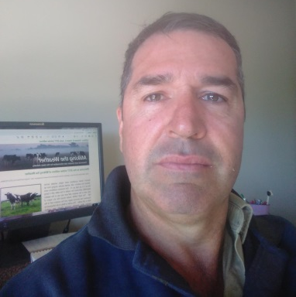
Case Study 1: Glenn Allan, Millawa, North east Victoria
The Allan family-run dairy farm is 200 hectares and located on the Tea Garden Creek flats in Milawa, north east Victoria. Fifty hectares is irrigated from this creek and ground water which can support around 200 dairy cows. Last season cow numbers were reduced to 110, so Glenn currently runs the farm without employees.
We are around average here weather-wise early September and not far off starting to cut silage so I am pretty confident of my feed situation until next spring (2018). I therefore see that my level of exposure to climate risk at the moment is low.
My key philosophy to deal with climate and seasonal risk, is to grow as much fodder as I can, when I can. Any surplus grass we have will be made into either silage or hay. Aiming to grow maximum tonnage per millimetre of water (rain and irrigation) is also a key strategy.
We focus first on making enough bailed silage rolls (rather than conserving it in a pit as we have a high water table) for the 12 months ahead; any extra grass is made into hay. From now onwards this spring, flood conditions are our biggest worry. Our current soil profile is wet with around six to eight weeks of moisture still in the ground and we’ve got a heap of snow above us.
If we suddenly get more good rains, we’ll cop a lot of water. Typically late September, early October is our highest risk for a big flood and typically we have a section of the farm that is grazed and a section that is conserved. So if and when we do get a flood this spring we will swap those sections around; the areas that don’t get flooded will be conserved for fodder and the areas that do get flooded will be progressively grazed.
A soon as paddocks become dry enough this spring we are going to put some summer crops in as early as we can. It is likely to be fodder beet again this year as we tried it for the first time last year. It went pretty well so I‘m going to give it another go. Also as paddocks become less water logged we will make sure fertiliser goes on as early possible, given it is forecasted to be an “average” sort of spring climate wise. So adding nitrogen in particular, will provide a timely boost in further pasture growth.
My longer term plans beyond this spring are to keep looking at the BOM website for long term weather forecasts of what conditions are likely and use that as a bit of a guide to keep planning ahead and make the necessary ongoing changes as required. Also I like to trial new varieties of fodder to boost our fodder production from whatever rainfall or irrigation water we have at hand.
We have and do use a soil monitoring probe and find it very useful in working out irrigation timings. I enjoy getting on line regularly to look at various sites containing climate weather and related practical information as you never know exactly what we are going to be dealt weather wise. I also like to follow sites on fodder trial information and regularly chat with my agronomist (he’s the one who put me on the fodder beet).

Case Study 2: Ron Cornall, Clifton Creek, East Gippsland
Ron together with his wife Vicki have run their 160 hectares dairy farm located on hectares in hill country at Clifton Creek, north of Bairnsdale, in East Gippsland for 35 years. They are currently milking 220 milkers this season with 16 hectares irrigated from dams as a supplement to the 720 mm annual rainfall when there is enough run off.

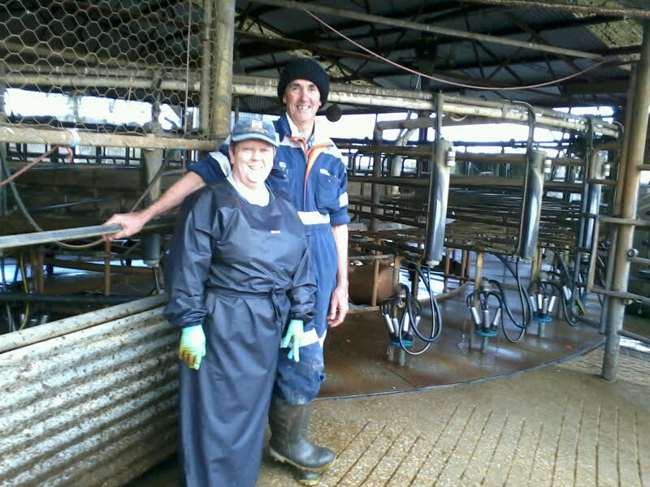
Currently on our farm the climatic risk is quite high because our soil moisture is very low. It’s the beginning of spring and we are fast approaching our peak growing season time and it’s not happening.
Our overarching aim in successfully dealing with climatic risk is to increase home grown pasture and to reduce our cost of production as much as we can. Key to this is our biggest goal of increasing vigour and intensity of our pasture base given the variable climate and the marginal soil type we’ve got. Being on hilly country we don’t like to work up the ground; the only crop that is useful for us is millet on the irrigation area.

We take a “belt and braces” (i.e. two-pronged) type of approach to feed planning in order to deal with climatic risk. The long term fodder reserve we aim for as much home grown silage to be put away and stored underground; equivalent to two to three years supply. With our immediate fodder reserves for a whole season we like to have at least three months ahead at hand. This is usually a mixture of our own home grown silage and bought in feed. Purchasing fodder to have stored and on hand helps us to make sure that we have an immediate milker feed alternative to flogging the pastures too much when we run short of available grazing pasture. Using a sacrifice paddock system, fairly long rotations, ensuring pasture survival and maximising (not compromising) grazes are main priorities in our pasture management approach. In addition to focusing on feed planning, currently we are making an early culling list and already building up bought in fodder supplies as well as re-evaluating any other expenditure that is not necessary.
Mid-September is critical for us up here on the hilly country; it’s when we can really tell if it’s going to be a usual spring or not. If we haven’t built up a wedge by then we will be early culling further sourcing more off farm fodder. The next critical time for us is around Christmas time/end of December; if it stays pretty dry and definitely looks like we’re in for a tough summer we will do all our seasonal culling then and cut our numbers back by one third (down to 180 cows).
Discretionary expenditure will probably be strongly scrutinised this year and trimmed; unnecessary forward planned maintenance won’t happen.
I am a regular outlook weather forecast follower and like to I keep a close eye always on the five day and three month forecasts on the BOM. I look to my dad (he’s still around with an interest in this family farm) often when it comes to planning for climatic risk situations. He’s been through a lot of seasons and a lot of dry years and that’s how over the years we’ve formulated trigger points for making our critical decisions.
At the same time as having plans in place you have to be in a position to optimise any of these decisions – you can’t just be too cautious so you’ve got to take a bit of a gamble on making a decision as it might not always be dooms day. Certainly Vicki and I discuss critical decisions in relation to climate risk regularly; daily in fact in high risk season’s like this one. Neighbours, older farmers, older district members and any source like that such as the Bairnsdale dairy discussion group that is run at least once every season are important sounding boards. I often share notes with discussion group members in between meeting days who think along similar lines as I do; they have different properties to ours so they give me a different perspective to think about for our farm.

Case Study 3: Andy Powell, Cooriemungle, Western Victoria
Andy has run the Powell family dairy farm at Cooriemungle, near Timboon, western Victoria for the last 12 years as a third generation family member. This seasonal calving, dryland dairy farm enterprise is currently 380 hectares in total with 230 of that utilised as the dairying platform. Andy manages the property to support over 480 milkers and 300 young stock with the help of four employees.

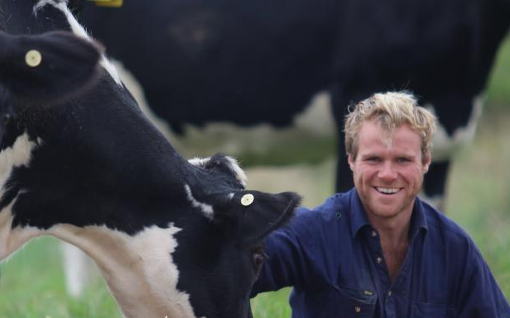
For us it’s been a better season than normal in terms of wet muddy conditions, despite having had a lot of rain in the last couple of weeks. Feed planning on our farm is based around the random nature of northern rain patterns to ensure that we don’t get caught out. In a typical northern or easterly weather pattern, the rain won’t reach us, or if it does we get a hell of a lot of it (which was the case last week). As we move forward towards early December the rainfall with this weather pattern on average becomes even more sporadic.
Our current exposure to this climatic risk is medium because of this weather pattern. We are pasture-based and for us it’s about keeping our exposure to buying in hay to a minimum. Where we are located we are guaranteed rain in winter, so a drought to us is a poor autumn break or a short spring. We plan to harvest as much of our own silage and pasture hay as possible so we don’t have to buy in feed – that’s an outside risk we don’t have to worry about. If we didn’t have the extra land that we have now then our exposure to this risk from the effect of northern rains would be much higher.

Our farm is mostly on very heavy clay soil. So when our water table gets full, the soil becomes soggy and very difficult to manage; consequently it becomes extremely hard to not only grow pasture, but to utilise the pastures over winter. In the last 25 to 30 years we’ve put in a lot of sub surface drainage. It is a management tool for winter just the same as feed pad is to others. To see an informative video on this type of drainage that we’ve installed I recommend visiting the web page: https://www.youtube.com/watch?v=XS5ow6zTKz4&authuser=1

With sub surface drainage on the farm, once 12-24 hours has passed after a rainfall event we can spread fertilizer and not leave a tractor wheel mark. Because of the extent of this drainage over the property, we are now able to utilise 95 per cent of the farm over winter. I do weekly pasture budgets on the farm to ensure that we capture as much of the spring growth as possible. By doing the regular pasture budgets we are able to follow the growth rates of the pasture, monitor the post grazing level to ensure pastures are not becoming rank or clumpy. If the post graze levels are getting too high we shorten the rotation by taking paddocks out for hay. Being diligent about pasture budgets and fertiliser applications gives us the opportunity to maximising our hay/silage harvest. We are hitting urea at five to six weeks at 100kg of urea. So that’s the trigger point within our feed planning which is critical for us.

In regard to climatic risk that may eventuate, we’ve got good data to know the various worst case scenarios (e.g. early finish to the season and or a poor autumn break) and what silage we need for them. We always make sure to cover our minimum requirements in a bad year.

Because of our soil type, we don’t crop paddocks for the sake of cropping them. We only do so when we improve pasture species or do pasture renovation. We are happy with the species of grass in the paddocks we have. Also we like to keep our farming system simple for staff and would rather feed grain in the bale than having to worry about strip fences been shifted. Buying in grain will be our major feed cost. We will be keeping tabs on the grain market in Australia and globally and looking forward to the December and January to determine whether we should be locking a price for grain in to minimise risk exposure to the market.

We are pretty pedantic on following weather forecasts; especially now as we are wet at the moment and want to reduce any potential damage to paddocks; drainage needs 12-24 hours post rain event to have the soils back to 100 per cent ( if there’s a week of wet weather it puts more pressure on managing the pastures). For short term forecasts (especially hourly and weekly rainfall forecasts), I use a Norwegian website (https://www.yr.no/place/Australia/) which I find is very reliable. For long range weather forecasts we do use the BOM mostly the one they present on the ABC “on the land” TV show - I do find that quite informative. Also we regularly use the radars and map section on the Elders Weather website (http://www.eldersweather.com.au/).

Going forward, because we are solely reliant on water running off and filling dams for dairy and stock water use, ground water is not an option. Water security is our biggest risk as we can always buy in feed. But because we’ve had enough rain this year it’s not an issue currently. Every 10 years we know our dams don’t fill up and the last time was the winter of 2015 where we had to move water around on the farm to fill dams. Having gone through that experience of dams not filling up after the 1982 and the 1995 dry winters, we now have back up dams and reserves of water in place, ready for the next time it may happen.
Everything we do in our dairy farming system is about managing our pastures. If you look after your pastures they look after you (like my father has taught me). If we can reduce pugging in paddocks because of our heavy soils by 10, 20 and even 30 per cent the pasture is going to grow far better. It’s all about being aware of the potential losses and timing practices to avoid these losses. Drainage is our management tool to combat pugging.

We are proactive when it comes to climatic risk; always addressing it because the risk is always there and eventually it will happen again. Its every 1 in 10 years that our dams wont fill from the winter rains; so we are always planned for that.

Want to hear and see more about these guys - The Climatedogs ( the four drivers that influence Victoria’s climate)?
Then go to: http://agriculture.vic.gov.au/agriculture/weather-and-climate/understanding-weather-and-climate/climatedogs

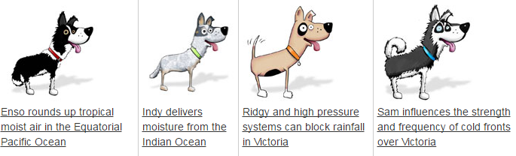
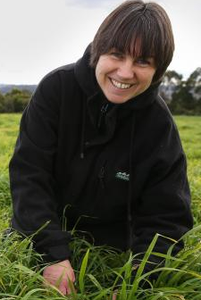
I was pretty anxious in July as it was extremely dry and was starting to feel like the drought year 2015 all over again. When August came, we started to get some rain but not enough to deliver maximum spring pasture growth. The BOM changed its three month outlook dramatically last month from forecasting a low likelihood of median rainfall, to now saying there is an even chance of median rainfall for spring. Currently, I see my exposure to the risk of not getting a good spring now as “medium” rather than the “very high” it was back in August; particularly given that I bought in some fodder early.
The key steps I took back in early August were getting advice about doing a feed budget and then following that up with a Taking Stock session to canvass other realistic options. This initial step reminded me that “the only thing worse than an actual disaster is the fear of it” and it spurred me to look into the fodder market. I found there was an abundance of low protein cereal available but a scarcity of high protein fodder, which is why I ended up sourcing locally made high quality silage.
We soil test every paddock annually to fine tune our fertiliser requirements. Particularly given that spring hasn’t taken off yet, we are very careful to put on urea and potassium only where it is really needed; minimising costs and maximising the productivity of our pastures at the same time.
The dry conditions led us to carefully consider what’s best to sow into our paddocks this summer. Research by Joe Jacobs showed that even if you water millet to only 25 per cent of its capacity, it’s quite productive (something like 70 per cent of its maximum productivity). Based on this research, we are considering hanging on to annual pastures through this spring and then sowing millet in November when conditions become warm enough. We will put millet in over more acres and use the limited water we have sparingly, rather than use it more intensively on a smaller area.
There are a number of sources of climatic information which we find extremely helpful and complementary. In addition to BOM data, we use the Pastures from Space Plus website available through the Western Australia Government Landgate Program (https://www0.landgate.wa.gov.au/maps-and-imagery/imagery/pastures-from-space-plus) to plot pasture growth rates for our farm. Also we subscribe to the Very Fast Break seasonal climate update video and the Milking the Weather e-newsletter which helps us better understand why the climate is doing what it’s doing. Additionally we look at the BOM’s Soil Moisture Maps to see what’s going on underground (down deep) and follow all their Outlook sections.
Bringing all this information together helps us better understand what’s actually driving weather patterns that may influence our farm and if their behaviour is likely to remain this way or change rapidly. If everything points to deteriorating conditions that are likely to continue throughout the season, we develop a contingency plan (i.e. reducing stock, locking in feed, thinking about summer cropping options). We also walk over the farm weekly and measure leaf emergence rates looking for trends and then speak to our agronomist to further refine our contingency plan. Planting new pasture species we also find worthwhile; on our farm Prairie Grass seems to greatly outperform ryegrass during those periods of too much or not enough rain.
As a direct result of the 2015 drought year we put in irrigation infrastructure; a spray irrigator to take advantage of our 40ML dam. As irrigation is new for us, there’s scope to improve our current irrigation water use efficiency. We need to do this to further reduce our vulnerability to a shortened spring or a false autumn break while increasing summer grazing feed.

Case Study 4: Marian Macdonald, Yarram, South Gippsland
Marian with her husband Wayne have run their 200-hectare dryland family farm as a dairying enterprise since 2008. During the 2015 drought the Macdonald’s installed a 40 ML capacity storage dam and spray irrigation system which covers 32 HA to supplement the annual rainfall of around 800mm. They milk seasonally and currently their herd numbers are close to the peak of 250. The Macdonald’s employ one farm worker.

